**ANNELIDA – EARTHWORM**

**Distribution**

More than 3000 species of earthworms are distributed worldwide and many more are yet to be discovered. 18 families of class Oligochaeta have several genera of earthworms. In India out of these 18 families, earthworms of 7 families are found.

Among these, Megascolidae is the largest genera. The members of this genus Pheretima, Perionyx, Eutyphaeus and Polypheretima are distributed in north India and other members like Drawida, Megascolex etc. are distributed in south India. Drawida grandis is the longest earthworm in India.

**Habit and habitat**

Pheretima posthuma is a fossorial animal that lives in moist soil burrows. It makes its burrows only in loamy and sandy soil. This burrowing habit provides it protection and helps in respiration indirectly. Generally it lives in the upper layers of damp soil which is rich in dead and decaying matter. In summer, when the top soil is dry, earthworms burrow deep into the soil. Earthworm burrows are lined by slimy secretion of its body.

**External morphological features**

**Size-** A fully grown, mature worm measures bout 3-5 mm in width and 150 mm in length.

**Shape-**Pheretima posthuma is long, elongated, cylindrical and narrow in shape. Its body shape is well suited for burrowing habit. It is bisymmetric animal. Its anterior end is slightly pointed whereas the posterior end is blunt. A little behind the anterior end it is thickest.

**Color-**The dorsal surface of the body is dark brown in color due to the presence of the pigment called porphyrin. This pigment protects the animal from harmful UV rays. The dorsal surface also carries a dark colored median line which is due to the presence of dorsal blood vessel which is seen through the integument.

**Body segmentation-**The body of Pheretima posthuma is soft and naked. It is divided prostomium, trunk and pygidium. Prostomium is fleshy lobe which overhangs mouth, trunk has 100-120 similar segments called as metameres or somites and pygidium bears anus. The segments are separated externally by intersegmental grooves and internally by corresponding intersegmental septa. External segmentation corresponds with the internal segmentation.

New segments are formed from the germinal zone located in front of the pygidium. Hence the old segments are at the anterior and the new segments are formed at the posterior end. The first segment of the body is peristomium which is the oldest segment of the body, while the preanal segment is the youngest segment of the body.

**Head-**Earthworm does not have distinct head and also sense organs like eyes, cirri, tentacles are absent. The first segment of the body at the anterior end is called buccal segment or peristomium. Peristomium bears terminal, crescentic mouth. The mouth is bordered by anterior edge of peristomium and overhung by prostomium.

**Clitellum-** In mature earthworms, a prominent circular band around the segments 14-16 is called cingulum or clitellum. Based on the location of the clitellum, the body of the earthworm is distinguished into three regions namely pre-clitellar, clitellar and post-clitellar regions.

**Genital papillae-**These are two pairs of conspicuous rounded elevations, one pair each in the 17th and 19th segments on the ventral surface. Each papilla bears shallow cup-like depression at its top which acts as sucker during copulation.

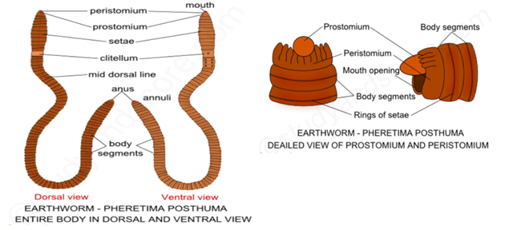

**External openings**

**Mouth**is situated at the anterior side of the first segment. It is surrounded by peristomium and overhung by prostomium.

Along the mid dorsal line, in the intersegmental grooves a series of minute openings called **dorsal pores** are present. Coelomic fluid flows out through these pores and keeps the skin slippery and moist. The first pore lies in the groove between segments 12-13.

**Anus**is the terminal opening present in the posterior terminus of pygidium

The openings of integumentary nephridia are called nephridiopores. These are minute apertures present on the body wall behind first two segments. They are scattered irregularly all over the surface of the body.

On the ventral surface of 14th segment, a single median aperture called female genital aperture is present.

On the ventral surface of 18th segment there is a pair of male genital apertures.

Four pairs of small elliptical openings called spermathecal apertures are situated ventro-laterally, in the intersegmental grooves of 5-6, 6-7, 7-8, and 8-9 segments. One pair is present in each intersegmental groove.

**Body wall -** About middle of each segment there is a ring of tiny curved bristles called as setae. Setae are also known as chaetae. They are formed of a horny nitrogenous organic substance known as chitin. On each body segment there are about 80 -120 setae. They are absent on the peristomium, pygidium and clitellum. The protrusion and retraction of the setae are effected by protractor and retractor muscles respectively. Setae grip the soil to help the earthworm move about and sense the environment.

The body wall of the earthworm covers the internal parts and also provides protection. Mucus protects the body wall from bacteria and other pathogens that lie on the body wall. Mucus also assists in respiration by keeping the skin moist. Body wall also serves as a receptor organ. The body wall consists of cuticle, epidermis, two muscular layers and the parietal layer of the coelomic epithelium.

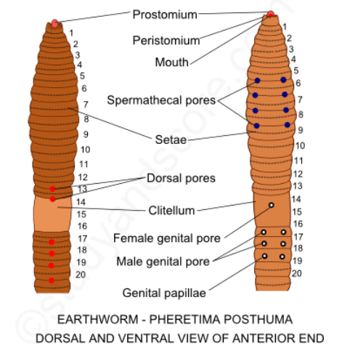

**Coelom-** Coelom which is also known as perivisceral cavity is the space between the body wall and the alimentary canal. Coelom is filled with an alkaline fluid called as coelomic fluid. The coelom of earthworm is schizocoelom and it is divided into two compartments by the septa. The coelom of the first four segments is undivided. The first septum is thin and membranous. It lies between the fourth and fifth segments.

The intersegmental septa present between 5-6, 6-7, 7-8, 8-9 and 10-11 segments are thick and muscular. No septum is present between the 9-10 segments. These septa are not horizontal but are oblique in disposition forming six cones with their apices directed backwards. These septa form complete partitions without perforations on them.

The intersegmental septa of 11-12, 12-13 and 13-14 are transverse and non-perforated. The septum between 14-15 segments is typical as all the septa that follow it are characterized by the presence of minute oval or circular sphinctered pores. These pores are the characteristic of Pheretima posthuma.

By closing the septal pores, the flow of coelomic fluid is stopped making a particular region turgid and stiff. This turgidity helps in locomotion.

**LOCOMOTION IN EARTHWORM**

Pheretima posthuma moves by alternate contraction and relaxation of circular and longitudinal muscles of the body wall. The setae and the coelomic fluid also assist in the locomotion. The body of earthworm exhibits extension, contraction and anchoring in the anterior and posterior regions during locomotion. Circular and longitudinal muscles of the body wall are useful in extension and contraction of the body respectively. The setae are useful in anchoring. The coelomic fluid causes turgidity during locomotion of earthworm. Metamerism is beneficial for the burrowing worms.

**DIGESTIVE SYSTEM OF EARTHWORM**

The digestive system of Pheretima posthuma comprises of the alimentary canal and the associated glands. The alimentary canal is the straight tube extending from mouth to anus. The following are different parts included in the alimentary canal and also a description of associated glands is given.

**Mouth:**Mouth is present at the anterior end below the prostomium. Anterior margin of peristomium borders this crescent shaped opening. The mouth leads into the buccal chamber.

**Buccal chamber:** Buccal chamber is a short tube with thin and slightly floded walls. It extends upto the middle of the third segment. The buccal chamber is followed by a pear-shaped pharynx.

**Pharynx:**Pharynx is partly present in the third segment and partly it occupies the fourth segment. The pharyngeal cavity is divided into a dorsal salivary chamber and a ventral conducting chamber by the lateral pharyngeal folds.

**Oesophagus:**The pharynx leads into the oesophagus. It extends from the fifth segment to the eighth segment. Oesophagus is a short and narrow tube. In the eighth segment it is modified to form gizzard. The gizzard is an oval shaped, glandular region with thick walls of circular muscle fibers and is lined by internal cuticle. With the contraction of the muscles, the food is ground into fine particles in gizzard. Hence for this reason, gizzard is also known as the grinding mill.

**Stomach:** The gizzard is continued as a long, highly vascular, glandular tube like stomach. It lies from ninth to fourteenth segments

**Intestine:** The stomach is continued as a thin walled wide tube called as intestine. It extends from the fifteenth segment till the last segment. On the basis of the presence of the typhlosole, intestine can be distinguished into the following parts,

**Pre-typhlosolar region-** It lies in the segments from 15th to 26th. In 26th segment two short conical outgrowths, one on either side, are given off from the intestine called intestinal caeca. They extend forwards over three or four segments. These caeca are digestive glands and they secrete amylase.

**Typhlosolar region-** This part of the intestine extends from 26th segment till the last segment excluding 23, 24 and 25 segments. In this part, a median longitudinal fold called typhlosole is present. It increases the area of absorption of the digestive food. Typhlosole is poorly developed in Pheretima posthuma.

**Post-typhlosolar region-**This is the posterior part of the intestine occupying the last 23 or 25 segments. It is also called as the rectum. It opens out through anus. It temporarily stores the faecal pellets, which are defecated through the anus.

The digestion in earthworm is extracellular. Earthworm obtains its nourishment from the organic debris present in the soil. So it is called detritivorous animal. Pharynx is ejected due to the inside out of the buccal chamber. Pharynx, with the help of its radial-dilator muscles, work as a suction-pump in feeding.

**CIRCULATORY SYSTEM**

The circulatory system of earthworm is closed type, as the blood flows only thorough the blood vessels. The blood of earthworm is red in color due to the presence of hemoglobin dissolved in the plasma unlike other vertebrates where hemoglobin is present in the red blood cells. The cells suspended in the plasma are transparent and colorless.

The blood vessels of the circulatory system of earthworm include:

1. longitudinal blood vessels – dorsal, ventral, lateral-oesophageal pair and supra-oesophageal vessel (first 13 segments)

dorsal, ventral, sub-neural, commissural vessels, and intestinal plexuses (14th segment onwards)

1. hearts – 4 hearts (2 ventral and 2 lateral-oesophageal)
2. anterior loops - connect the lateral-oesophageal blood vessels with the supra-oesophageal blood vessel
3. ring vessels

**General Excretory system of Earthworm**

The excretory organs of earthworm are minute, coiled tube like structures called nephridia. Nephridia are ectodermal in origin. They are derivatives of the ectodermal ciliated ducts. The typical nephridia consists of three parts:

1. Ciliated funnel called as nephrostome lying in the segment preceding the segment containing the main mass of the nephridium
2. A short ciliated canal called neck which is in continuation with the nephrostome. It enters the next segment by piercing the septum.
3. Body of the nephridium which is long convoluted tube. It opens outside through the nephridiopore. This pore lies on the ventral or lateral surface of the segment. A pair of such nephridia is arranged one on either side of the alimentary canal.

**Respiratory system of Earthworm**

There are no special respiratory organs in earthworm. Exchange of respiratory gases takes place through the thin moist body wall. In the body wall there is extensive system of blood capillaries. The respiratory pigment hemoglobin is dissolved in the plasma of the blood. Hemoglobin carries oxygen from the blood to the body wall of the tissues.

**Nervous system of earthworm**

The nervous system of earthworm consists of three parts namely,

1. Central nervous system: cerebral ganglia, circumpharyngeal connective and ventral nerve cord
2. Peripheral nervous system: nerve fibres and nerves
3. Sympathetic nervous system: nerve plexuses beneath epidermis and alimentary canal

**REPRODUCTIVE SYSTEM OF EARTHWORM**

Clitellum is the most important feature of reproduction in earthworm. Clitellum is secreted by specialized gland cells present in clitellar region. The clitellar region contains:

1. Mucous cells - secrete mucous that forms the outer case of the cocoon,
2. Albumin cells – secrete albumin deposited along the zygotes in the cocoons, and
3. Cocoon secreting cells

The earthworm is hermaphrodite or monoecious animals i.e. male and female reproductive organs are found in same individual. But in earthworms cross fertilization occurs because of the relative position of male and female genital apertures and protandrous nature of hermaphroditism.

**Male Female**

Testes Ovary

Testes sacs Oviduct funnel

Seminal vesicle Spermathecae

Spermiducal funnel

Vasa deferentia

Prostate gland

Accessory gland

Genital papillae

**REPRODUCTION IN EARTHWORM**

**Copulation**

In rainy season, two earthworms copulate at night. During copulation, two earthworms get attached through their ventral surface with their anterior end pointing in opposite direction. The male genital aperture become erected and inserted into the spermathecal pore of each other. During the process sperms are exchanged together. Then they separate after about an hour. The sperms are received by spermathecae and are stored in their diverticula. The fertilization in earthworms is external and takes place in the cocoons.

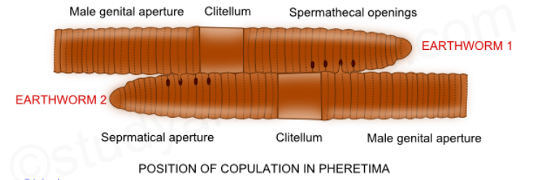

**Cocoon formation**

After copulation, a membrane is secreted around clitellum by membrane secreting glands. The membrane starts to move towards anterior end of earthworm whereas the worm starts withdrawing itself backward. During the process, the membrane receives ova coming from female genital aperture and sperms coming from spermathecal pores. Lastly, the membrane is laid out on the ground. The elastic opening of membrane becomes closed. The structure is called cocoon (ootheca). Within cocoon, one of the sperm fertilizes the ovum to form zygote and young worm is developed inside the cocoon. The young worm comes out of cocoon after about 2-3 weeks. A dozen of cocoons are formed after copulation by each conjugant.

**Development**

The complete development from the fertilized egg up to the formation of young worms takes place within the cocoon. Though a cocoon contains many fertilized eggs, only one embryo develops. And this embryo grows at the expense of other eggs. All the other eggs become nursing cells and serve the growing embryo. Development is direct without any free larval stages. Cleavage is holoblastic, determinate, spiral and unequal resulting in the production of small micromeres and large megameres. Micromeres form the ectoderm and megameres form the endoderm.

As the cleavage proceeds, a hollow sphere or blastula is formed. The cavity of the blastula is called blastocoel or segmentation cavity. The wall of the blastula is composed of a single layer of cells. The upper part of the blastula contains micromeres, while the lower part contains megameres.

All the cells of the blastula continue to divide. Two large cells, which lie side by side near the equator remain quiescent for some time. These are mesoblastic pole cells. They give rise to two rows of cells by successive divisions. These pole cells together with two rows of cells form mesoblastic bands. These mesoblastic bands form the future mesoderm.

The lower surface of the embryo starts to invaginate to form gastrula. As a result of this invagination, cavity referred to as archenteron with an elongated aperture called blastopore is formed. As the development proceeds, the lips of blastopore close from behind till only a small opening is left at the anterior end. This opening is the mouth. The tall ciliated cells of ectoderm that surround the mouth grow inwards to form stomodaeum. The stomadaeal canal leads into archenteron. On the formation of stomodaeum, the embryo starts feeding on the albumen present in the cocoon.

The two mesodermal bands divides in anterio-posterior axis into mesodermal somites. These somites are solid at first, but soon develop cavities within them called coelomic cavities. These mesodermal somites grow upward and downward on either side between ectoderm and endoderm. Ultimately they fuse dorsally and ventrally. Thus outer layer is applied to the ectoderm to form somatopleure and inner layer is applied to the endoderm to form splachnopleure.

Somatic mesoderm forms the muscle of the body wall and the parietal peritoneum. Splanchnic mesoderm forms visceral peritoneum and muscles of alimentary canal. The transverse partitions between the somites form intersegmental septa. The ectodermal invagination of the last segment fuses with the enteron to form proctodaeum.

The primary embryonic layers five rise to the body structures. The ectoderm gives rise to epidermis, nervous system, stomodaeum, proctodaeum, excretory system and setal sacs. The mesoderm gives rise to muscles, coelomic epithelia and their derivatives, intersegmental septa, blood vessels and reproductive system. The endoderm gives rise to inner epithelial lining of alimentary canal and associated glands.

Young earthworms when grown fully crawl out of the cocoon. The newly hatched young worm receives no parental care and they even resemble the adults except for size and absence of clitellum.

**ANNELIDA – CATTLE LEECH**

Leech is vermiform, bilaterally symmetrical and metamerically segmented animal that has a broad posterior sucker for attaching to substratum. It is olive-green in colour and sometimes with stripes of lighter colour and can reach a length of 30 cm. Body is metamerically segmented into 33 segments or somite, each of which is further subdivided into annuli by grooves. A temporary **clitellum** or **cingulum** is formed on segments 9-11, which is meant to produce a cocoon in breeding season. The anterior sucker helps in attachment as well as feeding. On the dorsal side there are 5 pairs of eyes on the first five segments. Mouth is in the middle of anterior sucker and anus is a small aperture that opens on the dorsal side of 26th segment.

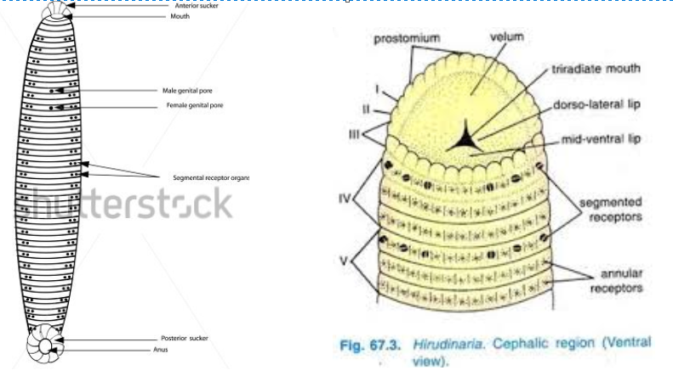

Nephridia open to the outside by 17 pairs of nephridiopores on segments number 6 to 22. Male genital opening is in the middle of 10th segment and female genital pore exists midventrally on 11th segment.

Skin contains many types of glands, namely, *Slime glands*, which are modified mucous glands that are distributed all over the body surface. *Sucker glands* are situated on anterior and posterior suckers and provide them with adhesive properties. *Prostomial glands* are present on prostomium and their secretion forms plugs on the anterior and posterior ends of cocoon. *Clitellar glands* are present on segments 9-11and secrete a frothy girdle that dries to form a cocoon inside which eggs are deposited.

**DIGESTIVE SYSTEM**

Mouth is a tri-radiate aperture situated in the middle of the anterior sucker. There are three jaws, one is dorso-median and the other two are ventro-lateral. Jaws are provided with papillae which bear the openings of salivary glands. Pharynx extends from 5th to 8th segments, on the outer side of which are unicellular salivary glands that secrete *hirudin*, which prevents coagulation of host blood during feeding. Radial muscles dilate the pharynx and carry out suction of blood. The crop is the largest chamber of alimentary canal and extends from 9th to 18th segments, one chamber in each segment and a total of ten chambers. A pair of caeca project out laterally from each chamber, their length increases towards the posterior side and the last pair of caeca extends as far as 22nd segment. The crop leads to stomach whose walls are produced internally into transverse folds. The next chamber is intestine which is a small straight tube located in 20-22nd segments and narrows down at the posterior end into rectum, which opens on the dorsal side of 26th segment by anus. The sucked blood is stored in crop and enters for digestion in stomach and intestine drop by drop and takes lot of time for digestion.

**RESPIRATORY SYSTEM**

There are no special respiratory organs in leech. Skin also serves respiratory function as epidermis is a permeable membrane through which the carbon dioxide and oxygen dissolved in water can be exchanged. The skin is always kept moist by the mucus secreted by the slime glands which prevents it from drying even on land.

**CIRCULATORY SYSTEM**

The blood vascular system is represented by haemocoelomic channels, which are filled with blood-like fluid that contains haemoglobin dissolved in plasma and colourless corpuscles. The haemocoelomic system consists of four longitudinal channels, two of which run ventro-laterally, one on each side, one runs along the mid-dorsal side and the other along the mid-ventral side. The four channels are connected with each other in the posterior as well as anterior region of body. Branches from these channels supply blood to different organs.

The dorsal haemocoelomic channel supplies blood to dorsal and dorso-lateral parts of the body and the alimentary canal. The blood from these parts is collected by the lateral channels.

The ventral haemocoelomic channel supplies blood to the ventro-lateral body walls and nephridia, from where the blood returns to the lateral channels. Lateral channels distribute blood to the nephridia, genital organs, gut and ventral body wall.

**EXCRETORY SYSTEM**

Like other annelids excretory system consists of nephridia, which are 17 pairs of small coiled tubules embedded in syncytium and arranged segmentally, one pair in each segment from 6th to 22nd segment. They are of two types – Testicular nephridia and Pre-testicular nephridia. Testicular nephridia are 11 pairs, located from 12th to 22nd segment and their initial lobes end in the testis sacs in each of these segments. Pretesticular nephridia are present in segments 6-11 and their initial lobe ends blindly in the botryoidal tissue as there are no testis sacs in these segments.

The ciliated organ has no excretory function in adults but manufactures coelomic corpuscles. The nephridia serve to eliminate excess water and nitrogenous wastes. Nitrogenous waste consists mainly of ammonia and small quantities of urea. Nephridia also serve as osmoregulatory organs. The nephridium is richly supplied with branches of haemocoelomic channels. Its gland cells separate the waste products from the haemocoelomic fluid and transport it to the vesicle, from where they are discharged through the nephridiopore. Some scientists also assign excretory function to the botryoidal tissue because the capillaries in it are in communication with the haemocoelomic fluid.

**NERVOUS SYSTEM**

There are three parts in the nervous system:

1. **Central nervous system:**

It is enclosed in the ventral haemocoelomic channel & consists of a nerve ring on dorsal side of which is a cerebral or supra-pharyngeal ganglion. It is connected by a pair of lateral circumpharyngeal connectives with the ventral sub-pharyngeal ganglion. Ventral nerve cord arises from sub-pharyngeal ganglion and runs backward from 6th to 26th segment and make one ganglion in each segment. The ventral nerve cord ends in a large terminal ganglionic mass, situated within the posterior sucker.

1. **Peripheral nervous system:** nerve fibres and nerves arising from segmental ganglia and optic nerves
2. **Sympathetic nervous system:** nerve plexuses beneath epidermis, within muscles and alimentary canal

**SENSE ORGANS**

There are specially modified epidermal cells to serve as receptor organs. These cells remain scattered and sunk within the body wall. The different receptors found in leech are:

1. Eyes - five pairs of eyes, one pair each on the first five segments
2. Annular receptors - papillae arranged in a row on each annulus of the segment; tactile in function
3. Segmental receptors – present as papillae on the first annulus of each segment of the body; tactile as well as photoreceptor in nature

In addition to these receptors there is large number of free nerve endings scattered between the epidermal cells of the skin which are tactile as well as chemoreceptors in function.

**REPRODUCTIVE SYSTEM**

Like earthworm leech is hermaphrodite and male and female reproductive organs occur in the same animal. Cross fertilization occurs by copulation in which mutual exchange of spermatophores takes place.

**Male Female**

Testes Ovaries

Testes sac Ovisacs

Vasa efferentia Oviducts

Prostate glands and atrium

Copulation takes place in March-April. During copulation two leeches come together pointing in opposite directions so that the male aperture of one leech lies opposite the female aperture of the other. The penis of each leech is inserted into the vagina of the other and **spermatophores** are exchanged. Copulation may occur on land or in water and lasts for about an hour after which the two leeches separate. Fertilization is internal inside the vagina. The fertilized eggs are deposited into the cocoon in which further development of the embryo occurs.

The cocoons are secreted by the **clitellum**, which is formed around segments 9-11 during breeding season. The **clitellar glands** secrete albumen into the cocoon which is used as nourishment by the developing embryo. The cocoon is then passed over the head of leech as the leech withdraws its anterior end backwards by rhythmic movements of body. The **prostomial glands** secrete two polar plugs to close the two ends of cocoon. The cocoons are laid in moist soil where eggs develop into tiny leeches without undergoing through a larval stage.

**MOLLUSCA**

**TORSION AND DETORSION**

In freshwater and terrestrial molluscs, there is no free swimming larval stage. Both trochophore and veliger stages are passed inside the egg and a tiny snail hatches out of the egg. Early larva is symmetrical with anterior mouth and posterior anus and gills lie on the posterior side. As the larva develops shell its visceral mass starts twisting in anticlockwise direction to rearrange the visceral organs so that they are accommodated inside the coils of the shell and openings of organs are shifted to the anterior side where the shell opening lies.

During torsion visceral and pallial organs change their position by twisting through 180°. Posterior mantle cavity is brought to the front position. Gills and kidney move from left to right side and in front which helps in breathing. In nervous system the two pleurovisceral connectives cross themselves into a figure of 8, one passing above the intestine and the other below it. Alimentary canal twists in the visceral mass and opens by anus on the side of the head on the anterior side. After torsion the foot can be withdrawn after the head.

During torsion head and foot remain fixed and rotation takes place in the visceral mass only behind the neck so that the visceral organs of the right side come to occupy the left side and vice versa. Before torsion the visceral mass points forward and the mantle cavity is posterior in position. This position is called **exogastric**. After torsion the position becomes **endogastric** in which visceral mass points backwards and intestine lies in the whorls of the shell and anus opens on the anterior side.

Ninety percent of the torsion is affected by the **right retractor muscle** which is quite prominent in the larva while the left retractor muscle is rudimentary. Rest of the 10% of torsion is caused by the differential growth of the visceral mass. Torsion takes place quickly and is completed from 15-30 minutes.

Anticlockwise rotation of the visceral mass causes **dextral** (right handed) coiling of the shell, which happens in majority of the cases. However, rarely clockwise rotation of visceral mass also takes place, which causes **sinistral** (left handed) coiling of the shell.

**SIGNIFICANCE OF TORSION**

As gastropod shell has only one opening, it has to serve as entrance as well as exit for all visceral organs. Both mouth and anus must open on the anterior side. Mantle cavity also must open on the anterior side for easy respiration. Respiratory current opposes locomotion after torsion which increases availability of water inside the branchial chamber. Visceral mass has to undergo rearrangement so that openings of kidneys, gonads and anus should migrate to the front side which is the only opening of the shell. The small chemoreceptor **osphradium** also migrates to the front side so that it could chemically analyse water current entering the mantle cavity. The bulky buccal mass migrates to the anterior side that provides stability during locomotion. Torsion allows foot to be retracted after the head for better protection of head.

**DETORSION**

Detorsion is reversal of torsion which takes place when during evolution shell is lost or a type of shell evolves that has openings on the opposite sides. In such situations twisting of visceral mass is not necessary. Hence, detorsion takes place during the larval stage and the animal again becomes bilaterally symmetrical. Nervous system becomes symmetrical and not twisted in the shape of 8. Pallial complex travels backwards. Ctenidium travels backwards or to the lateral side. Auricle moves behind the ventricle. Visceral loop and intestine become straightened.

Detorsion takes place in Pulmonata, such as *Acteon* and *Bulla* in which anus and ctenidium are directed laterally. In *Aplysia* (Opisthobranchia), detorsion takes place owing to the loss of shell. The gills are directed laterally but lie posterior to the heart and the body becomes symmetrical.

In *Pterotracheacoronata* (floating sea slug) the shell, mantle and visceral sac are lost and hence the animal becomes symmetrical, worm-like with a long proboscis for feeding.

Nudibranchs *(Eolis* and *Doris)*also undergo detorsion due to the loss of shell. *Doris* has symmetrical rhinophores and anal gills on the posterior side. The sea slugs, *Eolis* and *Iolidia* are symmetrical animals because they have undergone detorsion due to the absence of shell. They move with the help of a ventral foot and breathe with respiratory cerata that are present all over the body.

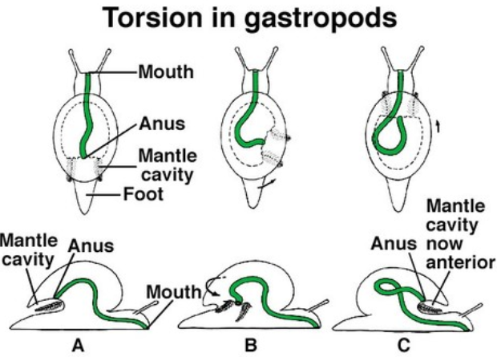

**LAMELLIDENS**

*Unio* is a bivalve mollusc that inhabits freshwater rivers and ponds and lakes. It burrows in a furrow in sand with the help of a hatchet-shaped foot, keeping the inhalant and exhalent siphons above the sandy surface for maintaining a current of water. It is a filter feeder of planktons which are trapped by the specially modified gills.

The bivalve shell is held together by anterior and posterior adductor muscles and it can be opened by retractor muscles. Protractor muscle moves the foot while burrowing. Just below the two valves of the shell there are flap-like mantle lobes on either side which provide insulation between the hard shell and soft body. Mantle is also respiratory in function. Gills or ctenidia are large and made of two gill plates on either side of body under the mantle flaps. They are respiratory as well as food gathering in function.

**DIGESTIVE SYSTEM**

*Unio* is filter feeder and traps planktons by the enlarged sieve-like gills plates or demibranchs. Water current enters the mantle cavity through the inhalant siphon and moves upwards through the gills to the suprabranchial chamber. Gills are coated with mucous which traps the planktons on the gill surface. Movement of cilia on the gill surface pushes the food particles downward into the food groove present on the lower margin of gill lamina. Inside the food groove the food is constantly pushed forward towards the mouth where two pairs of feeding palps sort out the sand particles from the mucous cord and push the food and mucous into the mouth.

The stomach is bag-like with ciliated lining and a crystalline style that rotates at the bottom, churning the food and mixing it with the digestive juices. Digestive gland is dark brown to greenish in colour and surrounds the stomachs and opens into it through many ducts.

The intestine is coiled and passes through the gonad and pericardial cavity to end in rectum that opens by anus at the base of the exhalent siphon. Rectum carries a typhlosole to increase the absorptive area. Most of the digestion and absorption takes place in the intestine.

Intracellular digestion also takes place in the digestive gland by wandering amoebocytes.

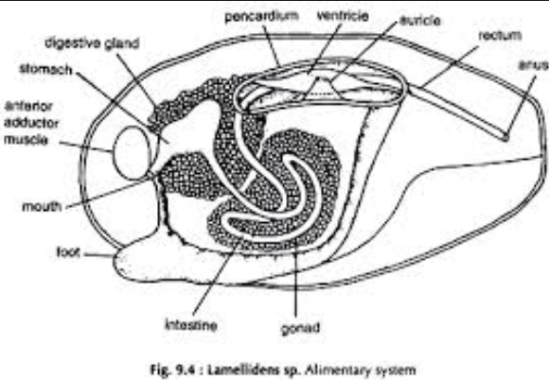

**RESPIRATORY SYSTEM**

The chief respiratory organs are a pair of ctenidia and mantle. Each side of the gill or ctenidium has inner and outer gill lamina or demibranch or gill plate, which is made of inner and outer layers called lamella. All lamellae have vertical gill filaments which are joined by the interfilamental junctions at short intervals. The lamellae and the interfilamental connections together make the gill lamella a sieve-like structure through which the water is filtered and food particles are trapped. At the same time exchange of gases also takes place through the epithelium of the lamellae. During breeding season the outer gill lamina enlarges and serves as a brood pouch to hold the eggs and glochidium larvae.

**CIRCULATORY SYSTEM**

Blood vascular system is open type comprising heart, arteries, veins, lacunae and sinuses. **Blood** is colourless but in some cases is slightly bluish due to the respiratory pigment **haemocyanin**. Only *Solen* has haemoglobin dissolved in plasma in bivalves. Large number of granular and agranular leucocytes and amoebocytes are present in the blood.

**Heart** is 3-chambered, with one ventricle and 2 auricles. Pericardium encloses the heart. **Ventricle** gives off anterior and posterior **aortae**, the former carrying blood to foot, mantle and visceral organs. The posterior aorta supplies blood to mantle only.

The blood from the posterior part of mantle is collected by the **pallialvein** and is taken to the auricle. On the anterior side the visceral vein and pedal veins collect blood and take it to the kidneys or organ of Bojanus. From kidneys either the blood can go directly to auricles via the efferent renal vein or can be taken to gills for oxygenation through the afferent ctenidial vein. From the ctenidium the blood is collected by the efferent ctenidial vein and taken to auricles. Thus auricles receive the venous blood from all over the body and pump it to the ventricle.

There are no capillaries in *Unio*. The arteries end in **lacunae** and **sinuses** and veins collect blood from major sinuses and take it to the heart. This type of circulatory system is called **opentype**.

**EXCRETORY SYSTEM**

Excretory organs are a pair of kidneys collectively known as **organ of Bojanus** that lies below the pericardial cavity. Kidney is a u-shaped tube that on one side opens into the fluid filled pericardial cavity and drains its contents. A reddish-brown **Keber’s organ** or pericardial gland is attached on the anterior side of pericardium. It discharges waste products into the pericardial cavity. Another opening of the kidney is **renal pore** that opens into the suprabranchial chamber for releasing the nitrogenous wastes into the outgoing current of water. The kidney has glandular part that extracts nitrogenous wastes from the surrounding blood and its ciliated part forces them to the outside. The excretory products are mainly ammonia and ammonium compounds and traces of urea and uric acid.

**NERVOUS SYSTEM**

Nervous system is symmetrical having a pair of cerebral ganglia on the dorsal side of oesophagus and connected to each other by a cerebral commissure. A pair of pedal ganglia is located in the foot and connected to the cerebral ganglia via a pair of cerebro-pedal connectives. Visceral ganglion forms an X-shaped bilobed mass in the posterior side of the body. It is connected directly to the two cerebral ganglia via a pair of cerebro-visceral connectives.

Statocysts are connected to the pedal ganglia in the foot.

**SENSE ORGANS**

Owing to the near sedentary habit sense organs are not very well developed in *Unio*. **Osphradium** is located at the base of gills and is made of yellow coloured group of sensory cells that test the chemical nature of the incoming current of water.

**Statocyst** is one pair of sense organs of balance and posture located in the foot near the pedal ganglia, to which it is connected by pedal nerves.

**Tactile cells** are distributed on the edges of mantle and on the inhalant siphon.

**Photoreceptor cells** are also present on the margins of siphons which detect the intensity of light.

**REPRODUCTIVE SYSTEM**

*Unio* is a dioecious animal in which sexes are separate. Gonads are paired structures made of branching tubes that lie in the coils of intestine. **Testes** are whitish in colour and **ovaries** reddish. Ducts of gonads open into the suprabranchial chambers of gills.

The **sperms** are released into the suprabranchial chamber from where they pass out of the body through the outgoing current of water. However, **ova** that are released in the suprabranchial chamber are held by mucous cords into the brood pouches of the outer gill lamina. Sperms of other mussels that enter the brood pouches with the current of water fertilise ova to form zygotes within the water tubes. Development of the eggs takes place inside the brood sac of the outer gill lamina and a glochidium larva is formed.

The **glochidium** larva has a bivalve shell whose two valves are attached together with adductor muscle. The free ends of the valves carry sharp **hooks** that help the larva to attach on the gills of fish. On the inner side of the shell there is **mantle** bearing bunches of cilia and a glandular pouch at the base. The glands secrete sticky mucous onto the **byssus** thread that helps the larva to firmly anchor on the gills of fish.

The glochidium larvae escape from the brood pouches into the surrounding water and along with the water current reach the gill chambers of fish, where they attach to the gills by hooks and byssus and forms a **cyst**. The cyst remains on the fish for about 10 weeks and is carried to long distances by the host. Then the cyst detaches from the gills of fish and drops on the sea floor where it gradually metamorphoses to become adult. The fishes help in the dispersal of the species.

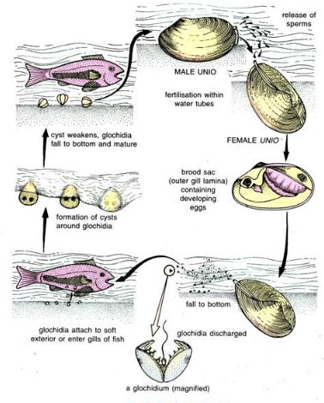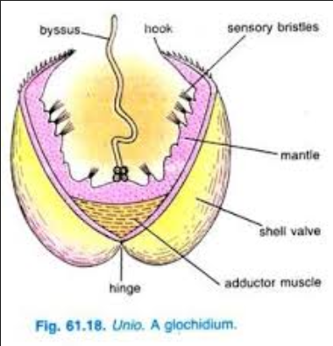

**SEPIA**

Cephalopods are advanced molluscs in which foot is modified as tentacles and oral arms attached on the anterior side of the head. Sepia is a marine cephalopod found up to 3000 metre depth. They are predators and feed on fish, crabs, shrimps and prawns that they seize with prehensile tentacles and oral arms which are supplied with suckers. Sepia can also change colour and some are bioluminescent.

Body is divided into head and trunk. Head bears 8 **oralarms** and two **tentacles**, two large **eyes** and a pair of **olfactorypits** behind the eyes. Trunk has a visceral hump that carries internal shell called **cuttlebone**. Between the neck and trunk there is collar through which water enters into the mantle cavity. One pair of lateral fins help in swimming.

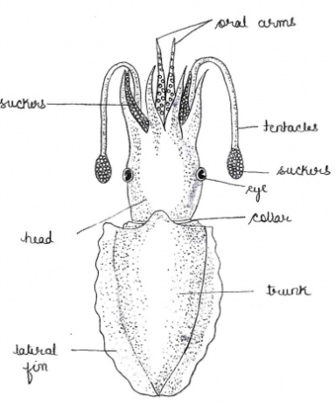

Visceral cavity can be opened by cutting mantle. There are three paired cartilages, namely, **nuchal cartilages, mantle cartilages**and**funnel cartilages,** which can interlock to close the collar opening. A **funnel** lies on the ventral side of the neck, through which exhalent current of water is expelled in the form of jet. **Visceralmass** lies on the posterior side of the mantle cavity and intestine and kidneys open at the base of funnel. One pair of large bipectinate **ctenidia** lay on either side of the visceral mass.

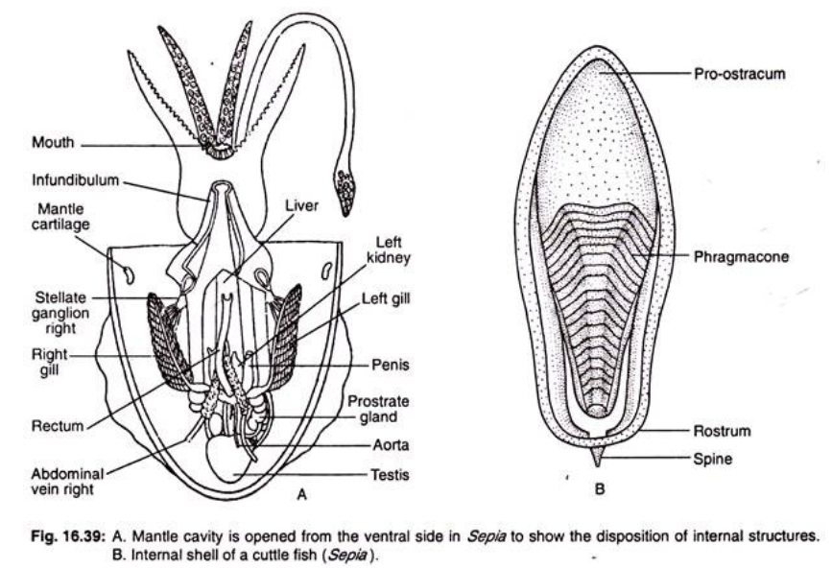

**DIGESTIVE SYSTEM**

Mouth has circular fleshy lips and a pair of sharp **jaws** for tearing the prey into small pieces which are swallowed through the pharynx that lies in a small buccal mass. Radula is rudimentary in cephalopods. Two pairs of **salivaryglands** lie on either side of oesophagus and a salivary duct releases poisonous saliva at the base of jaws. Saliva also contains mucous and protein digesting enzymes. **Oesophagus** leads into a gizzard-like stomach that has a **caecum** or pyloric sac with spiral folds attached on its side. Stomach churns the food and crushes exoskeleton of arthropods on which *Sepia* feeds. Digestive gland has two sections, namely, a bilobed brownish **liver** and a cream coloured **pancreaticappendage** that surrounds the stomach. Ducts of digestive glands are called hepatopancreatic ducts that open into the pyloric sac of stomach. There is no intracellular digestion in the liver of cephalopods. **Intestine** is short and opens at the base of funnel. The **inkgland** also opens by a duct at the base of rectum. A cloud of ink released from ink gland helps the animal to camouflage from predators. Liver also serves to assimilate and store food.

**RESPIRATORY SYSTEM**

One pair of bipectinate gills are the respiratory organs of Sepia. Water is inhaled through collar opening and expelled through the funnel opening. **Inhalentphase** is carried out by the longitudinal **radialmuscles** which contract to increase the volume of mantle cavity. Then the three pairs of cartilages interlock to close the collar opening. For **exhalent phase,circularmuscles** contract and radial muscles relax to increase pressure of water inside the mantle cavity. The collar opening being closed, water is forced through the funnel in the form of a jet. **Haemocyanin** is the respiratory pigment in cephalopods.

**CIRCULATORY SYSTEM**

Circulatory system is closed type in cephalopods and there is complete separation of arterial blood from venous blood. There is one **systemicheart** or arterial heart and two **venoushearts** or branchial hearts at the base of gills. Systemic heart is enclosed in a pericardial cavity and consists of two **auricles** and one median **ventricle**. Auricles receive oxygenated blood from gills through the efferent branchial vessels and pour it into the ventricle. Ventricle pumps blood into the anterior or **cephalicaorta** that supplies blood to the head region and **posterioraorta** that takes blood to the visceral organs.

The venous hearts are located at the base of gills and receive blood from the anterior side through the **precava** and from the posterior side through the **abdominalveins** and **pallialveins**. This deoxygenated blood is pumped by the venous hearts to the gills through the afferent branchial vessel. There are no sinuses and lacunae in cephalopods. Blood contains **haemocyanin** dissolved in plasma and amoebocytes.

**EXCRETORY SYSTEM**

Excretory organs consist of glandular renal growths or **renalappendages** that are wrapped around the paired precava and extract nitrogenous wastes from the blood and pour it into a pair of **viscero-pericardial sacs.** One end of these sacs opens into the **pericardialcavity** and drains its contents, while the other end opens into the mantle cavity as external renal opening. **Pancreaticappendage** also performs excretory function. The excretory material from this is collected by the single **mid-dorsal sac** that opens into the two viscero-pericardial sacs. The excreted nitrogenous wastes are in the form of guanin.

**NERVOUS SYSTEM**

Nervous system is advanced type and centralised. There is a **brain** enclosed within a cartilaginous skull. It is formed by the fusion of cerebral, pedal and pleuro-visceral ganglia. On the anterior side of brain there is a **basalbrachialganglion** from which emerge 10 brachial nerves that on the anterior side meet 10 brachial ganglia in a nerve ring. From this brachial ring nerves go to tentacles and oral arms. Visceral nerves emerge from the ventral side of the brain.

From the posterior side of brain a pair of **pallialnerves** emerges and meets the large **stellateganglia** on the lateral sides. From the stellate ganglia nerves are supplied to the visceral organs and the fins. From the posterior end of the brain also emerge a pair of **branchial nerves** that innervate the two gills or ctenidia.

Sympathetic nervous system includes a pair of nerves emerging from brain and joining the gastric ganglion in the stomach lining.

**SENSE ORGANS**

Sense organs include a pair of large **eyes**, a pair of **statocysts** situated on the ventral side to the pleuo-visceral ganglion of brain, a pair of **olfactorypits** behind the eyes and **gustatoryorgan** on the floor of the buccal cavity.

Cephalopod **eye** is strikingly similar to the vertebrate eye, although the two are not homologous structures. **Cornea** is not true cornea as it is made of modified horny skin. Sclera is made of cartilages that form eye orbit. **Choroid** is absent. **Ciliary body** is present and holds the lens in its place. **Retina** contains rod cells only but does not have fovea centralis. Unlike in vertebrates, the rod cells point towards the source of light and the nerve fibre is attached to the posterior side of rod cells. The gelatinous **vitreous humour** fills the eye ball posterior to the lens. A pair of whitish **optic glands** is present at the junction of the optic nerve with the eye ball. There is no blind spot in the eye of cephalopods.

**REPRODUCTIVE SYSTEM**

Sexes are separate. Male has a single yellowish **testis** enclosed in the coelomic capsule, which is located on the posterior end of the visceral cavity. **Vasdeferens** emerging from the testis is a highly coiled duct that leads to an elongated and ciliated **seminalvesicle**. An accessory **prostategland** is attached to the terminal end of the seminal vesicle. Seminal vesicle opens into a large **Needham’ssac** that serves to store **spermatophores** till they are passed out through the male genital opening at the base of the funnel. Sperms are produced in testis but they are packed in elongated and chitinous spermatophores inside the seminal vesicle. These spermatophores possess a spring apparatus at the base of the cap that makes them blow up to release sperms when placed inside the mantle cavity of female.

Female has a single whitish saccular **ovary** enclosed in a coelomic sac and located on the posterior end of the visceral cavity. Ova travel through the **oviduct** and are released in **bursacopulatrix,** which is formed by the enlargement of the funnel and in which fertilization takes place. A pair of **nidamentalglands** secrete egg capsule around the fertilized eggs. The orange coloured **accessorynidamentalglands** secrete sticky material that helps the eggs to adhere to the sea weeds where the female deposits them.

Conventional copulation does not take place in *Sepia*. Sperms are packed in spermatophores which are released into the mantle cavity from where male collects them with its hectocotylized arm and transfers into the mantle cavity of female. Left 4th arm is modified as hectocotylised arm in *Sepia*for the transfer of sperms. Development is direct and there is no larval stage in cephalopods.

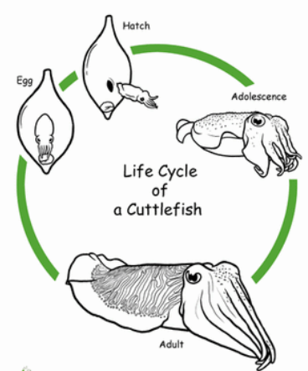

**PILA**

*Pila globosa* is an amphibious apple snail found in the Indian subcontinent. Its flesh is commonly used as prawn feed in aquaculture. It is also used as poultry feed and also as human food in some places. This species uses water bodies, rice fields and highly humid areas for breeding.

*Pila* shell is unilocular in which all the whorls are internally connected together. The single opening of the shell is called **peristome** which is closed by a hard operculum. Body that is covered by mantle consists of head, foot and visceral mass.

An **epitaenialridge** divides the mantle cavity into a pulmonary and a branchial chamber as *Pila* is an amphibious animal. Water enters the branchial chamber through the left nuchal opening and goes out through the right nuchal opening. Branchial chamber contains a single monopectinate gill or **Ctenidium**. The openings of the rectum, gonoducts and excretory ducts also open in the branchial chamber at the base of right nuchal lobe so that their products are expelled along with the outgoing current of water. Operculum is opened to make the foot extend out of the shell for locomotion. Head bears a pair of stalked eyes and two pairs of tentacles. First pair of tentacles is also called labial palp as it helps in feeding.

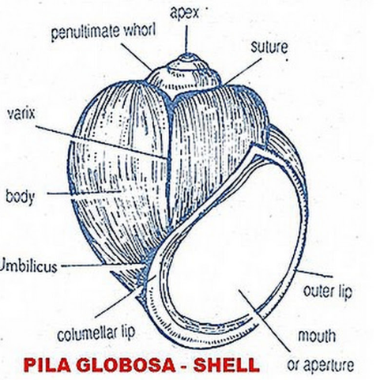

**DIGESTIVE SYSTEM**

*Pila* is herbivore and has a pair of strong **jaws** for cutting and chewing. It also has a belt-like **radula** with teeth to corrode and rasp algae from the surface of rocks. A pair of whitish **buccalglands** secrete mucous in the buccal cavity. Oesophagus is long and passes through the buccal mass or **odontophore**, which is a heavy and large structure containing cartilages, protractor and retractor muscles of radula and odontophore muscles and tissues. Oesophagus also contains a pair of **salivaryglands** located inside the oesophageal pouches. These release saliva that carries starch digesting enzymes.

**Stomach** is large sac like divided into cardiac and pyloric portions with a pyloric **caecum** that carries cellulose digesting bacteria. Intestine is long coiled inside the visceral mass and leads to rectum that opens by anus near the right nuchal opening. A large brownish to greenish **digestivegland**, which has a larger and a smaller lobe, is present in the coils of intestine and opens into the pyloric stomach by a duct. Digestive enzymes are secreted by this gland into the stomach. Gonads are also present in the coils of intestine in the visceral mass. Intracellular digestion also takes place inside the digestive gland by amoeboid cells.

**RESPIRATORY SYSTEM**

*Pila* is an amphibious animal and carries a single monopectinate **ctenidium** on the right side of the branchial chamber, separated by the epitaenidial ridge from the pulmonary chamber. Water current enters through the left nuchal opening and passes out through the right nuchal opening. An **osphradium**, which is a chemoreceptor, is located near the left nuchal opening.

For aerial respiration respiratory **siphon** of the pulmonary sac is thrust out of the left nuchal opening to inhale outside air into the single **pulmonarysac**, which is supplied with network of blood vessels. Inhalation and exhalation is carried out by the muscles that surround the pulmonary sac. During aerial respiration the **epitaenialridge** shuts off the branchial chamber so that it does not get dried up by air.

**CIRCULATORY SYSTEM**

*Pila* has an open type of circulatory system that consists of blood vessels, lacunae and sinuses. Heart is made of an **auricle** and a **ventricle**, the latter gives off a cephalic aorta and a visceral aorta. **Cephalicaorta**supplies blood to the osphradium, foot, pulmonary sac and the mantle. The **visceralaorta** supplies blood to the liver, kidney and other visceral organs including the digestive system. From the kidneys the blood is collected by renal vein and taken to auricle. Also from the kidneys **afferentctenidial vein** takes the blood to gills for oxygenation. From gills the **efferent ctenidial vein** collects blood and carries it to the auricle of heart. From the pulmonary chamber the blood is collected by the **efferentpulmonaryvein** and taken to the auricle.

There are numerous small lacunae in which the blood vessels end. All lacunae open into 5 major sinuses, namely**, perivisceral sinus, peri-intestinal sinus, branchio-renal sinus, pulmonary sinus**and**the pericardial sinus.**

Respiratory pigment in the blood is **haemocyanin** dissolved in plasma and there are blood corpuscles such as amoebocytes.