**STATUS OF PROTISTA**

Sponges were initially treated as plants because they are sedentary and grow asymmetrically by budding and branching. Moreover in Mediterranean region, bath sponges are cultivated like plants by planting their cuttings.  Sponges also show no response to touching or other stimuli. They have no superficial food catching organs like other animals.

But Aristotle documented them as animals. Carolus Linnaeus, classified sponges into Phylum Coelenterata in his book ‘Systema Naturae’. Sponges are sedentary, diploblastic animals with central cavity known as spongocoel (similar to coelenteron of cnidarians). Their life cycle includes a free swimming ciliated amphiblastula larva (similar to planula larva of Coelenteron).

**Phylum Porifera**

Robert Grant established a distinct group for sponges called as Porifera. According to him the water flows into and out of the sponge body through minute pores.

**Protozoan characters of Porifera**

* Cellular independence (as in colonial protozoans)
* Totipotent nature of the cells
* Absence of organ-level or tissue-level organization
* Absence of gonads
* Intracellular digestion through the process of endophagy
* Presence of amoeboid cells and collar cells (as in Choanoflagellates)

**Metazoan characters of Porifera**

* Reproduction through budding and branching (as in cnidarians)
* Development includes free-swimming ciliated amphiblastula, parenchymula and stomoblastula larva
* Zygote develops by cleavage to enter blastula and gastrula stages
* Presence of water vascular system (as in Jellyfish)
* Spongocoel is comparable to the coelenteron of cnidarians
* Multicellular and diploblastic nature with non-cellular mesoglea between ectoderm and endoderm.

**Groups related to Porifera**

**Phylum Mesozoa:**Van Beneden considered Mesozoans as missing link between Protozoa and Metazoa. Mesozoans are ciliated, worm-like multicellular animals. They live as parasites on marine invertebrates like Platyhelminthes, annelids, molluscs and echinoderms. They are very tiny animals with slender, vermiform body composed of 20-30 cells arranged in two layers (comparable to ectoderm and endoderm of metazoans). They have complex trematode-like life cycle with a ciliated larva. They are considered to be probably descended directly from Protozoa and are related to ciliates.

There are two classes in Mesozoa:

* Rhombozoa (parasites in kidneys of cephalopods)
* Orthonectida (parasites in polychaetes, molluscs and echinoderms)

**Phylum Placozoa:**Phylum placozoa was suggested by K.G. Grell to include a single marine species, Trichoplax adhaerens. Trichoplax adhaerens was discovered in a seawater aquarium in Europe. This organism has a flat, plate-like asymmetrical body which constantly changes shape. It is diploblastic in nature. A gelatinous matrix acts as intermediate layer. This layer consists of fiber cells and vacuoles. There are no organs, nerves or muscles in its body. This animal slides over food with the help of cilia. Mode of nutrition is saprophagy; it secretes digestive enzymes over its food and absorbs the product. It possesses microvilli to increase the absorptive surface.

Placozoans are closely related to poriferans and are classified as an independent phylum under subkingdom Parazoa. It is supposed that during early stages evolution Mesozoa, Porifera and placozoa must have evolved from a common unicellular ancestor. Out of these three, Placozoa and Porifera are more closely related, while mesozoa has undergone tremendous transformation due to its parasitic mode of life.

**Subkingdom Parazoa**

Huxley and Sollas created a separate Subkingdom Parazoa to include sponges. They kept parazoans separate from other metazoans.  Parazoans are different from metazoans due to the absence of body organs, nervous tissue, cellular differentiation and cell specialization. Parazoans also lack a true mouth and possess peculiar collar cells. The digestion in parazoans is intracellular.

The origin of sponges and other metazoans can be well explained with the help of following two theories:

**Syncytial ciliate hypothesis**: This hypothesis assumes that poriferans originated from multinucleated ciliates by the division of cytoplasm. This is proved by the fact that sponges and their closest relatives, mesozoans and placozoans all have multicellular bodies with ciliated cells.

**Colonial flagellate hypothesis:** This hypothesis assumes that poriferans originated from colonial choanoflagellate ancestors similar to Proterospongia. Proterospongia had choanocytes and amoebocytes embedded in a gelatinous matrix. Later, as the colony became more and more complex, the cells became specialised. As the animals became sessile due to availability of plenty of planktonic food, the external flagellated cells migrated inside the body to line a central cavity. Gradually a complete water canal system developed. Similarities in cellular organization of Porifera, Mesozoa and Placozoa also support this hypothesis.

Sponges have diverged early in evolution from the main metazoan lineage and have not evolved into any other kind of organism since then. Sponges have maintained their distinctness and remained unchanged since Palaeozoic. They still maintain their isolated phylogenetic position and hence it is placed in a separate subkingdom Parazoa.

Placozoans (represented by a single species, Trichoplax adhaerens), appear to be the closest relatives of sponges. Hence placozoans are also included in Parazoa but as a separate phylum. The phylogenetic position of   mesozoans is not certain as they are parasitic animals. Though parasitic mesozoans are very simple may be due to their primitiveness. Hence mesozoans are placed in a separate phylum but much close to Parazoa.

**Origin of Metazoa**

Metazoans possess organ grade of body organization in which tissues develop to form organs. These organs perform various functions in the body. There are three theories which explain the origin of Metazoa.

**Colonial theory:** Butschli, Lankester & Haeckel and Hyman proposed this theory. According to this theory, metazoans have evolved from colonial flagellate ancestor similar to Volvox. Haeckel said that the hollow flagellate spherical colony of Volvox appears like blastula or gastrula of metazoans. Some protozoans like Gonium, Synura and Pandorina form morula-like solid colonies that superficially resemble metazoans.

**Syncytial theory:**Hanson and Hadze propose this theory. According to this theory, multinucleate ciliates are the ancestors of metazoans. Ciliates possess high grade of organelle development and body organization among protozoans. By partitioning the multinucleated cytoplasm with cell membranes the ciliate body could have become multicellular to give rise to Metazoa.

**Polyphyletic theory:**Greenberg and Preston proposed this theory. According to this theory, metazoans originated from many types of protozoan ancestors in different lineages.

**STATUS OF PROTOZOA**

Carl von Linnaeus suggested 2-kingdom classification of organisms in his book, Systema Naturae. This was the first comprehensive classification of the living organisms.

These two kingdoms were,

**1. Kingdom Plantae** (non-motile organisms that possessed cell wall, chlorophyll and starch as stored material) and

**2. Kingdom Animalia** (motile organisms that did not possess cellulose and starch but stored glycogen as stored material).

But Bacteria, Fungi, Slime moulds (Mycetozoa), Phytoflagellates (Euglena), Cryptomonadina (Cryptomonas, Chilomonas), Dinoflagellates and diatoms could not be definetly placed into any of the two kingdoms. And hence this posed objections to two-kingdom classification.

**Three-Kingdom Classification**

In view of these objections, Ernst Haeckel proposed a third kingdom Protista for all non-multicellular animals.

These three kingdoms were,

1. Kingdom Plantae

2. Kingdom Animalia and

3. Kingdom Protista (Non multicellular animals)

But still bacteria, ray fungi, multicellular fungi and PPLO were still difficult to be classified in the above categories.

**Five-Kingdom Classification**

Finally, R.H. Whittaker suggested 5-kingdon classification for all organisms which is universally accepted.

**1. Kingdom Monera** which included prokaryotes such as bacteria, PPLO (pleuropneumonia-like organism), actinomycetes and blue-green algae.

**2. Kingdom Protista** which included single-celled eukaryotes with a definite nucleus but with or without chlorophyll and cell wall.

**3. Kingdom Fungi** which included multicellular fungi that had no chlorophyll and cell wall was made of N-acetyl glucosamine.

**4. Kingdom Plantae** (Metaphyta), which included plants with chlorophyll and cell wall made of cellulose.

**5. Kingdom Animalia** (metazoa), which included all multicellular animals.

Thus the kingdom Protista now includes species of single-celled organisms that have the genetic material enclosed in a nucleus and have membrane bound organelles like Golgi body, mitochondria, lysosomes, centrosome etc.

The kingdom Protista includes both plant Protista (=Protophyta) and animal Protista (=Protozoa). Protists are the most nutritionally diverse of all eukaryotes. They use mitochondria for cellular respiration. Some which do not possess mitochondria either live anaerobically or contain mutualistic bacteria. Protists move by use of flagella or cilia during some part of their lives. They may reproduce sexually or asexually, sometimes both during certain stages of life. Some protists are involved in symbiotic relationships, living in body fluids, tissues or cells of hosts. These relationships may be mutualistic or parasitic.

**STATUS OF ONYCHOPHORA**

Onychophora is a Greek term (onyx=Claw and pherein=to bear) which means claw bearing animals. Onychophora was conventionally classified as one of the classes of the phylum Arthropoda. But modern system of classification gives it a status of independent phylum. As there are only 70 species included in this phylum it is considered as a minor phylum.

The most familiar genus of this phylum is Peripatus. These are very interesting caterpillar like forms which display both Annelida as well as Arthropoda characters besides its own typical features. Owing to its resemblance with the two phyla, Peripatus is often referred to as the connecting link between Annelida and Arthropoda.

**Peculiar anatomical features of Peripatus**

1. The body wall is dermo-muscular, consisting of cuticle, epidermis, dermis and striped circular and longitudinal muscles.
2. Coelom is in the form of small cavities around the gonads and metanephridia.
3. The body cavity is haemocoel, lined with epithelium.
4. A pair of slime glands is located one on either side of the body cavity
5. The mouth leads into alimentary canal which consists of tongue with rows of sensory spines, muscular pharynx, large salivary glands and short oesophagus, long mid gut or stomach-intestine and short hind gut or rectum.
6. The respiratory organs are unbranched trachea communicating outside through spiracles.
7. The excretory organs are coxal glands opening at the base of legs.
8. Dorsal tubular contractile heart lies within pericardial cavity.
9. The nervous system consists of brain with two circum-pharyngeal connectives and a pair of longitudinal nerve chord.
10. Sensory organs are a pair of eyes near the base of antennae, taste spines on the lips, pre oral cavity and tactile spines on surface tubercles.
11. Female reproductive system includes a pair of ovaries, a pair of oviducts and a pair of beaded uteri. Male reproductive system consists of a pair of testes, vas differentia, genital openings and seminal vesicles.
12. Female produces about 30 or more young ones in a year. The young resemble the adults.

**Affinities of Peripatus**

Peripatus has no economic importance but zoologically it is very interesting because it possess the characters of both Annelida and Arthropoda as well as the peculiarities of its own.

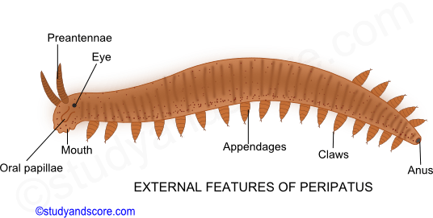

**Annelidan characteristics**

1. Vermiform body with truncated extremities
2. Absence of true head
3. Dermo-muscular body wall consisting of flexible cuticle with underlying circular and longitudinal muscles.
4. Locomotion is slow and by peristalsis as in case of earthworm.
5. Structure of eyes is simple as in case of polychaetes.
6. Unjointed, hollow, stumpy appendages like the parapodia of polychaetes.
7. Simple, straight alimentary canal with terminal mouth and anus.
8. Segmentally arranged paired nephridia.
9. Similar excretory glands
10. Presence of cilia in excretory and reproductive ducts

**Arthropodan characteristics**

1. Presence of antennae
2. Jaws are modified appendages provided with striped muscles.
3. Locomotion by definite legs with well-defined musculature and claws
4. Cuticle with thin deposit of chitin like arthropods
5. Body cavity is haemocoel
6. Coelom is reduced to small cavities arranged around gonads and metabephridia
7. Peculiar salivary glands
8. Dorsal tubular heart
9. Presence of tracheal respiratory system
10. Large and typically arthropod like brain
11. General structure of the reproductive organs resemble arthropods

**Onychophoran characteristics**

1. Body shows no or indistinct external segmentation
2. Skin has rough cuticle covered with numerous velvety processes not known in other phyla
3. Antennae not homologous to the antennae of Arthropoda
4. Three segmented head which is a condition midway between Annelida and Arthropoda
5. Restriction of jaws to single pair.
6. Irregular distribution of the spiracles of the tracheal openings
7. Two ventral widely separated nerve chords and no true ganglia
8. Structure of eyes is less complicated
9. Distribution of reproductive organs.

**Molluscan characteristics**

Peripatus was previously included in the phylum Mollusca due to its slug-like appearance of body and ladder like nervous system. But these characters are only superficial resemblances.

**Systemic position of the Phylum Onychophora**

Onychophora has the characters of both Phylum Annelida and Phylum Arthropoda. Therefore, they are regarded as the intermediate stage or the connecting link between Annelida and Arthropoda. However, they appear to be more closely allied to arthropods than to annelids and have arisen as an offshoot from the base of arthropod line.

Based on such phylogenetic considerations, Manton and many other Zoologists have included Onychophorans as a class in Arthropoda. But, lack of exoskeleton, joined limbs and presence of Annelidan characters in Onychophora created a serious problem.

Many others claim that Peripatus is definitely an annelid. In fact Onychophorans are neither worms nor arthropods but have distinct characters of their own. Hence, Onychophora is now-a-days treated as a separate phylum.

**STATUS OF HEMICHORDATA**

Hemichordata was till recently treated as the sub phylum of the phylum Chordata but is now regarded to be the independent phylum of invertebrates very close to the phylum Echinodermata. The peculiar characteristics of the animals belonging to Hemichordata are as follows,

* Enterocoelous coelom
* Pharyngeal gill slits
* Buccal diverticulum (earlier considered as notochord)
* Vermiform body divisible into three regions – proboscis, collar, trunk

The phylum hemichordata includes a small group of soft, primitive and marine chordates called as acron worms or tongue worms. Most familiar genus of this phylum is Balanoglossus which belongs to the class Enteropneusta. Other closely related genera are Saccoglossus, Glossobalanus etc.

The class Enteropneusta was established by Gegenbaur in 1870. Since then due to the peculiar anatomical organisation and embryology, Hemichordata have been considered closer to chordata as well as non-chordate phyla by different workers from time to time. The phylogenetic relationship and the taxonomic position of hemichordate are given below:

**Affinities with Chordata**

Zoologists proposed closer affinities between the phylum Chordata and Hemichordata. Their resemblance was based on the presence of three fundamental characteristics of Chordates in hemichordates,

* Notochord
* Dorsal hollow nerve chord
* Pharyngeal gill slits

Moreover the structure and functions of pharyngeal and branchial apparatus of Hemichordates is similar to that of Cephalochordates and Urochordates. Also the origin of coelom is enterocoelous type in the form of five pouches from the archenteron as in Brachiostoma. Due to all the above stated similarities Hemichordata was considered as sub-phylum of the phylum Chordata till recently.

**Objections:**

Following are the objections which lead the establishment of Hemichordata as a separate phylum.

1. A true notochord does not exist in hemichordata. Unlike the notochord of Chordates, the so called notochord of hemichordates is very short, confined to proboscis and without any supporting function. Instead of being solid and made up of vacuolated cells, it is hollow and made up of epithelial cells. Instead of being called notochord, it is now referred to as Stomochord by Bateson and as buccal diverticulum by Hyman.

2. The nervous system is distinctly of invertebrate type being intra-epidermal in position and having a ventral nerve cord and circumcentric nerve ring which are absent in chordates.

3. Gill slits in hemichordates are numerous and dorsal in position where as they are 5 to 7 and laterally positioned in chordates.

**Affinities with Rhynchocephala**

Some workers linked Hemichordata with Rhynchocephala as the feeding and borrowing habits are similar in both. Body in both is elongated, vermiform, without external metamerism, with terminal anus, with smooth skin and metamerically arranged simple gonads.

**Objections:**

1. But Rhynchocephalis differ in lacking a dorsal nerve chord and having lateral nerve chord.

**Affinities with Phoronida**

Some Zoologists advocated relation between hemichordata and Phoronida due to similar nature of epidermal nervous system and paired gastric diverticula. The larval forms of both show some similarities and both have great power of regeneration.

**Objections:**

1. But Phoronida differ in lacking Pharyngeal gill slits. More over Phoronida had paired metanephridia which are absent in hemichordata.

**Affinities with Pogonophora**

Some Zoologists tried to relate hemichordata with Pogonophora due to similarities in the formation of enterocoelous coelom, division of body and coelom into three regions, intra epidermal nervous system and gonads.

**Objections:**

1. But Pogonophores differ in having protocoelic nephridial coelomoducts and lacking alimentary canal. Moreover the nervous system is concentrated in protostome in pogonophores whereas in hemichordates it is concentrated in mesosome.

**Affinities with Annelida**

Some zoologists drew relationship between hemichordata and Annelida due to similarities in vermiform body and coelom, burrowing habits, ingesting mud which is passes out as castings through anus, arrangement of blood vessels with blood flowing anteriorly in dorsal vessel and posteriorly in ventral vessel, dorsal position of heart.

**Objections:**

1. But annelids differ in lacking pharyngeal gill slits, stomochord and dorsal tubular nerve chord. Hemichordates do not have double ventral nerve chord and nephridia as in annelids.

**Affinities with Echinodermata**

The following are the resemblances of the adult hemichordates and echinoderms:

* Echinoderms and hemichordates are similar in having enterocoelus coelom which is divided into three different parts filled with sea water to serve hydraulic mechanism.
* Hearth vesicle and glomerulus of hemichordates are considered homologous to dorsal sac and axial gland of echinoderms.
* Both have common habits, ecological niches and remarkable power of regeneration.

The following are the resemblances of the larval hemichordates and echinoderms.

* Larvae of both groups are small, pelagic, transparent and  oval
* Similarity in the development of the coelom
* Blastopore becomes anus and digestive tract is complete with mouth, anus and same parts.

**Objections:**

1. But Echinoderm larvae differ in lacking apical plate with sensory hair, eye spots and telotroch. Protocoel is single in hemichordate larva and paired in echinoderm larva.

**Systemic position of hemichordata**

Peculiar anatomical organisation of hemichordata makes their phylogenetic position uncertain and controversial. Earlier workers placed hemichordates as a sub phylum under the phylum Chordata. But the only chordate feature shown by them is the presence of pharyngeal gill slits. Therefore, some recent workers like Van der Host, Marcus etc. have chosen to remove them as the sub phylum of phylum Chordata and treat them as an independent invertebrate phylum.

Since the hemichordate group consists of only 80 species, it is included in the category of minor phylum. The name Hemichordata suggests that they are half chordates.

The close affinities of Hemichordata with Echinodermata, Annelida, Pogonophora, Phoronida have led to the conclusion that they have arisen from a common ancestral stock. But many workers like Marcus, Berril and Hyman do not contribute to this view.

According to Barrington, Echinodermata deviated greatly from the line of ancestral stock and formed a blind branch. Even hemichordata did not stand on the direct main line of chordate evolution. Hemichordates arose from the ancestral line after divergence of the ancient echinoderms but before the rise of true chordates and hence they are often called as pre-chordates.

**PHYLUM PROTOZOA - LOCOMOTION**

**Protozoan movement in water**

Protozoans in water are subjected to forces of water resistance like pressure drag and viscous drag. Pressure drag is due to the difference of pressure between two ends of the body. Viscous drag is due to the water molecules attached to the surface of the body.

For protozoans which are small in size, viscous drag is of much importance. These organisms are not streamlined to minimize the pressure drag.

**Locomotory Organs in Protozoa**

Locomotion is the movement of the animals from place to place. It is performed in search of food, mate, and shelter or to escape from predators etc. it is influenced by external and internal stimuli.

Protozoans are very primitive, single celled animals which show great adaptability in their locomotion. They exhibit slowest locomotion like amoeboid locomotion and also the fastest locomotion like ciliary locomotion.

In protozoans, locomotion is brought about by

* Cellular extensions like **Pseudopodia** (Eg: Amoeba)
* Pellicular contractile structures like **Myonemes** (Eg: Euglena and Sporozoans)
* Locomotory organelles like **Flagella** (Eg: Euglena) and **Cilia** (Eg: Paramoecium)

**PSEUDOPODIA (CELLULAR EXTENSION)**

They are also known as false feet. These are the temporary outgrowths of the cell. They are formed on the surface of the body by the movement of the cytoplasm.

**Depending on number of pseudopodia formed on the surface:**

**Polypodia**- Several pseudopodia formed on the surface of the body.

Eg: *Amoeba proteus*

**Monopodia**- Only single pseudopodia is formed on the surface of the body.

Eg: *Entamoeba histolytica*

**Depending on the structure of the pseudopodia:**

**Lobopodia**: These are lobe like and blunt structures with broad and rounded ends. These structures composed of endoplasm and ectoplasm. Lobopodia move by pressure flow mechanism.

Eg: *Amoeba proteus, Entamoeba histolytica*

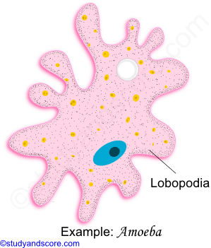

**Filopodia:** These are slender filamentous pseudopodia tapering from base to tip. Sometimes these may be branched out but they are not fused to form a network. They are composed of only ectoplasm.

Eg: *Euglypha, Lecithium*

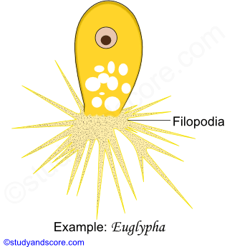

**Reticulopodia**: They are also known as rhizopodia or myxopodia. They are filamentous, profusely interconnected and branched. They form a network. The primary function of these pseudopodia in ingestion of food and the secondary function is locomotion. They exhibit two way flow of the cytoplasm. They are commonly found in foraminifers.

Eg: *Elphidium, Globigerina*

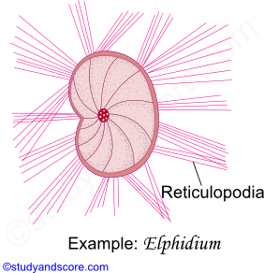

**Axopodia**: These are fine needle like, straight pseudopodia radiating from the surface of the body. Each Axopodia contain a central axial rod which is covered by granular and adhesive cytoplasm. The main function of these axopodia is food collection. Axopodia also exhibit two-way flow of cytoplasm. Axopodia are mainly found in Heliozoans and radiolarians.

Eg: *Actinosphaerium, Actinophrys, Collozoum*

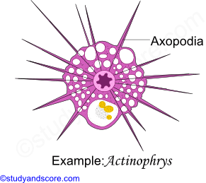

**MYONEMES (PELLICULAR CONTRACTILE EXTENSIONS)**

Many protozoans have contractile structures in the pellicle or ectoplasm called as myonemes. These may be in the form of,

*\* Ridges or grooves (Eg: Euglena)*

* Contractile myofibrils (Eg: Larger ciliates)

* Microtubules (Eg: *Trypanosoma*)

**FLAGELLUM (LOCOMOTORY ORGANELLES)**

Flagella are the locomotory organelles of flagellate mastigophoran protozoans. They are mostly thread like projection on the cell surface. A typical flagellum consists of an elongated, stiff axial fiber called as axial filament or axoneme enclosed by an outer sheath. The axoneme arises from basal granule called as blepharoplast or kinetosome which is further derived from Centrioles. Blepharoplast lies below the cell surface in the ectoplasm. The region around blepharoplast is called microtubular organizing center that controls the assembly of microtubules.

When the axial filament is viewed under an electron microscope 9 + 2 arrangement can be observed. The 2 central longitudinal fibers are enclosed by membranous inner sheath. The 2 central longitudinal fibers are surrounded by 9 longitudinal peripheral doublets (each with microtubules A and B) which form a cylinder between the inner and the outer sheath. Each peripheral paired fiber is connected to the internal membranous sheath by radial spokes.

Each peripheral doublet also has pairs of arms directed towards neighboring doublet. These arms are made of the protein called as dynein. The arms create the sliding force. The peripheral doublets are surrounded by an outer membranous sheath called as protoplasmic sheath, which is an extension of the plasma membrane. Some flagella also bear lateral appendages called as flimmers or mastigonemes along the length of the axoneme above the level of the pellicle.

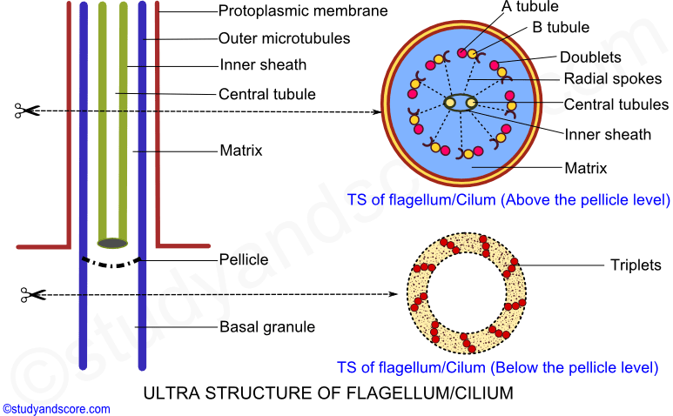

**Types of Flagella**

Number and arrangement of flagella vary in Mastigophora from one to eight or more. Free living species usually have one to eight flagella whereas the parasitic forms may have one to many flagella. Flagella are classified based on the arrangement of lateral appendages and the nature of the axial filament.

**Stichonematic**: Only one row of lateral appendages occurs on the axoneme up to tip.

Eg:*Euglena, Astasia*

**Pantonematic**: Two or more rows of lateral appendages occur on the axoneme

Eg: *Peranema, Monas*

**Acronematic**: Lateral appendages are absent and axoneme ends as a terminal ‘naked’ axial filament

Eg: *Chlamydomonas, Polytoma*

**Pantacronematic**: Flagellum is provided with two or more rows of lateral appendages and the axoneme ends in a terminal naked axial filament.

Eg: *Urceolus*

**Anematic**: In some cases the flagella is simple without any lateral appendages and a terminal naked filament.

Eg: *Chilomonas, Cryptomonas*

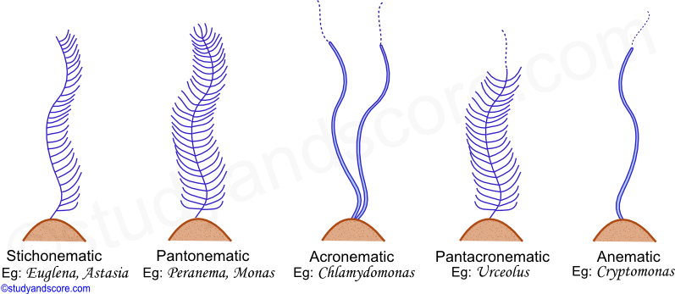

**CILIA (LOCOMOTORY ORGANELLES)**

Cilia are short hair like structures present all over the surface of the body. They may be also confined to specific regions of the ciliate protozoan. Cilia help in locomotion as well as in food collection.

Cilia greatly resemble the flagella in the basic structure. The major difference between the flagella and the cilia is that cilia are smaller compared to the flagella. Cilia arise from the kinetosome. Cilia consist of an axial filament called as axoneme surrounded by the protoplasmic outer sheath.

Electron microscopic studies of axoneme reveal 9 + 2 organization of the peripheral doublet fibrils and central singlet fibrils. The details of the 9 + 2 organization and the presence of the dynein arms are similar to that of the flagellum. All these fibrils are embedded in a matrix. The central fibrils are enclosed within a delicate sheath.

The infraciliary system is located just beneath the pellicle. It consists of kinetosomes at the bases of cilia, kinetodesmos or kinetodesmal fibrils that are connected to the kinetosomes and running along the right side of each row of kinetosomes as cord of fibers known as kinetodesmata. A longitudinal row of kinetosomes, kinetodesmal fibrils and their kinetodesmata form a unit called kinety. All the kineties together form an infraciliary system that lies in the ectoplasm. The infraciliary system is connected to the motorium, a neuromotor center neat the cytopharynx and forms the neuromotor system. This neuromotor system controls and coordinates the movement of cilia.

**Types of cilia**

* In some primitive forms like holotrichs (Eg: *Paramecium*) cilia are present all over the body

* In some forms like peritrichs (Eg: *Vorticella*) cilia are present only in the peristomial region

* In Suctorians (Eg: *Acineta*) cilia are present in only in the young ones which are later replaced by sucking tentacles in the adults

**Differences between Flagella and cilia**

| **Flagella** | **Cilia** |
| --- | --- |
| They may be one to four in number. Mor than four flagella are present in mastigophoran parasites | Generally cilia are more in number compared to flagella. Cilia vary from 3,000 to 14,000 in number |
| A flagellum is about 150 microns in length | A cilium is about 5 to 10 microns in length |
| Flagella are commonly found at one end of the cell | Cilia occur either all over the body surface or at specific regions of the cell |
| Flagella produce undular movement | Cilia produce pendular movement |
| Flagella help in locomotion only | Cilia help both in feeding and in locomotion |
| Flagella do not form compound organelles | Cilia may form undulation membranes and other compound ciliary organelles |

**Compound ciliary organelles**

* Cilia in compound ciliary organelles do not fuse, but their basal granules are sufficiently close to introduce a sort of coupling.

* A group of cilia that forms a bundle is called as cirrus. An undulating membrane is a row of adhering cilia forming long sheet.

* The smaller rows of adhering cilia form the membranelles

**METHOD OF LOCOMOTION**

Basically there are four known methods by which the protozoans move

1. Amoeboid movement

2. Swimming movement

3. Gliding movement

4. Metabolic movement

**AMOEBOID MOVEMENT**

This type of locomotion is also called as pseudopodial locomotion. Here locomotion is brought about by the pseudopodia. It is the characteristic of rhizopod protozoans like *Amoeba proteus* and *Entamoeba histolytica.* Also such movement is exhibited by amoeboid cells, macrophages and phagocytic leucocytes like monocytes and neutrophils of metazoans. Various theories have been proposed to explain the amoeboid locomotion.

|  |  |
| --- | --- |
| **Name of theory** | **Proposed by** |
| Contraction theory | Schultuz |
| Walking theory | Dellinger |
| Rolling movement theory | Jenning |
| Surface tension theory | Berthold |
| Adhesion theory | Jenning |
| Fountain zone theory | Allen |
| Folding and unfolding theory | Goldacre and Lorch |
| Hydraulic pressure theory | Renoldi and Jaun |
| Sol-gel theory | Hyman |

**Sol Gel theory**

Sol Gel theory convincingly explains the mechanism involved in the formation of pseudopodia. This theory, also known as Change in viscosity theory was advocated by Hyman. Later Pantin and Mast explained this theory. According to this theory, the cytoplasm of amoeba can be distinguished into outer ectoplasm/Plasmagel and the inner endoplasm/Plasmosol.

The plasmagel which forms the outer layer of the cytoplasm is thick, less in quantity, non-granular, transparent and contractile. The plasmosol which forms the inner layer of the cytoplasm is more in quantity, less viscous, fluid like, more granular and opaque. Due to change in the viscosity, the plasmagel and plasmosol inter-convert and consequently the pseudopodia form and disappear causing the movement of Amoeba.

This inter-convertibility of plasmagel and plasmosol is physicochemical change. Gel becomes sol by taking water and sol becomes gel by losing water.

Amoeboid locomotion can be explained in the following steps:

**Step 1:**Initially Amoeba attaches itself to the solid substratum by the plasmalemma at the temporary anterior end.

**Step 2:** Then the hyaline layer of the ectoplasm at the anterior end forms a thickened hyaline cap. It is the first stage in the formation of the pseudopodium.

**Step 3:** Behind the hyaline cap, a point of weakness in the elasticity of plasmagel is formed. Hence the inner plasmosol flows forward, forming a pseudopodium.

**Step 4:** The plasmosol that flows outward behind the hyaline cap changes its colloidal state from sol to gel and joins the ectoplasm.

**Step 5:** The outer region of the plasmosol, which is flowing forward undergoes gelation and produces a rigid plasmagel tube. The gelation of plasmosol extends the plasmagel tube forward.

**Step 6:** Two ends appear in Amoeba at this stage. The anterior end is smooth with the rounded surface which the retractile end also called as Uroid has a wrinkled surface.

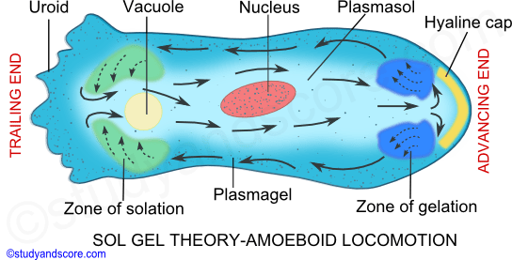

**Step 7:** Around the region of the hyaline cap, an annular region of sol to gel transformation is formed. It is called the zone of gelation. At the uroid end a region where gel transforms into sol is called as zone of solation.

**Step 8:** Plasmagel at the uroid end changes into sol and flows forward continuously through the gelatinized tube. As the plasmosol flows forward, the pseudopodium elongates further and the body of amoeba moves in that direction. The ectoplasm does not move but grows at the leading tip and is broken down at the uroid end.

**Step 9:** The gelation at the advancing end and the solation at the trailing end occur simultaneously and at the same rate thus making the forward movement of amoeba continuous.

**Step 10:** The contraction of the plasmagel at the trailing end causes hydraulic pressure on the sol and makes the plasmosol flow forward continuously in the plasmagel tube.

**Step 11:** As the pseudopodium advances continuously in the direction of the movement the body of amoeba also moves.

**Basis of action of protein molecules: Sol gel theory**

Amoeboid locomotion is brought about by the protein molecules (actin and myosin) present in the cytoplasm. Goldacre and Lorsch explained the phenomenon of gelation and solation based on the folding and unfolding of these protein molecules. According to them, the cytoplasm gelates when the protein molecules unfold by losing water and the cytoplasm solates when the protein molecules folds by absorbing water.

Hence, the proteins in the plasmosol are in folded state and the proteins in the plasmagel are in the unfolded state. This folding and unfolding of the protein molecules lead to the formation of the pseudopodia and thus the amoeboid movement. The energy required for this process is made available from the ATP.

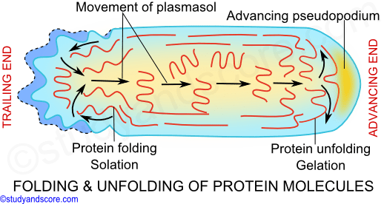

According to the foundation zone theory put forth by Allen, the plasmosol flows forward due to the pulling force caused by the sliding action of the actin molecules over the myosin molecules at the advancing end.

This interconvertibility of sol and gel is mainly due to the assembly and disassembly of actin filaments. Assembly results in gel formation and the disassembly leads to the sol formation.

**METABOLIC MOVEMENT**

In protozoans a pellicle is present in the ectoplasm which is composed of proteinaceous strips supported by dorsal and ventral microtubules. In many protozoans these protein strips can slide past one another, causing wriggling motion. This wriggling motion is called as metaboly or metabolic movement. This movement is mainly caused by the change in the shape of the body.

This metabolic movement is observed in most of the sporozoans at certain stages of life cycle. These kinds of movement are also referred to as Gregarine movements as this movement is the characteristic of most of the gregarines.

**SWIMMING MOVEMENT**

Swimming locomotion in protozoans is caused by the flagella and cilia. Flagella bring about the movement of some parasites in the body fluids of the hosts. As the movement in this case is caused by the beating flagella and cilia are also known as undulipodia.

Depending on the structure involved swimming movement can be of two types namely,

**\*** Flagellar movement

**\*** Ciliary movement

**Type 1 swimming movement: Flagellar movement**

A flagellum pushes the fluid medium at right angles to the surface of its attachment, by its bending movement. The bending movement of flagellum is made by the sliding of microtubules past each other with the help of dynein arms. The dynein arms show a complex cycle of movement with the energy provided by ATP. These dynein arms attach to the outer microtubule of an adjacent doublet and pull the neighbouring doublet. As the result the doublets slide past each other in opposite direction. The arms release and attach a little farther on the adjacent doublet and again pull the neighbouring doublet.

The doublets of the flagellum are physically held in place by the radial spokes and thus the doublets cannot slide past much and their sliding is limited by the radial spokes. Instead the doublets can curve causing a bend in the flagellum and this bending has an important role in the flagellar movement. Flagellum shows the following movements,

**Undulation movement:** Undulation from the base to the tip causes pushing force and pushes the organism backwards. Similarly undulation from the tip to the base causes pulling force and causes the organism to pull forward. Also when the flagellum ends to one side and shows wave like movement from base to tip the organism moves in laterally in opposite direction. Finally when the undulation is spiral, it causes rotation of the organism in the opposite direction and this is called as gyration.

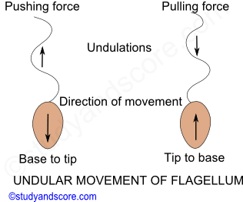

**Sidewise lash movement:** The flagellar movement of many organisms is a paddle-like beat or sidewise lash consisting of strokes namely effective stroke and recovery stroke.

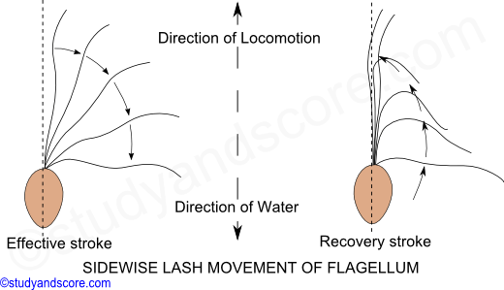

**Effective stroke**- During effective stroke the flagellum becomes rigid and starts bending against the water. This beating in water at right angles to the longitudinal axis of the body causes the organism to move forward.

**Recovery stroke**- During recovery stroke, the flagellum becomes comparatively soft and will be less resistant to the water. This helps the flagellum move backwards and then to the original position.

**Simple conical gyration movement:** In this kind of movement the flagellum turns like a screw. This propelling action pulls the organism forward through the water with a spiral rotation around the axis of movement and gyration on its own.

**Type 2 swimming movement: Ciliary movement**

Just like the flagellum, the cilium also shows back and forth movements during the locomotion. These back and forth movements of the cilia are also called as effective and recovery strokes respectively. Cilium moves just like a pendulum or a paddle. The cilium moves the water parallel to the surface of its attachment like that of paddle stroke movement. The movement of water is perpendicular to the longitudinal axis of cilium.

**Effective stroke:** During effective stroke, the cilium bends and beats against water thus bringing the body forward and sending the water backwards.

**Recovery stroke:** During recovery stroke, the cilium comes back to original position by its backward movement without any resistance.

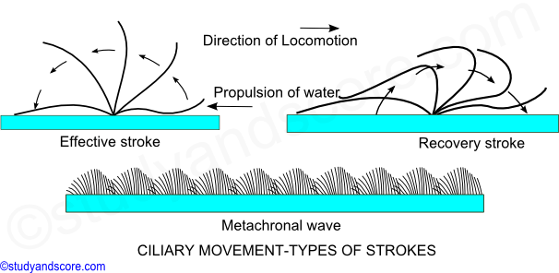

Cilia shows two types of coordinated rhythms:

**\*** Synchronous rhythm, where in the cilia beast simultaneously in a transverse row.

**\*** Metachronous rhythm, where in cilia beat one after another in a longitudinal row. The metachronal waves pass from anterior to posterior end.

The beating of the cilia can be reversed to move backwards when a Paramoecium encounters any undesirable object in its path. The ciliary movement is coordinated by infraciliary system though neuromotor center called as motorium present near the cytopharynx in the ciliates like Paramoecium. The infraciliary system together with motorium form neuromotor system which helps in coordination of the beating of the cilia. Ciliary movement is the fastest locomotion in protozoans.

**GLIDING MOVEMENT**

The zigzag movement in the protozoans brought about by the contraction and relaxation of myonemes present below the pellicle in the ectoplasm is called as the gliding movement. The movement by gliding is comparatively small. Myonemes are the contractile fibrils which are similar to the myofibrils. This kind of gliding movement is shown by flagellates, Sporozoans, Cnidospora and some ciliates.

**NUTRITION IN PROTOZOA**

Protozoa obtain nutrition in many ways. Some synthesize their own food other get it synthesized by algae living in their cytoplasm and still others capture the food. Some Protozoa lead a parasitic life, usually doing no harm or very little harm to their hosts but occasionally cause serious diseases.

All types of nutrition are found in protozoa namely holophytic nutrition, holozoic nutrition, saprozoic nutrition, mixotrophic nutrition and parasitic nutrition. Their modes of nutrition are as follows:

**Holophytic nutrition:** The phytoflagellates possess chloroplasts and chromatophores to synthesize their food by photosynthesis. They utilize sunlight, carbon dioxide and water as raw materials. This method of self-feeding is referred to as Autotrophic phototrophy. The dextrose sugar paramylon synthesized is characteristic of euglenoid flagellates.

**Holozoic nutrition:** Most of the Protozoa derive nutrition by ingesting other organisms. This mode of nutrition is said to be holozoic. It involves development of organelles for food capture, ingestion, digestion, assimilation and egestion of undigested food materials. They capture their food by flagella, pseudopodia and trichites.

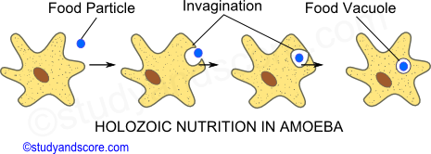

Some use axopodia, reticulopodia and tentacles to pull the prey that comes within their reach. In ciliates the ciliary oral apparatus is well developed for food capturing and driving it towards mouth or cytosome and then pushing it into the cytopharynx.

**Pinocytosis:** This method also called as cell drinking involves ingestion of liquid food by invagination through the surface of the body. The pinocytosis channels are formed at some parts of the body, which enclose the fluid from the surrounding medium. The lower ends of these channels are pinched as food vacuoles into the endoplasm. Pinocytosis is only induced by certain active substances in the medium surrounding the cell.  High molecular compounds from the external medium are absorbed by this method.

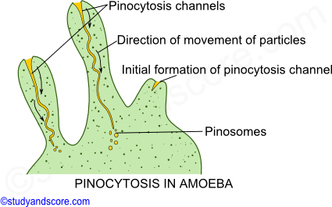

**Saprozoic nutrition:** This involves the absorption of food by osmosis, through the general body surface. So this method is referred as osmotrophy. The food mainly is the dead organic matter rendered so by the decomposing bacteria. This kind of nutrition is found in *Mastigamoeba* and also some of the colorless flagellates.

Suctorians feed on other ciliates with the help of their tentacles which have funnel ends. Each tentacle consists of a rounded rigid central tube. As soon as the prey is attached, the tentacles tips paralyses the prey with some hypnotoxin and gradually suck the body fluids with the central tubes.

**Myxotrophic nutrition:** This is a combination of more than one mode of nutrition. Many protozoa using photosynthesis as a means also take in some part of their diet in dissolved form by osmotrophy or solid form by phagocytosis. The best examples of this kind of nutrition are flagellates like *Euglena* and *Peranema*.

**Nutrition of parasitic protozoa:** The mechanisms used by parasitic protozoa are almost are similar to that of their non-parasitic protozoa.  Parasites inhabiting the intestine and blood have a distinct mouth through which food particles are ingested through the process of phagotrophy. The osmotrophic forms of protozoa are either coelozoic or histozoic. The coelozoic forms absorb their food by their cell surface. The histozoic forms feed on the substances by osmotrophy. Parasitic saprozoic forms may also directly use the serum of their host blood.

**PARASITISM IN PROTOZOA**

Parasites are the species which live at the expense of certain other species. The other animals on which the parasites live are called as hosts. The parasites are biologically and economically closely connected with the hosts throughout their life time. Hence parasitism can be defined as an association between the parasites and their hosts. Almost all the protozoan groups have parasitic species and the group Sporozoa is exclusively parasitic.

**Types of parasites**

**Ectoparasites:** These are the parasites which inhabit the external surface of their hosts.

Eg: *Hydramoeba hydrozena* feeding on the ectodermal cells of hydra,

       Icthyopthirius multifilis burying in the epidermis of freshwater fishes

**Endoparasites:** These are the parasites which inhabit the internal surfaces of their hosts. They may be further subdivided into the following types,

* The parasites which dwell in the lumen of the alimentary canal of the host.

Eg: *Entamoeba histolytica, Giardia lamblia, Isospora hominis, Balantidium coli*

* The parasites which reside in the mouth cavity of hosts.

Eg: *Trichomonas tenax, Entamoeba gingivalis*

* The parasites which inhabit the genital tract of the hosts.

Eg: *Trichomonas vaginalis*

* The parasites which live within the tissues of hosts. These may enter the host tissues through the skin or even from the digestive tract.

Eg: *Trypanosoma, Plasmodium, Leishmania, Babesia*

**Hyperparasites**: These are the protozoans which parasitize other parasitic protozoans. In other words these are parasites on parasites.

Eg: *Zelleriella, Nosema notabilis, Sphaerospora polymorpha*

**Pathogenic parasites:** Generally the parasitic protozoans are not always pathogenic but sometimes these parasites are pathogenic and can cause grave diseases in humans and other animals. These parasites which are causing disease are called as pathogenic parasites.

Eg: *Leishmania donovani, Plasmodium vivax, Trypanosoma gambiense*

**Host specificity**

The protozoan parasites are generally host specific and in this regard two trends are seen.

* Firstly, some of the parasites like Trypanosome, Entamoeba and Eimeria successfully parasitize wide range of hosts.
* Secondly, some parasites like Plasmodium restrict themselves only to few specific hosts.

**Transmission**

Protozoan parasites are transmitted by various ways to their hosts. The following are the few examples of various ways used by the protozoan parasites to reach their hosts,

| **Protozoan parasite** | **Transmssion type** | **Transmission method** |
| --- | --- | --- |
| *Entamoeba gingivalis* | Direct transfer | By mechanical contact like kissing. |
| *Entamoeba histolytica* | Contaminative transfer | By cysts in contaminated food or water |
| *Trypanosoma sps.* | Inoculative transfer | By invertebrate vectors |
| *Plasmodium sps.* | Inoculative transfer | By invertebrate vectors |
| *Babesia sps.* | Congenital transfer | By invasion of ovary or eggs |
| *Eimeria tenella* | Contaminative transfer | By cysts in contaminated food or water |

**Life cycle of the protozoan parasites**

Many of the protozoan parasites have single host throughout their life cycle and only a part of the life is spent outside the host. These parasites with only one host in their life cycle are called as monogenetic parasites. For example, Eimeria and Monocystis

Many other protozoan parasites have two or more hosts through their life cycle. These two hosts included in the life cycle of the protozoan parasite belong to separate animal groups. The two hosts are designated as primary host or definitive host, in which the ancestors of the parasite have evolved. The other host is called as secondary host or vector or intermediate host. This vector acts as the transmitting agent for the parasite. These parasites with more than two hosts in their life cycle are called as digenetic parasites. For example, Trypanosoma and Plasmodium

Sometimes a reservoir host can harbor a pathogen indefinitely with no ill effects. A single reservoir host may be reinfected several times.

If the parasite undergoes part of its life cycle in vector, then its transmission is called as cyclical. If the parasite does not undergo part of its life cycle in vector, then its transmission is called as mechanical transmission.

**Effects of protozoan parasites on their hosts**

The parasites can bring about several changes within their hosts. Some parasites can also prove to be injurious to the host, while others may produce no effect on the host. The following are the few examples,

* *Entamoeba histolytica* destroys the large intestine of the host and this in turn causes ulcerations.
* *Eimeria stiedae* causes hyperplasia of the liver cells of rabbits.
* *Polymnia nebulosa* which is a parasite of earth worm brings about hypertrophy of the sperm mother cells.
* *Plasmodium gallinaceum* which is malarial parasite of bird clogs fine blood capillaries

**EVOLUTION OF SEX**

In sexually reproducing population only 50% individuals produce offspring, while the rest half just contribute their genes, thus reducing the reproductive capacity, whereas in asexuals all individuals produce offsprings with no apparent help from others. Asexual reproduction saves energy and time.

**Basic steps in the origin of sexual selection in Protozoa**

There was asexual reproduction in the beginning which was fast and simple but had its disadvantages as it produced clones and could not get rid of harmful effects of mutation.

* Meiosis evolved to reduce the no. of chromosomes to half.
* Isogamy produced similar and equal sized gametes.
* Different mating types originated.
* Anisogamy to some extent tried to solve the problem of cell fusion.
* Large number of mating types was reduced to two.
* Larger gametes specialized in the storage of nutrients and development of embryo.
* Larger gametes could now be produced in small numbers.
* Larger gametes being in small numbers became limiting resource, triggering competition.
* Individuals producing larger gametes were called females.

**Evolution of Sex in Protozoa**

Early protozoan probably reproduced by asexual means such as binary fission, multiple fission, budding etc. as these methods were quick, had lesser energy demands and all individuals participated in producing offspring.

Asexual reproduction was best suited to animals which had delicate bodies and no apparent defense system and, therefore, must have needed a speedy way of multiplication for the recovery of population. Gametogenesis in protozoan is variable and can be classified in the following three forms:

* The protozoa in which adult (trophozoite stage) is haploid.
* Those protozoa in which adult stage is diploid.
* In ciliates gametic nuclei rather than gametes are formed.

Haploid protozoan such as sporozoans, Elphidium etc., perhaps evolved when diploid individuals produced gametes.

Paramecium adults produce gametes by meiosis and then by mitosis.

Conjugation is a perfect sexual process in which exchange of genetic material takes place.

In sporozoans and some other protozoans, haploid adults are formed and whole individual behaves like a gamete.

In Elphidium, Volvox and mycetozoa, biflagellate isogametes are formed.

Sexual reproduction rejuvenates protozoan populations instantly.

**SEXUAL REPRODUCTION IN PROTOZOANS**

Reproduction is an important life process to produce young ones of the same kind. As single celled organisms protozoans lack special reproductive structures like gonads. Protozoans reproduce both by asexual and sexual reproduction. Out of these two, asexual reproduction is common. In some of the protozoans asexual reproduction is the only mode of reproduction.

Sexual reproduction takes place by fusion of pronuclei with the formation of gametes or without the formation of the gametes. There are numerous chances of genetic recombination in sexual reproduction. This genetic recombination occurs during the formation of pronuclei and during the fusion. Unlike asexual reproduction, sexual reproduction is induced by the unfavorable conditions. Sexual reproduction in protozoans occur by the following methods,

**Syngamy**

It is the fusion of the pronuclei of two gametes. This is a complete fusion of the two sex cells resulting in the formation of the zygote. The fusion nucleus of the zygote is called as synkaryon. Depending on the degree of differentiation displayed by the fusing gametes syngamy is of following types:

**A) Autogamy**: This is the fusion of the gametes derived from the same parent cell. For example, in *Actinophrys* during sexual reproduction, the pseudopodia are withdrawn and a cyst is formed. Now a meiotic division takes place and two daughter nuclei with half the number of chromosomes are formed. No cell division takes place but after sometime, gametic nuclei fuse to form a zygote nucleus.

**B) Hologamy**: In this type of reproduction, the two mature protozoan individuals themselves behave as gametes and fuse together to form zygote. Hologamy occurs in few species of Sarcodina and Mastigophora. (Ex: *Copromonas*)

**C) Isogamy**: When the two fusing gametes are similar in size and shape but different in behaviour they are called as isogametes. The fusion of the isogametes is called as isogamy.  Isogametes are generally produced by multiple fissions. Isogamy is common in few species of Foraminifera (Ex: *Elphidium*), Gergarinia (Ex: *Monocystis*) and Phytomonatida (Ex: *Chlamydomonas*).

**D) Anisogamy**: When the two fusing gametes differ morphologically as well as in terms of behaviour they are called as anisogametes. Generally small and motile gametes are male or microgametes whereas the large and non-motile gametes are female or macrogametes. The fusion of two such anisogametes is called as anisogamy. This mode of reproduction is seen in Sporozoa (Ex: *Plasmodium*), Phytomonatida (Ex: *Volvox*)

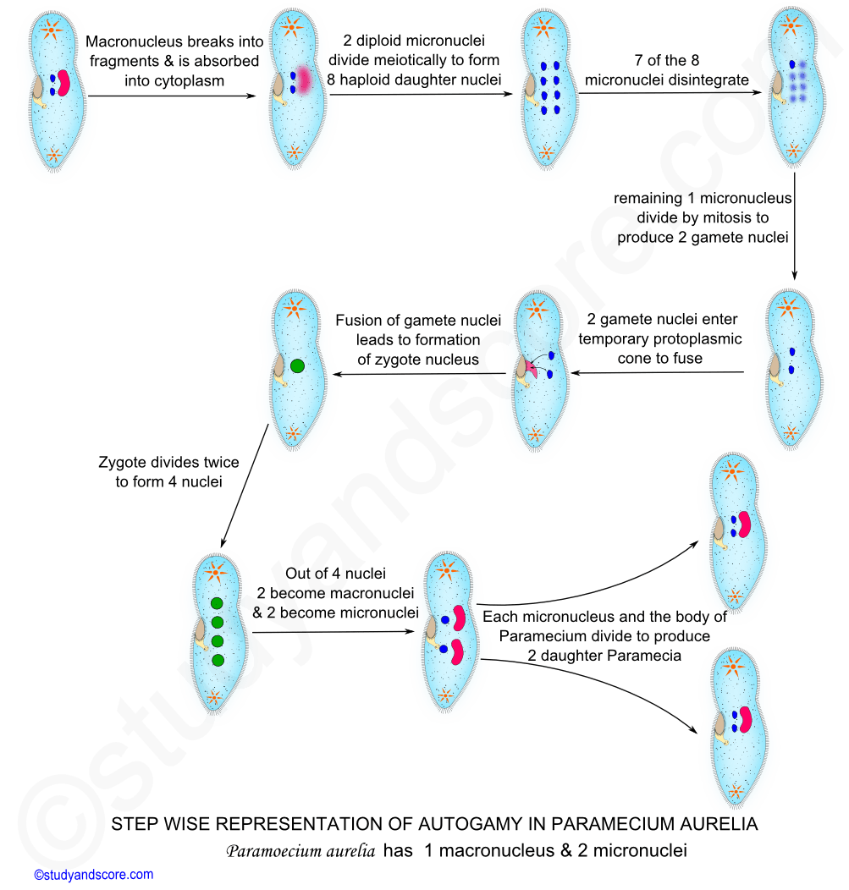

**Conjugation**

It involves temporary fusion of two individuals called as conjugants at the oral or buccal regions. This type of reproduction is the characteristic of the suctorians and holotrich ciliates.

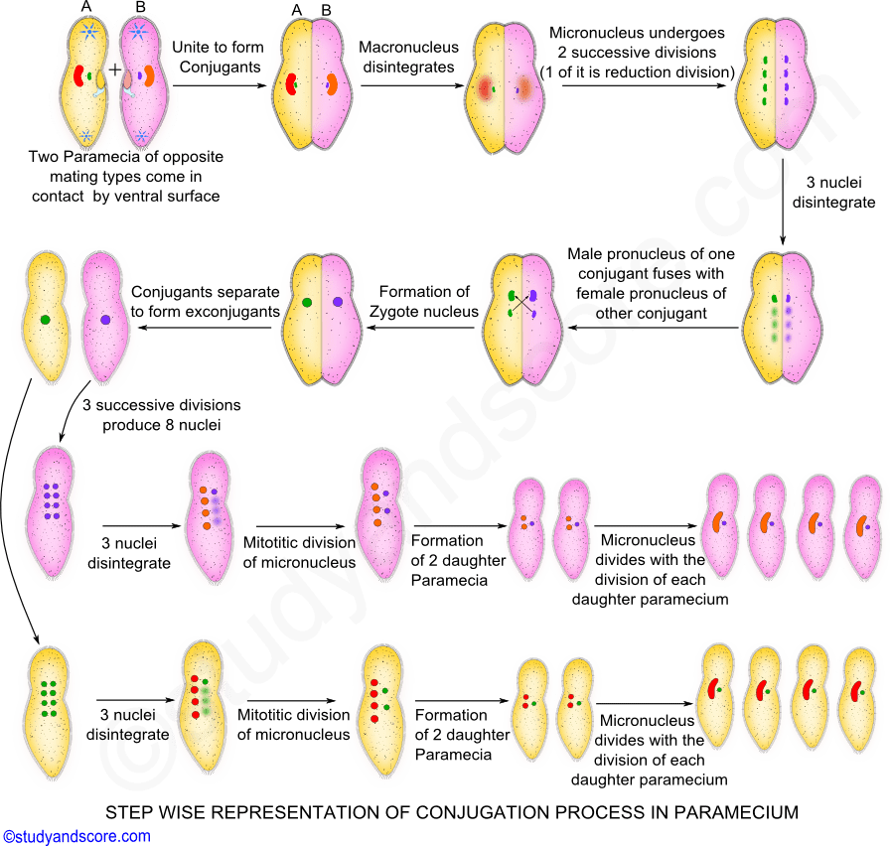

Fusion of the protoplasm takes place at the point of contact.  Macronuclei break up and disappear but the micronuclei undergo meiotic division. After the meiotic division of the micronuclei, all the micronuclei get degenerated and only one remains. This remaining micronucleus divides forming two gametic micronuclei. Out of these two one is considered male pronucleus and the other female pronucleus.

The male pronucleus of one of the conjugants moves through fused protoplasm into the other conjugant. In each conjugant, these male and female pronuclei fuse together forming zygote nucleus. Now two individuals separate and are called as ex-conjugants. Each ex-conjugant undergoes further nuclear and cytoplasmic divisions forming four daughter individuals.

The association during the conjugation process is highly specialized. The unique feature of conjugation is the exchange of hereditary material so that each of the conjugant benefits from a renewed hereditary constitution.

**ASEXUAL REPRODUCTION IN PROTOZOANS**

Asexual reproduction is the method in which reproduction occurs without the fusion of pronuclei. Asexual reproduction does not generate new genetic recombination. The offspring show uniparental inheritance, without any genetic variations. In protozoans, asexual reproduction occurs only under favorable conditions.

The following are different modes of asexual reproduction occurring in protozoans:

**Binary Fission**

It is the most common method of asexual reproduction where in the parent divides into two daughter individuals. It involves division of nucleus followed by the division of the cytoplasm. The plane of fission differs in different protozoans. Depending on the plane of fission binary fission is of following types:

**Irregular binary fission-** Binary fission is irregular in some of the protozoans which do not have defined body shape. In these protozoans, there will be no defined plane of fission either and hence the name irregular binary fission. Example: *Amoeba*

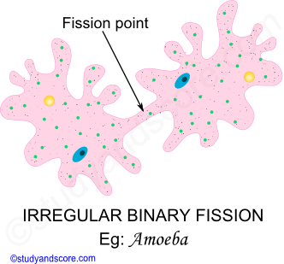

**Longitudinal binary fission-** Longitudinal binary fission is common in Mastigophoran protozoans and in few ciliophorans also. This type of fission process starts at the anterior end and proceeds towards the posterior end. The plane of fission is parallel to the longitudinal axis of the body of the organism. Example: *Euglena, Vorticella*

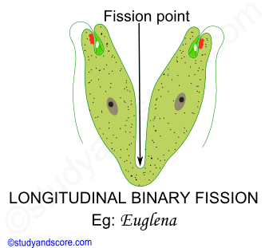

**Transverse binary fission-** Transverse binary fission is seen in ciliate protozoans. The plane of fission in this type is at right angles to the kineties. All the paramecia produced asexually by repeated binary fission from a single parent constitute a clone. Example: *Paramecium*

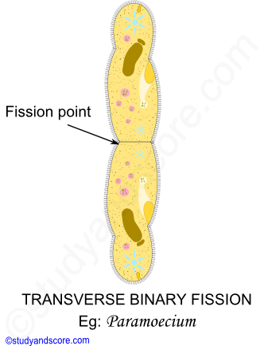

**Oblique Binary fission-** Oblique binary fission is common in some protozoans like dinoflagellates. In this type the plane of fission is oblique to the body axis of the organism. Example: *Ceratium*

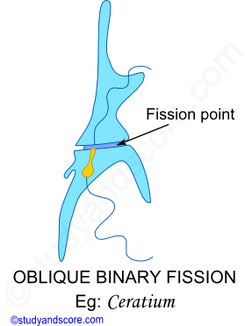

**Multiple Fission**

It is the division of the parent into numerous daughter individuals. Nucleus divides into many nuclei followed by the cytoplasmic division forming many daughter individuals. It is prominent in Sporozoans and Sarcodines.

Schizogony is the asexual kind of multiple fission and its end products of schizogony grow into trophozoites. Gamogony is the sexual kind of multiple fission by which gametes are formed. Also sporogony is also sexual kind of multiple fission by which spores are formed. Example: *Aggregata*

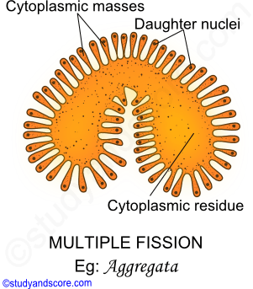

**Budding**

It is common in suctorian protozoans. The bud is a smaller individual formed after nuclear division. Monotonic budding (Vorticella) is seen in ciliates whereas multiple budding is seen in suctorians. Buds can occur either exogenously (Ephelota) or endogenously (Acineta) in some of the protozoans. Example: *Acineta, Ephelota, Vorticella*

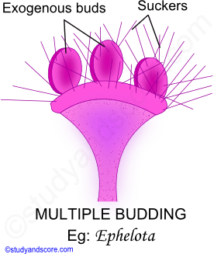

**Plasmotomy**

It is the division of a multinucleate protozoan into multinucleate daughter individuals by cytoplasmic division but without nuclear divisions. The parental nuclei are distributed among the daughter individuals. Example: *Opalina, Pleomyxa*

**LEISHMANIA**

Leishmania sps are the cause of various diseases in man, cattle, dogs, sheep, horse etc. collectively known as leishmaniasis.  It is a pathogenic zooflagellate and is closely related to Trypanosoma. These pathogens are carried by blood sucking sand flies of the genus Phlebotomus. Leishmania species are intracellular parasites in the white blood cells, liver cells and spleen cells.

**Distribution**

Leishmania donovani is known to infect man in India, China, South America, parts of Africa and Mediterranean countries. This genus was created by Ronald Ross in 1903. The species was simultaneously reported by Leishman in London and Donovan from Madras (India), hence the Leishmania donovani.

**Habit and habitat**

It lives as an intracellular parasite in the leucocytes or the organs of the reticulo-endothelial system like bone marrow, spleen, liver and lymphatic glands etc. This parasite causes disease called as kala azar fever in humans with the symptoms like enlargement of spleen and reduction in the number of white blood cells. It is transmitted through the bite of Sand flies.

**Morphology**

**Size and shape:** The genus Leishmania occurs in two forms namely leishmanial and leptomonad. These two forms alternate between a vertebrate and an invertebrate host. These two forms are recognized on the basis of the position of the kinetoplast and blepharoplast. Also the course taken by the flagellum is important in identification of the leishmanial form.

**Leishmanial form**- This form is also known as the amastigote form. The size ranges from 2 µ to 4 µ in diameter. This form occurs intracellularly in the blood cells and the organs of the reticulo-endothelial system like liver, spleen, bone marrow of man. This form is microscopic, rounded or oval with a central nucleus, blepharoplast and kinetoplast. This form does not have a free flagellum.

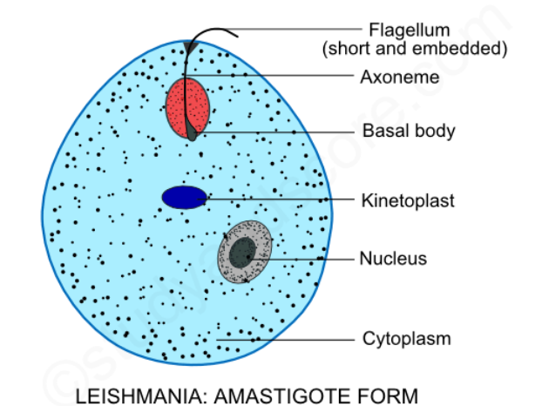

**Leptomonad form**- This form is also known as the promastigotes form. Its size ranges from 15 – 20 µ in length and 1-2 µ in width. This form occurs in the midgut of the invertebrate host or sand fly. This form is elongated, slender and spindle shaped with a large centrally placed nucleus, blepharoplast and kinetoplast. These forms possess a free flagellum.

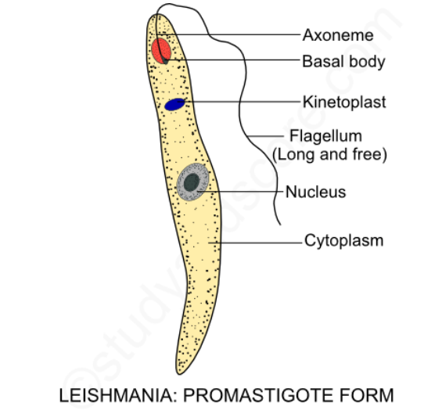

**Cell membrane**: The whole body is covered externally by a very thin, delicate, elastic and firm covering called as pellicle. This pellicle gives a definite shape to the body.

**Flagellum**: Leishmania is uniflagellate that is it has only single flagellum. In the leptomonad form the flagellum is long and free. This flagellum arises from a minute basal body or blepharoplast situated near the anterior end. Near the blepharoplast a disc-shaped parabasal body called as kinetoplast is present. In the leishmanial form, there is no free flagellum rather the flagellum is reduced and embedded in the cytoplasm. Embedded

**Cytoplasm:** Homogenous and colorless cytoplasm is present in this parasite. The cytoplasm is not differentiated into ectoplasm and endoplasm. The cytoplasm is marked by longitudinal striations or microtubules. Many other structures like Golgi body, mitochondrion, vacuole, nucleus, blepharoplast and kinetoplast are present in the cytoplasm.

**Nucleus**: The nucleus of Leishmania is spherical and lies in the middle of the body. It has a central distinct nucleolus. The nucleus is covered by a double unit membrane with pores of size 1 µ in diameter.

**Metabolism**

Leishmania do not have a mouth or a cytostome and so the nourishment is obtained saprozoically through the general body surface from the host cells. The exchange of the gases and elimination of the waste products takes place by the process of diffusion. Only asexual reproduction takes place in Leishmania through longitudinal binary fission.

**LEISHMANIA LIFE CYCLE**

Leishmania is a digenetic parasite which requires two hosts to complete its life cycle. These two parasites are named as primary and secondary hosts. The primary host is the principal host which is a vertebrate or man. In the primary host the parasite feeds and multiplies itself asexually. On the other hand the secondary host is the intermediate host or vector which is usually an invertebrate or a blood sucking insect. In the case of Leishmania it is sand-fly (Tse-tse fly). This sand fly belongs to the genus Phlebotomus.

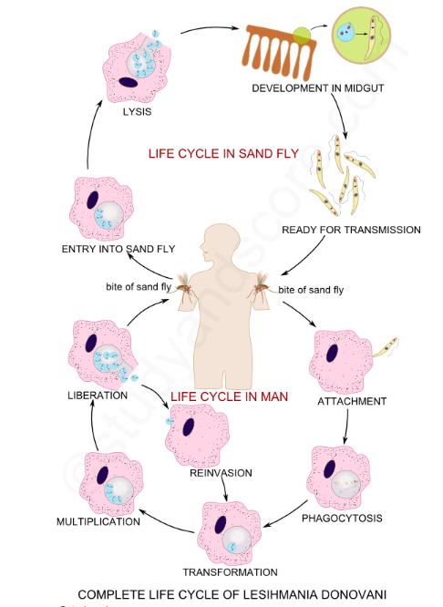

In the life cycle of Leishmania we can also find a reservoir host which can be mammals like dog, jackals and ground squirrels. In the reservoir host the parasite does not undergo any change rather it simply waits to find its principal host through sand fly.

**Life cycle in Man**

In India, Leishmania donovani is transmitted to man by the infected sand fly (Phlebotomus argentipes). The sand fly injects the infective stages called as promastigotes or leptomonad forms from their proboscis into the human blood. Some of them which enter the blood circulation are phagocytized by the macrophages and other mononuclear phagocytic cell. Some of promastigotes enter the cells of reticulo-endothelial system (consists of the organs like spleen, bone marrow, liver and lymph nodes). Now these promastigotes forms get transformed into amastigote or leishmanial form. These amastigotes get settled in the organs of the reticulo-endothelial system and undergo slow multiplication by binary fission and because of this the respective organs become significantly enlarged.

When the number of parasites reached 50 to 200 or more the macrophages get ruptured to liberate the parasites. Now the liberated parasites are taken up by new host cells and the cycle of multiplication repeats consequently the reticulo-endothelial system progressively becomes infected.

Some of the free amastigotes become phagocytized by neutrophils and monocytes. These heavily parasitized cells wander through the general blood circulation leading to the general infection.

**Life cycle in Sand fly**

When a sand fly sucks on the blood of an infected person, it obtains free amastigotes and parasitized neutrophils and monocytes along their blood meal. The amastigote forms develop in the midgut of the sand fly. They get transformed into elongated, free flagellated promastigotes forms again. These promastigotes forms multiply by longitudinal binary fission. In about a weeks’ time the number of parasites become enormous thus spread to other organs of the sand fly like pharynx and buccal cavity. The important point to be noted in vector is that the salivary glands are not infected. The transmission to the host takes place when a heavily infested sand fly bites a new host.

**DUMDUM FEVER**

**Occurrence:** Dumdum fever is the serious oriental disease of man caused by Leishmania donovani and transmitted by Phlebotomus argentipes. It is also known as black fever or Kala-azar. The word kala-azar is derived from two Indian words Kala meaning black and azar meaning sickness. This fever is prevalent in India, China, Mediterranean countries and some parts of Arica and South America.

**Symptoms and pathogenesis:** The incubation o period of dumdum fever is long ranging from 3 to 6 months. Also the symptoms of the fever may appear even after 2 years. The very early symptoms of dumdum fever include swelling, high fever, enlargement of organs or reticulo-endothelial system like spleen and liver. These symptoms are followed by general weakness, anemia due to reduction in the number of blood cells and darkening of the skin.

In the advanced stages the skin of the infected person becomes completely dry, rough and dark with lot of pigmentation, hair becomes brittle and fall out. If the patient does not receive proper treatment it can lead to his death in 2 years. Generally death is due to the secondary infection by bacteria or virus as the patient becomes immune-compromised in other words, the patient would not be able to resist the infections caused by bacteria or virus or any other microbes.

**Diagnosis:** Microbial examination of the blood film or the biopsy material taken from the spleen or bone marrow of the patient are the main diagnostic samples used for the identification of the infection in a person. Amastigote forms of Leishmania donovani are tested in these samples. Also the examination of the white blood cells shows decrease in the number of neutrophils and increase in number of lymphocytes and monocytes. The number of red blood cells is also found to be decreased.

**Treatment:** Generally two groups of drugs are used for the treatment of dumdum fever. These include pentavalent antimony compounds like sodium-antimony tartrate and sodium-antimony glutamate, urea stibamine, aminostiburea along with pentamidine isethionate.

**Prevention:** The following are the prophylactic measured to be taken to prevent the disease

**\*** Eradication of the insect vector is of prime importance to keep the disease under control. Low trees and bushes should be cleared out in the endemic areas. Periodic fumigation and spraying of the insecticides is also advisable to prevent the disease.

**\*** Reservoir hosts like dogs, jackals, squirrels should be kept at bay.

**\*** Proper treatment campaign is a good control measure in India.

**\*** To avoiding the bites of sand fly insect repellants, mosquito nets can be used. Also avoiding to sleep on the floor can be beneficial.

**PLASMODIUM**

**PLASMODIUM GENERAL CHARACTERS**

*Plasmodium vivax, plasmodium ovale, plasmodium falciparum,*and*plasmodium malariae* are the organisms causing malaria in human beings. Malaria is the most common disease of man. In olden days it was believed that malaria is caused due to the bad air or the harmful vapors produced in the marshy lands. The word malaria is an Italian word meaning mala=bad and aria=air.

**History of malaria**

For the first time, in 1860, Laveran, a French doctor, observed the Plasmodium in the blood of a malarial patient. Then Golgi, an Italian scientist in 1885 observed Plasmodium in the red blood cells of a malarial patient.

On 20th August 1897, Ronald Ross discovered the oocytes of Plasmodium in the crop-wall of the female Anopheles mosquito. For his work on malaria Ross was awarded Nobel Prize in 1902. Also every year 20th August is celebrated as the Malaria day in recognition of his Work. Ross carried out a major part of his work on malaria in India. Grassi, an Italian professor described the complete life cycle of Plasmodium vivax in female Anopheles mosquito.

**Structure of malarial parasite**

The infective stage of the malarial parasite, Plasmodium to man is called Sporozoite. The sporozoites are spindle shaped with swollen middle part and slightly pointed ends. It measures about 15 µ in length and 1µ in width. Externally the body of plasmodium is covered by a three layered pellicle which is elastic in nature. It contains longitudinally arranged hollow microtubules. These tubules are contractile in nature and help the parasite in its wriggling movement.

At the anterior end a cup like depression called the apical sucker is present. In to this apical sucker, opens a pair of narrow secretory organelles called rhoptries. These secretory organelles secrete cytolytic enzymes which help in penetration of the parasite in to the liver cells. Numerous convoluted tubules are scattered throughout the body of sporozoite.

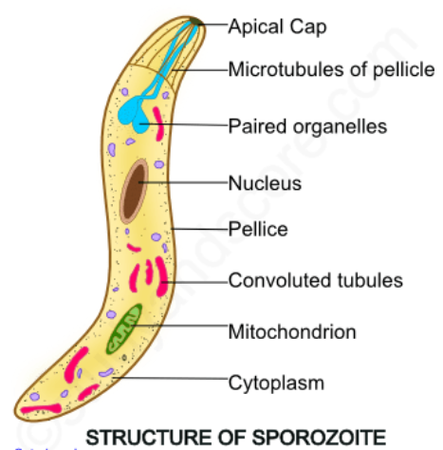

**PLASMODIUM LIFE CYCLE IN MAN**

The life cycle of plasmodium includes two phases, namely asexual and sexual which are completed in two different hosts. The sexual phase of the life cycle is completed in the female Anopheles mosquito and the asexual phase is completed in human beings. Female Anopheles mosquito is considered as the definitive host or invertebrate host whereas humans are considered as the intermediate hosts or vertebrate hosts. Mosquito is also called as the vector as it transmits the parasite from one person to another. Monkey is the reservoir host. In the life cycle of the plasmodium the asexual life cycle alternates with the sexual life cycle. This phenomenon is called as alternation of generations.

*Plasmodium vivax* reproduces by asexual multiple fission called as schizogony in the liver cells (Hepatocytes) and the red blood cells (Erythrocytes) of humans. The two stages in the human phase are exoerythrocytic stage and erythrocytic stage. In the liver cells two generations are produced-the earlier generation is called as the preerythrocytic generation and all the later generations are called as exoerythrocytic generations.

**Exoerythrocytic phase:** Sporozoites which are infective stages to man enter into the blood of humans with the bite of the infective mosquito. Within half-an hour these sporozoites enter the hepatocytes. After entering the hepatocytes they are transformed into trophozoites. These trophozoites feed on the on the infected cells and grow in size.

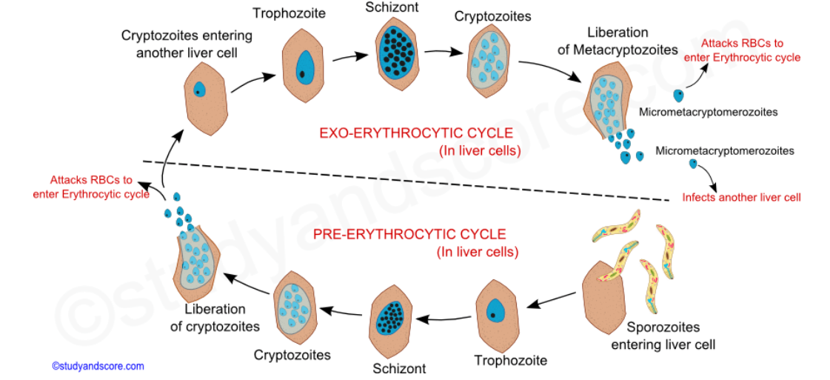

The nucleus of the trophozoite divides several times and the parasite now becomes a multinucleated schizont. Then the division of the cytoplasm of the schizont takes place forming large number of cryptozoites or first generation merozoites. After the formation of cryptozoites the liver cell and the cell membrane of the schizont break open to release all these cryptozoites into the liver sinusoids. These cryptozoites may either enter the red blood cells to continue erythrocytic phase or may again invade liver cells to produce second generation of merozoites.

If the cryptozoites enter the liver cell again it gets transformed into trophozoite and feeds on the infected liver cells. The nucleus of the trophozoite divides several times and the parasite becomes a multinucleated schizont. Then the cytoplasm divides, releasing large number of metacryptozoites or second generation of merozoites into the liver sinusoids by breaking the liver cell and the cell membrane of the schizont.

On the basis of the size the metacryptozoites are differentiated into bigger macrometacryptozoites and the smaller micrometacryptozoites. Now the micrometacryptozoites infect the erythrocytes to get into erythrocytic phase whereas the macrometacryptozoites infect other liver cells to produce one more generation of metacryptozoites.

The time interval between the initial infection by the sporozoites and the first appearance of the parasites in the blood of the infected man is called as prepatent period. The prepatent period is about eight days in case of plasmodium vivax. During this prepatent period the parasite increases in number and the host do not exhibit any symptoms of the disease.

**Erythrocytic phase:** This phase is also known as Golgi cycle in recognition of the scientist who discovered it. The entry of cryptozoites of the preerythrocytic generation or the metacryptozoites of the exoerythrocytic generation into the erythrocytes marks the beginning of erythrocytic phase.

As the name suggests this phase takes place in the red blood cells or the erythrocytes of humans. These merozoites get transformed into trophozoites after entering the RBCs. The earliest trophozoite has a central vacuole which increases in size pushing the cytoplasm and the nucleus to the periphery. This stage is called as signet ring stage as it gives the appearance of a ring.

The parasite in the signet ring stage develops pseudopodia and becomes amoeboid. This amoeboid stage feeds on the contents of the RBC. At this stage the infected erythrocyte grows almost double in size. This phenomenon of the growth of the RBC is called as hypertrophy. This infected RBCs become pale in color due to the loss of hemoglobin. Minute red-staining granules called schuffner’s dots appear in the cytoplasm of the RBC. These schuffner dots are the antigens excreted by the parasite.

The fully grown trophozoite fills the entire erythrocyte and becomes schizont. It undergoes erythrocytic schizogony. The nucleus divides by multiple fissions and each bit of the nucleus is surrounded by a mass of cytoplasm to form the erythrocytic merozoites.

In this cycle the parasite feeds on the hemoglobin of the RBCs. The ingested hemoglobin is broken down into globin and haematin. The digested haematin forms the characteristic brown colored haemozoin granules which are toxic and are the main cause of malaria.

In the infection caused by Plasmodium vivax, haemozoin is released into the blood every 48 hours along with merozoites after the completion of erythrocytic cycle. Also fever occurs every third day. Such a type of fever is called a tertian fever.

The time interval between the entry of sporozoites into the body and the onset of the disease is called incubation period. Incubation is about 10-14 days in case of Plasmodium vivax.

**Gametogony:** Some merozoites, after the completion of few erythrocytic schizogony cycles, develop into sexually differential forms called gametocytes instead of forming schizonts. The formation of gametocytes takes place in the bone marrow and spleen. After the formation the gametocytes appear in the blood circulation. They are generally of two types,

**\*** Macrogametocytes: They are larger, female gametocytes with small nucleus. Their cytoplasm is loaded with food materials.

**\*** Microgametocytes: They are smaller, male gametocytes with large nucleus. Their cytoplasm is clear. Comparably they are more in number.

The gametocytes remain unchanged in human blood waiting for a female Anopheles mosquito to bite. They remain so in the human blood for about a week after which they degenerate. Further development of the gametocytes to gametes can occur only in the crop wall of the mosquito.

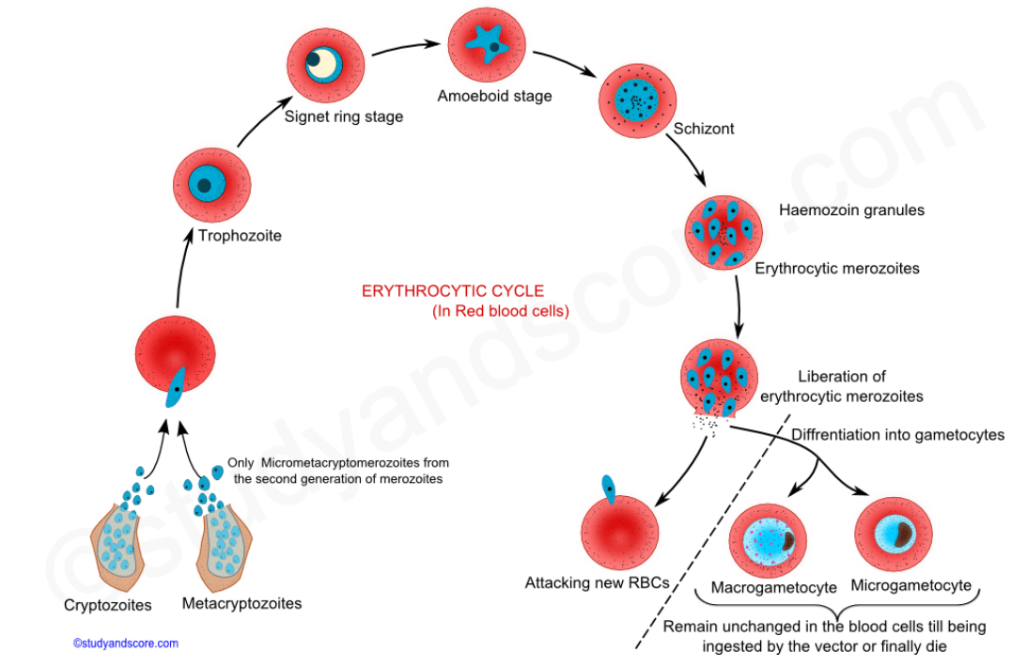

**PLASMODIUM LIFE CYCLE IN MOSQUITO**

The life cycle of the plasmodium in mosquito is called Ross cycle, in recognition of the work done by Sir Ronald Ross. When a female Anopheles mosquito bites an infected human, the gametocyte stages present in the blood of the infected human enters the mosquito. Only the gametocytes present in the blood survive the digestive action in the crop of mosquito and all the other stages are digested. The pH of the digestive fluid and the body temperature of the mosquito are favorable factors for further development of the gametocytes.

The life cycle of the plasmodium in mosquito includes the following events:

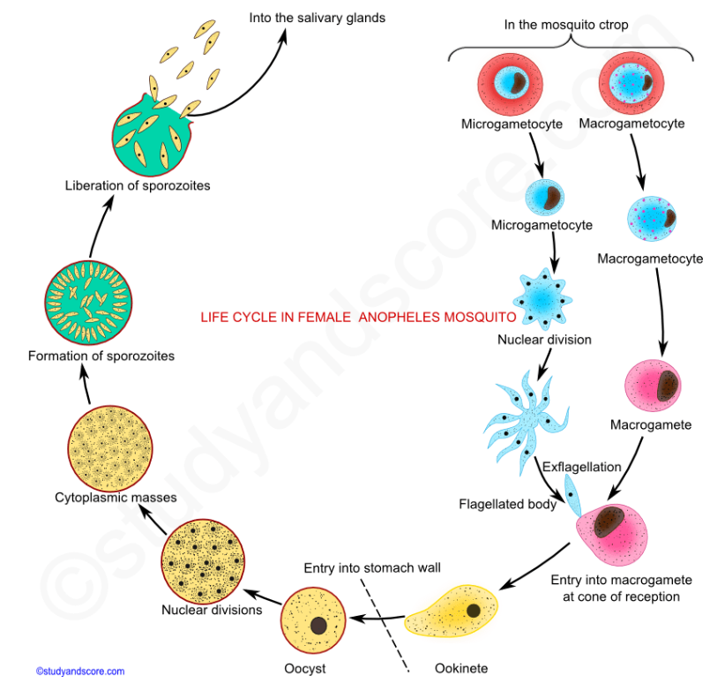

**Formation of Gametes:** During the formation of the gametes, the microgametocytes become very active and its nucleus divides into eight daughter nuclei, then eight flagella like process of the cytoplasm appear on its surface. This stage is called as flagellated body. Each nucleus passes into each of these cytoplasmic extensions and forms a microgamete or male gamete. These microgametes through their beating movement get themselves liberated from the flagellated body as male gametes. This process of formation of the male gametes is called as exflagellation.

On the other hand, the macrogametocytes do not undergo any division but get matured into female gametes or macrogametes. The nucleus moves towards the periphery and the cytoplasm is projected at that point. This projection point is called as the reception cone or fertilization cone.

**Fertilization:** The male gametes which move about with their beating movement get in contact with the reception cone of the female gamete and enter into it. The pronucleus of the microgametes fuses with the pronucleus of the macrogamete. As the gametes which are fusing are dissimilar in form, this fusion is called as anisogamy. It results in the formation of a spherical zygote.

**Formation of sporozoites:** The zygote thus formed after the process of fertilization remains inactive for some time and then becomes elongated, motile vermiform. At this stage it is called as ookinete. It pierces into the wall of the crop and comes to lie beneath the basement membrane. It becomes round and secretes an elastic cyst wall around it. This encysted zygote is called as oocyst.

The oocyst enlarges in size and begins multiplication by the process called sporogony. The nucleus first undergoes reduction and then it undergoes repeated mitotic divisions to produce a number of nuclei. The oocyst develops large vacuole which divides the cytoplasm into bits. Each bit of nucleus is surrounded by a bit of cytoplasm and these structures are called as sporoblasts. The cysts containing the sporoblasts are called as sporocysts. This multiple fission in mosquito is called as sporogony. Sporoblasts are formed into thousands of spindle shaped sporozoites. Cysts burst out and sporozoites are liberated from the cyst into the haemocoel. The life cycle in mosquito is completed in 10-24 hours depending on the temperature ambience.

The sporozoites thus formed are motile and they reach the salivary glands of the mosquito. Now they are ready to be injected into a new host. These sporozoites enter the human blood along with the saliva of the biting female Anopheles mosquito.

**Pathogenicity of Plasmodium**

Plasmodium vivax causes benign tertian malaria which is less dangerous form of this disease. The clinical features of malaria include, febrile paroxysm (spells of fever) followed by anemia and enlargement of spleen. A febrile paroxysm includes three stages,

* Cold stage, with symptoms of chills, headache and giddiness
* Hot stage, with high fever, increase in breathing rate & pulse rate
* Sweating stage, with symptoms of profuse sweating with body temperatures receding to normal

In some cases relapse of malaria disease takes place when some stages of the plasmodium remain dormant for a longer duration in liver. These dormant forms are called as hypnozoites. These hypnozoites may get reactivated in course of time leading to initiation of fresh erythrocytic cycle and new attack of malaria.

**Preventive measures and prophylaxis**

Malaria can be controlled by the following methods,

**Protection against mosquitoes:**

* Spraying of DDT, BHC and other insecticides in the house to kill the mosquitoes
* Fumigation in the dwelling places
* Use of mosquito nets
* Use of mosquito repellents to avoid mosquito bites

**Destruction of mosquito larvae:**

* Kerosene and pyrethrum oil are sprayed on the stagnant waters like sewage gutters and ditches were the mosquitoes lay their eggs. The oil film on the water surface affects the respiration of the larvae and the larvae die of suffocation.
* Use of insecticides in the mosquito breeding places to kill the larvae.
* Biological control is one of the most effective methods of destructing the mosquito larvae. Use of larvivorous fishes like Gambusia is one such biological method.

**MONOCYSTIS**

The parasites which complete their life cycle in only one host are called as monogenetic parasites. Also gregarines are the parasites existing in the coelomic epithelial cells, gut and reproductive organs of invertebrate hosts. There are two forms of these sexually reproducing gregarines namely acephaline and cephaline.

In the acephaline forms, the body is not divided into chambers and the anterior end does not bear any organ for the attachment to the host. In cephaline forms, the body is chambered and they also have an organ for attachment to the host. Monocystis is an acephaline gregarine. Monocystis in Greek means mono=single & kystis=bladder. It resides as a parasite in the seminal vesicles of the earthworm

**Distribution**

Monocystis species are cosmopolitan in distribution in other words they are found distributed throughout the world.

**Habit and habitat**

These are endoparasites in the earth worms. They reside in the coelom and seminal vesicle of the earth worms.

**Structure of trophozoite**

The adult and feeding stage of this parasite is called as trophozoite. It develops within the sperm morula. Sperm morula is a group of developing sperms in the seminal vesicles of earthworm.

**External morphology of Monocystis**

**Shape and size:** Trophozoites are small, unicellular and microscopic. The exact size and shape changes according to the developing stage of the trophozoite. Young trophozoites are rounded and oval measuring about 5 µ long. Fully grown trophozoites are elongated, spindle-shaped, flattened and worm like with tapering body ends measuring around 500 µ long and 40 µ broad. This fully grown trophozoite can be viewed with a naked eye.

**Pellicle**: Pellicle is the external thick and firm structure surrounding the body of the trophozoite. Pellicle may be modified as per the surroundings it may be striated, or ridged or furrowed. The pellicle contains microtubules which are arranged longitudinally.

**Cytoplasm:** The cytoplasm can be differentiated into the outer ectoplasm and the inner endoplasm. The ectoplasm is further divided into outer epicyte, middle sarcocyte and inner myocyte. The inner layer myocyte consists of longitudinal and transverse contractile fibrils called as myonemes. The myonemes assist the trophozoite in metabolic movement. The endoplasm consists of fat globules, granules of special glycogen called Para glycogen. Other organelles in the cytoplasm include mitochondria and Golgi complex.

**Nucleus:** Nucleus is single with one nucleolus. It may be in elliptical or spherical shape. The nuclear membrane is delicate and bears nuclear pores. Nucleoplasm contains four chromosomes.

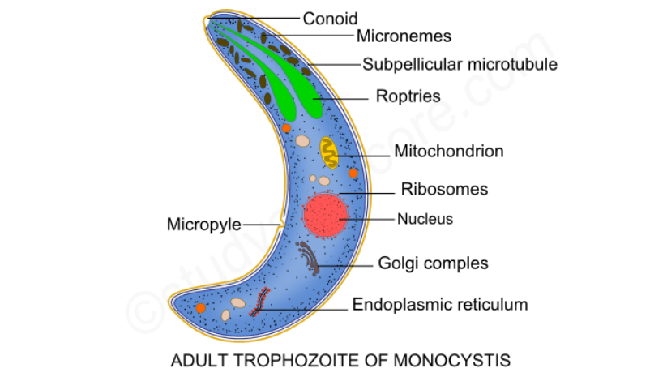

**Physiology of Monocystis**

**Locomotion**: Special organs for locomotion are absent in Monocystis. Monocystis moves by wriggling or gliding movement brought about by the rhythmic contraction and relaxation of myonemes. This movement is very much similar to the euglenoid movement of Euglena.

**Nutrition**: Monocystis absorbs the nourishment from the fluid of the seminal vesicles through the general body surface. So the nutrition of Monocystis is saprozoic type. The reserve food material is stored in the endoplasm in the form of Para glycogen granules.

**Respiration**: The mode of respiration is by the process of diffusion though its pellicle from the cell contents of the sperm morula. Also the mitochondria synthesize the respiratory enzymes for oxidation reaction for conversion of pyruvic acid to carbon dioxide and water.

**Excretion**: The resulting waste products of the metabolism like the carbon dioxide and nitrogenous wastes are eliminated out of the body through diffusion into the surrounding fluid of the sperm morula.

**MONOCYSTIS LIFE CYCLE**

Monocystis is monogenetic in other words its lifecycle completes in a single host and it does not require a secondary host like in case of digenetic parasites. The single host of Monocystis is earthworm. All the stages of the life cycle of the Monocystis are haploid except for zygote. The following are stages of the life cycle of the Monocystis.

**Gamontogamy**: This is a sexual reproduction process involving pairing of gamonts (Syzygy), formation of gametes (Gametogony) and fertilization (Syngamy).

**Syzygy**: The trophozoite in the seminal fluid and coelom of the earthworm wanders about feeding and growing in size and consequently becoming an oval shaped reproductive body called as gamont or gametocyte. These gamonts become shortened and associate with each other in pairs. This pair secretes a protective and resistant cyst wall around themselves. At this stage they are called as gametocyst or gamontocyst. The cyst wall has two layers, the outer called as ectocyst which is rigid and the inner called as endocyst which is thin. The very important point to be noted here is that inside the cyst wall the two gametocytes never fuse. This type of pairing of the gametocytes is called as syzygy

**Gametogony**: Inside the gametocyst, each gametocyte undergoes nuclear multiplication by mitosis. The nuclei formed after the mitotic division move to the periphery and get surrounded by cytoplasm. These uninucleate cytoplasmic bodies are called as cytomeres. These cytomeres get transformed as gametes and these gametes are called as anisogametes. Anisogametes contain haploid number of chromosomes. All the gametes from one gametocyte are of same sex.

**Syngamy**: Inside the gametocyst, the gametes mingle and fuse in pairs to produce diploid zygotes. The two gametes uniting come from different gametocytes and are of opposite sex.

**Sporogony**: The zygote which is initially spherical gets transformed into an oval and unicellular body called as sporoblast. The sporoblast secretes a thick cyst wall call as sporocyst and becomes a spore which is biconical in shape. The spores have a mucoid plug at each end.

Inside the sporocyst, the spores undergo successive nuclear divisions to produce eight daughter nuclei. Each daughter nuclei is surrounded by cytoplasmic mass and is known as sporozoite. All the eight Sporozoites are bundles together in the sporocyst. At this stage the cyst wall ruptures liberating the spores into the cavity of the seminal vesicles of the earthworm.

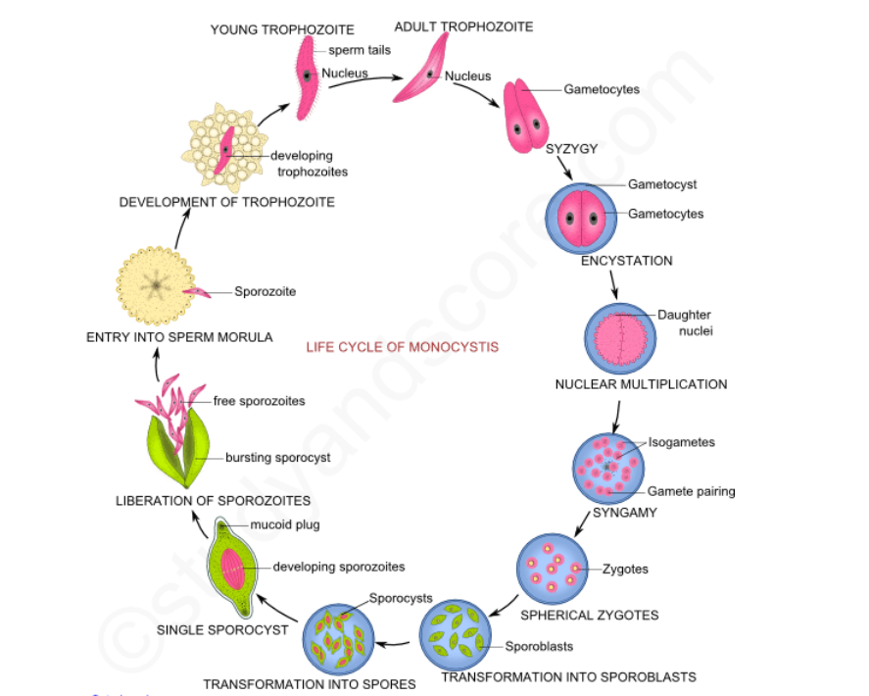

**Transference**: The transmission of the Monocystis parasite from one earthworm to other may take place through the following methods. But the exact manner in which the transmission occurs is not known with certainty.

**\*** During copulation

**\*** Death of host

**\*** By birds

**\*** Autotomization

**Sporozoites**: Sporozoites are minute, spindle shaped protoplasmic bodies. Each sporozoite has a single nucleus, one or more mitochondria, Golgi complex and granules of reserved food. The pellicle covering the body has longitudinally arranged contractile microtubules. A pair of secretory organelles called as roptries are present at the anterior end. The secretion of roptries helps the sporozoite to penetrate through the tissues.

**Invasion of the seminal vesicles:** The sporozoites move and make their way into the epithelial cells of the gut. Each sporozoite occupies one cell of the gut mucosa. The sporozoites grow in these cells and then escape into the seminal vesicles. After reaching the seminal vesicles each sporozoite enters into the cells of the sperm morula.

**Development of trophozoite**: Inside the sperm morula the sporozoite feeds and grows into a young trophozoite. These trophozoites have remnants of the degenerating sperms around its body. After the degeneration of these remnants the trophozoite becomes adult and free.

**ARTHROPODA**

Arthropoda is the largest phylum of Animal Kingdom. It includes about 1,13,40,000 species in all habitats. This constitutes about 83% of all the known animal species on earth. This huge number of species included in this phylum speaks volumes about the success of the species included in Arthropoda. Arthropoda includes spider, scorpions, prawns, crabs, millipedes, centipedes and many other insects.

Arthropoda is characterized by heteronomous metamerism, chitinous exoskeleton and joined appendages. The evolutionary acquisition of these traits is known as arthropodization.

**General Characters of Phylum Arthropoda**

1. Arthropods occur in all types of habitats i.e., marine, fresh water and terrestrial.
2. There is an increasing tendency of cephalisation in arthropods.
3. In Arthropods, body is metamerically segment; composed of a linear series of segments or somites. Externally endoskeleton is divided into hardened segmental scletites. Internally the nervous system, muscular system and heart chambers are segmentally repeated.
4. Metamerism is heteronomous. Segments and appendages are specialized for different functions. Arthropods are characterised by tagmosis. Head, thorax and abdomen are three typical tagmata.
5. Appendages are joined. They act as lever systems providing mechanical advantages for locomotion.
6. Muscles of arthropods are striated. Body wall is muscular and consists of chitinous cuticle. The chitinous cuticle or the exoskeleton is one of the key features for the arthropod success. It offers protection, prevents loss of body fluids. It also undergoes moulting to facilitate growth.
7. Coelom is reduced in association with a shift from fluid internal skeleton to a solid external skeleton. It is associated with gonads and saccate nephridia. Most of the small coelomic spaces which appear during the development get obliterated with the blastocoel and contribute to haemocoel. Some become excretory organs and gonads. Haemocoel is the functional body cavity and is filled with blood.
8. Alimentary canal consists of three regions: foregut which is responsible for ingestion, storage and trituration. Mid gut which helps enzyme secretion and digestion. Hind gut is responsible for the formation of faeces and reabsorption of water.
9. In very small crustaceans exchange of the respiratory gases occurs through the general body surface. Large aquatic arthropods respire through gills and book gills, whereas terrestrial forms respire through trachea and book lungs.
10. Blood vascular system is of open type. Heart id dorsal in position. Respiratory pigment if present is haemocyanin. It contains copper and is blue in colour. Haemoglobin occurs in few.
11. Saccate nephridia (Coxal glands and green glands) are the characteristic excretory organs of the aquatic arthropods. Malphigian tubules are the characteristic of terrestrial arthropods. Some arthropods have both saccate nephridia and malphigian tubules.
12. Nervous system consists of nerve ring and a ganglionated double ventral nerve cord.
13. Sense organs include compound eye, simple eyes, antennae, statocycts etc.
14. Most arthropods are unisexual. Fertilization may be external or internal in aquatic arthropods but internal in all the terrestrial forms.
15. Eggs are centrolecithal (yolk in centre). Cleavage is meroblastic and superficial. Development may be direct or indirect. Like annelids, they also show teloblastic growth.

**Classification of Phylum Arthropoda**

The animals included in phylum Arthropoda have different views concerning their phylogeny. So there is no absolute system of classification for this phylum. The below given classification is the most accepted one. Through seven subphyla are included in this classification, only three subphyla namely Trilobita, Chelicerata and Mandibulata are definitively arthropods.

The following is the classification of phylum Arthropoda:

**Sub Phylum I: Trilobita**(Gr. tri=three, lobos=lobes)

* This subphylum includes extinct arthropods which were abundant during Paleozoic era.
* These fossil trilobites were exclusively marine bottom dwellers
* Their body can be divided into head, thorax and pygidium.
* A pair of longitudinal axial furrows divided the body into median axial lobe and two lateral pleural lobes
* Head was distinct with one pair of antennae and compound eyes.
* All the post-antennal appendages were biramous and unspecialized.

**Examples**: *Triarthus, Dalmanites*

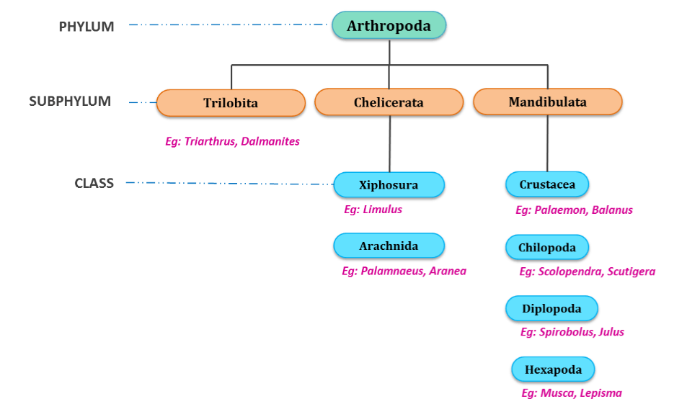

**Sub Phylum II: Chelicerata**(Gr. chele=claw, keros=horn)

* The body of the animals belonging to this subphylum can be divided into two cephalothorax and abdomen.
* The abdomen is further divided into anterior mesosoma and the posterior metasome with a telson.
* Cephalothorax has six pairs of appendages of which the first pair is chelicerae
* Antennae are absent.

Subphylum Chelicerata is further divided into the following two classes,

**Class I: Xiphosura**(Gr. xiphos=sword, oura=tail)

1. This class included horseshoe crabs. All the genera of this class are extinct except three
2. Animals of this class are marine in nature
3. Cephalothorax bears one pair of chelicerae, four pairs of walking legs and one pair of pusher legs.
4. Mesosomal appendages are modified into a genital operculum and five pairs of book gills
5. They have median ocelli and lateral compound eyes
6. Excretory organs are coxal glands
7. Development is indirect and includes trilobite larva.

**Examples**: *Limulus*

**Class II: Arachnida** (Gr. Arachne =spider)

1. This class includes scorpions, ticks, mites and spiders.
2. Mostly these animals are terrestrial
3. Cephalothorax has one pair or preoral chelicerae, one pair of postoral pedipalps and four pairs of winged legs.
4. The spiders bear fangs with poisonous glands on each chelicera
5. Abdominal appendages are modified into book lungs, spinnerets in spiders, pectin in scorpions etc.
6. Telson is usually absent but is present as sting in scorpions
7. Excretory glands are coxal glands and Malphigian tubules
8. Development is direct.

**Examples:***Palamnaeus, Aranea*

**Subphylum III: Mandibulata** (L. mandibula=mandible, ata=bearing)

* Mandibles are the first pair of mouth parts
* The first pair of appendages are antennae

This subphylum is further divided into the following four classes:

**Class I: Crustaceae** (L. Crusta =shell)

1. This class includes prawns, crabs, lobsters, crab fishes etc.
2. They are mostly marine water dwellers. Few also exist as freshwater forms.
3. Few of these animals are terrestrial but they are not well adapted to terrestrial life.
4. In most of the species the head and thorax fuse to form cephalothorax.
5. Cephalic appendages are five pairs namely First antennae, Second antennae, Mandibles, First maxillae, Second maxillae
6. Thoracic appendages are biramous
7. Respiration takes place with the help of gills or general body surface in small forms
8. Excretion is through green glands
9. Sensory organs include statocysts, compound eyes and antennae
10. Gonopores are paired.
11. Development is direct or indirect involving several larval stages, The basic larva is nauplius.

**Examples**: *Palaemon, Balanus*

**Class II: Chilopoda** (Gr. chelios =lips, podos=foot)

1. This class includes centipedes.
2. These animals are terrestrial and carnivorous.
3. The body of these animals is divisible into head and trunk.
4. They are trignathic with mandibles, first maxillae and second maxillae
5. Each segment of the trunk bears one pair of clawed edges.
6. Appendages of the first trunk segment bears poisonous claws
7. Respiration is through trachea
8. Excretory organs are Malphigian tubules
9. Centipedes are ophisthogoneate
10. Development is direct or indirect

**Examples**: *Scolopendra, Scutigera*

**Class III: Diplopoda** (Gr. diplos =double, podos=foot)

1. This class includes millipedes
2. They are terrestrial and detritivorous
3. The body is divisible into head and trunk.
4. They are dignathic with mandibles and gnathochilarium.
5. Most of the trunk segments are diplosegments, formed by the fusion of two segments during development
6. Each diplosegments, formed by the fusion of two pairs of legs and two pairs of spiracles
7. Respiratory organs are tracheae
8. Excretory organs are Malphigian tubules. They are progoneate
9. Development is direct

**Examples**: *Spirobolus, Julus*

**Class IV: Hexopoda** (Gr. Hex =six, podos=foot)

1. This class is also known as Insecta as it includes insects
2. These insects are present in all habitats except the marine habitat.
3. The body of the insects is divided into head, thorax and abdomen.
4. Thorax bears three pairs of joined legs hence the name Hexapoda.
5. Respiratory organs are tracheae
6. Excretory organs are Malphigian tubules
7. Insects are uricotelic. And this is a water conservation adaptation
8. Development includes metamorphosis.

**Examples**: *Musca, Lepisma*

**LARVAL FORMS IN CRUSTACEA**

The animals belonging to class Crustacea shows both direct and indirect development. In the direct development, the egg hatches into young one resembling adult in general structure. Progressive growth and differentiation transforms the young ones into adult.

Whereas indirect development includes larval stages which later become adults. These larval stages are different from the adult in form and structure. The larval stages achieve adulthood through the process of metamorphosis. The following is the detailed explanation of each of the larval forms of crustaceans.

**Nauplius larva**

* It is the first larvae hatched from egg in most of the crustaceans.
* It is free swimming larvae.
* It is minute and microscopic.
* The body has indistinct regions like a simple median eye also called as nauplius eye, three pair of jointed appendages (uniramous antennule, biramous antennae and mandible).
* Mandibles along with antennae are helpful in food collection.
* In some forms nauplius larva develops straight away into adult, but in many other crustacean forms it gives rise to other intermediate larval forms like metanauplius, protozoaea, zoaea, crypsis, mysis, megalopa, phyllosoma, alima

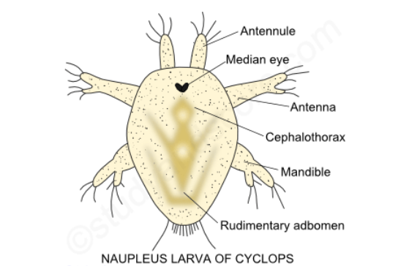

**Metanauplius larva**

* It is the larva of Apus.
* It is the second larval stage which develops from the nauplius larva.
* The body has an anterior oval cephalothorax, an elongated trunk-region and an abdomen terminating in a caudal fork provided with setae.
* The anterior end has a pair of frontal sense organs.
* Dorsal shield of the head grows back to form carapace.
* The larvae has three pair of appendages just as in nauplius, it also develops the rudiments of 4 pairs of appendages, which later become the maxillae and 2 pairs of maxillipedes of the adults.

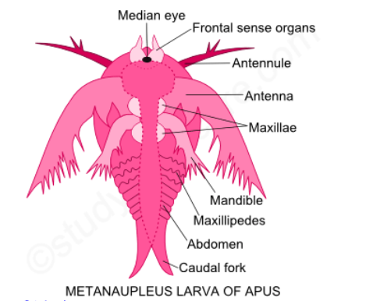

**Cypris larva**

* It is the larvae of Sacculina, Balanus and Lepas.
* It develops from nauplius
* It is a free swimming larva.
* It is triangular in shape with bivalent shell.
* The larva has seven pairs of appendages, namely a pair of antennules and six pair of thoracic appendages.
* A median eye is present.
* The larva contains a mass of germ cells.
* It undergoes a remarkable series of metamorphoses to become the sessile adult form.

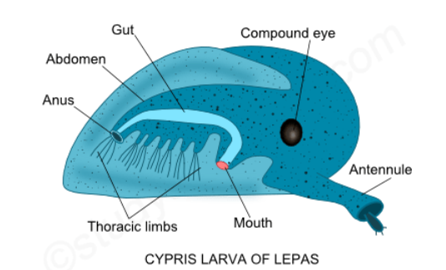

**Protozoaea larva**

* The metanauplius larva is succeeded by the protozoaea stage
* It is divisible into broad segmented cephalothorax covered with a small carapace and a slender abdomen which is unsegmented.
* Abdomen terminates in a forked telson.
* The carapace becomes enlarged and covers the dorsal surface anteriorly.
* The 7 pairs of appendages present in the metanauplius become well-developed and capable of movements.
* The rudiments of paired lateral eye begin to appear near the median eye.
* The rudiments of the remaining posterior six thoracic segments are also marked off, but the abdomen is still unsegmented and without limbs.
* The protozoaea swims by antennae.
* Marine prawns, Penaeus hatch in to protozoaea larva.

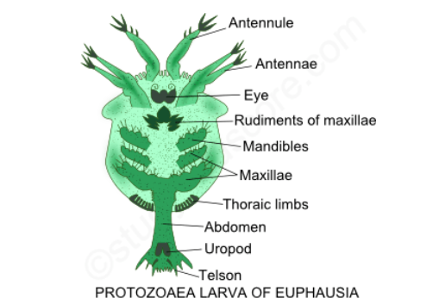

**Zoaea larva**

* Zoaea is the second important larvae of the Crustacea, after the nauplius larva.
* Protozoaea stage is succeeded by the zoaea stage.
* The zoaea is characterized by a distinct cephalothorax and abdomen, 8 pair of appendages and buds of 6 more, and resembles the adult Cyclops.
* The cephalothorax is immensely developed and covered by a helmet-like carapace, which is produced into two long spines, an anterior median rostral and a posterior median dorsal.
* Two lateral spines are also present.
* The paired lateral and stalked compound eyes become well-formed and but remaining 6 pair of thoracic appendages appears in the form of bud.
* The long abdomen is distinctly made of 6 segments, and terminates in a caudal furca and still lacking in appendages.
* Zoaea swims by means of thoracic limbs.

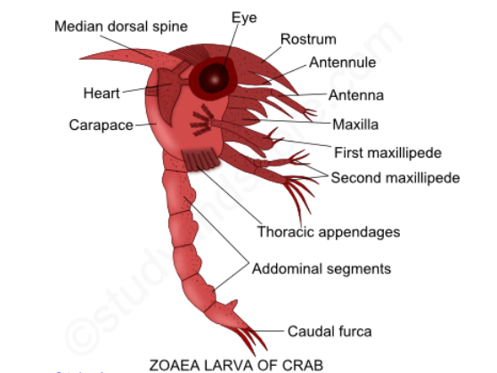  
**Mysis larva**

* In Penaeus, the zoaea larva, instead of converting into the megalopa stage, moults into the post larval mysis larva.
* It has 13 pairs of appendages. All the thoracic appendages are biramous. Even the 5 pairs of posterior thoracic legs are biramous with flagellar exopodites which take up the locomotory function.
* The abdomen develops similar to that of the adult form, with 5 pairs of biramous pleopods and a pair of uropods and a telson.
* The mysis larva metamorphosis in to the adult prawn by the loss of the exopodites on the thoracic legs.

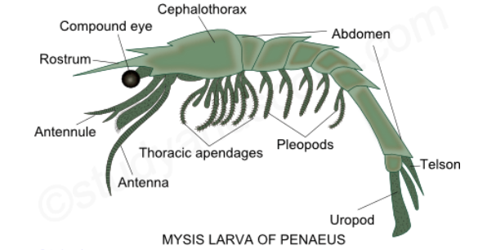

**Megalopa larva**

* In true crabs, the zoaea larva or metazoaea larva passes through successive moults into the post larval megalopa stage.
* It has a broad and crab-like unsegmented cephalothorax.
* The carapace is produced anteriorly into a median spine.
* The eyes are large, stalked and compound.
* All the thoracic appendages are well formed of which the last 5 pairs are uniramous.
* The abdomen is also well formed, straight and bears biramous pleopods.

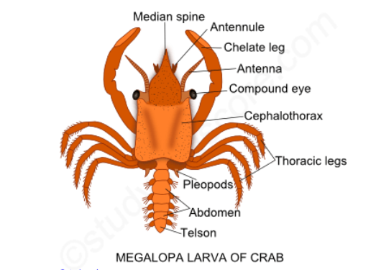

**Phyllosoma larva**

* In the rock- lobster (Palinurus), the newly hatched larva is called the phyllosoma larva or glass- crab
* It is a greatly modified mysis stage.
* It is a remarkable for its large size, extremely flattened and leaf- like delicate form and glassy transparency.
* A narrow constriction demarcates the head from thorax.
* A large oval carapace covers the head and the first two thoracic segments.
* The eyes are compound and borne by large stalks.
* Only anterior 6 pairs of thoracic appendages are present in the newly hatched larva.
* The first thoracic appendages or maxillipedes are rudimentary (Palinurus) or absent (Scyllarus) and the second are uniramous; succeed by 4 pairs of very long and biramous legs with exopodites.
* Last two pairs of thoracic appendages are usually absent.
* Abdomen, though indistinctly segmented is very small and limbless.
* Phyllosoma undergoes several moults before reaching the adult form.

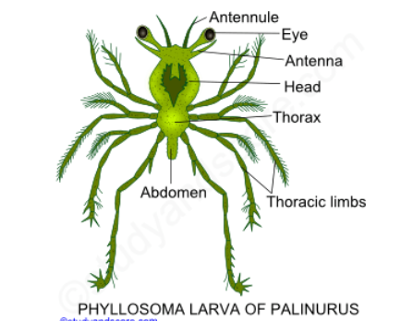

**Alima larva**

* The so-called alima larva of Squilla hatches out from the egg directly
* It is a modified zoaea larva form.
* It is apeagic larva, having a glass-like transparency and occurring in large numbers in the plankton. It has a slender form, and a sort and broad carapace. All the head appendages are present. But only is 6-segmented, having 4 or 5 pairs of pleopods. The alima larva differs from the zoaea larva in the armature of the telson and a very large raptorial second maxillipedes.

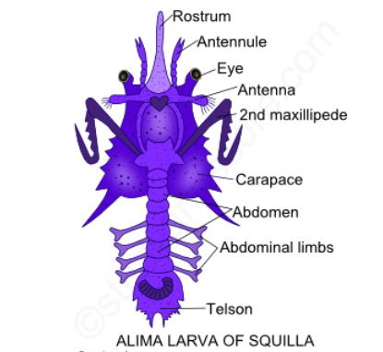

**Significance**

According the biogenetic law proposed by Haeckel, ontogeny recapitulates phylogeny. This in other words means that, the successive stages of individual development correspond with successive ancestors in the line of evolutionary descent. Nauplius larva occurs in the development of all the crustaceans and so it was considered as the ancestral form of crustaceans. The old idea of recapitulations stands greatly modified now-a-days and the crustacean larval forms are now regarded to be the larval reversions of simpler crustacean ancestors.

The larval forms are useful for finding out homologies and the affinities among various groups. The animals which pass through similar stages are closely related. Larvae are helpful in wide range distribution of species and also in keeping the food reserves of eggs to a minimum.

**PARASITISM IN CRUSTACEA**

Parasitism is a close association between two organisms of same or different species. One of them which obtain nourishment from the body of other organism is called the parasite and the other organism is called the host. In this type of association, the parasite is the gainer and the host is the loser. Host may be adversely affected by the parasite but is not actually killed or destroyed.

**Parasitism in Crustaceae**

The phenomenon of parasitism exists in various groups of the class Crustacea like Copepoda, Branchiura, Cirripedia, Isopoda and Amphipoda. The parasitic members are usually ectoparasites (The parasites that live on the host body surface), and these can be commercially important pests. Most crustaceans are dioecious organisms with marine or freshwater life cycles. Life cycles are varied, but generally the female produces eggs, which hatch into various larval forms. These undergo various numbers of molts, and transform into other larval forms or into adults. The larval stages also act as dispersal forms.

Morphologically, Crustaceans have segmented bodies covered with an exoskeleton. There are eyes, two pairs of antennae, mandibles, and two pairs of maxillae on the head. All these parts are often highly modified in some of the parasitic groups. The body shows varying degrees of fusion of head, thorax and abdomen. Appendages, when present, are usually biramous. Most female crustaceans brood their eggs in a pair of external egg sacs.

**Uniqueness of Crustacean parasites**

**Effect on host:** Sometimes the parasites may have no considerable effect on the host but sometimes the parasites may show dramatic effect on the host as a result of which the normal metabolism of the host is interrupted.

**Feeding:** The parasites greatly modify themselves to gain nutrition. In some forms feeding occurs by suction or absorption through general body surface.

**Degeneration:**The organs which are no longer used are degenerated in the parasitic forms. This phenomenon is called as parasitic degeneration. Because of this parasitic degeneration the parasitic Cirripedia and Copepoda look similar in shape.

**Reproduction:** To increase and ensure chances of fertilization, reproduction is massive.

**Adhesive organs:** These parasitic forms possess various adhesive organs like suckers and hooks which help in attachment to the host externally or inside the cavities. These suckers and hooks are specially developed organs.

**Hermaphroditism:** In some of the parasitic crustaceans hermaphroditism is induced type.

**Sexual dimorphism:** There exists a remarkable parallelism between the degree of parasitism and the degree of sexual dimorphism.

**Life cycle:** Generally to overcome various hazards in life, the life cycle of the parasites is very much complicated. But the life cycle in crustaceans is not complex as there is no need of wandering from host to host, no alternation of generation or alternation of hosts.

**PARASITISM IN SUBCLASS COPEPODA**

Most of the parasitic forms of class Crustacea belong to this subclass, Copepoda. The following are the general characters of the animals belonging to this group,

* They are small with head, thorax and abdomen.
* They do not have carapace or compound eye. They have a median eye.
* The antennules of these animals are long and antennae are smaller.
* The abdomen is limbless and the telson has two caudal styles.
* They are also known as fish lice as they live upon the gills, fins, skin or in the flesh of the fishes. They are also found upon other animals including other crustaceans.
* Mostly they remain immovable attached to their hosts but sometimes they may get detached from the host and float in the plankton.
* They undergo great degree of modifications and so are the most degenerated parasites.

The following are the parasitic forms of subclass Copepoda,

**Ergasilus:***Ergasilus sps.* is a member of a small group of parasitic crustaceans which are ectoparasites on freshwater and marine fishes. It may be found on the skin, fins, and gills of fishes. They can cause significant morbidity and mortality when heavily infesting fish.

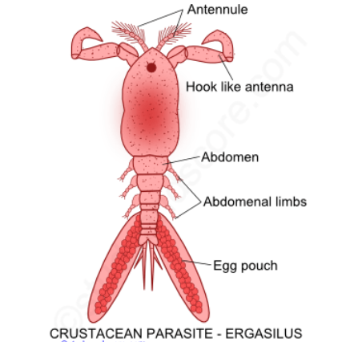

The offspring hatch and are broadcast into the water. The offspring undergo four molts before becoming adults. Ergasilus species are not host specific. Ergasilus infects eels, gars, herrings, killifishes, paddlefishes, perches, pirate perch, smelts, sticklebacks, sunfishes, temperate basses and troutperch.

**Lernaea:***Lernaea sps.* are also known as anchor worms. They are parasitic among freshwater fish.  The larvae are free-living, and resemble other free-living copepods.  However, the 3rd copepodid stage is parasitic, and will seek freshwater fish.  After mating, the males die, and the females undergo a remarkable metamorphosis to develop a prominent head which they use to burrow into the flesh of the fish.  The penetration site frequently also becomes the site for secondary bacterial and fungal infections.

The posterior portion of the parasites protrudes from the skin of the fish.  The adult female can survive up to 30 days, during which it produces pairs of egg sacs which can contain 200-250 eggs each.

**Notodelphys:** *Notodelphys* is the commensal parasite living in the branchial cavities of tunicates. They share the food of their hosts. They have true prehensile antennae and normal mouthparts. Their appendages are usually small. The exopodites of the thoracic limbs have a claw for attachment to the host. Females have a large egg pouch on the last somites. Both the sexes swim actively.

**Caligus:** *Caligus* lives on the skin and inside gill chambers of the fishes. It can swim rapidly. The body is clumsily built. It has piercing and sucking type of mouth parts. Proboscis is formed by both labium and labrum. Proboscis contains sickle-like mandibles for piercing.

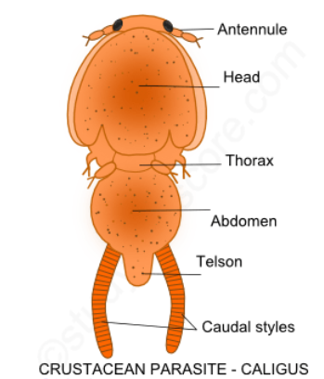

**Monstrilla:** Its first larval stage *Nauplius* is free swimming form but the subsequent larval stages are parasitic and sedentary in polychaete worms. The larval forms absorb nourishment from the host through antennae. But the adults do not have mouthparts and antennae. The adult after coming out of the host sheds off it antennae and assumes pelagic life as its digestive tract is vestigial. The adult lives on stored food. It has one dorso-ventral and median eye.

**Anthosoma:** *Anthosoma* lives as a parasite inside the mouth cavity of the fishes. The body of this parasite is greatly modified because of the curious overlapping of the lobes.

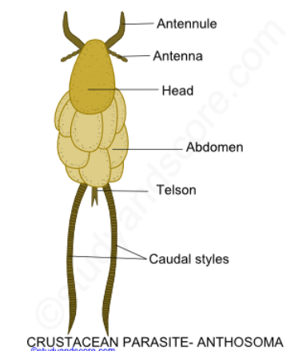

**Chondracanthus:** Chondracanthus lives on the gills of various marine fishes. It exhibits sexual dimorphism. Females are large, unsegmented with irregular lobes. They remain attached to the host permanently and they cannot swim as the appendages are degenerated. They do not have proboscis but the mouth has three pairs of sickle-shaped jaws. The males are smaller and are found permanently attached to the females near the genital aperture.

**PARASITISM IN SUBCLASS BRANCHIURA**

The following are the general characters of the animals belonging to this group,

* They are also known as fish lice or carp lice
* They live as temporary ectoparasites on the skin and in the gill chambers of fishes and some amphibians.
* The body is dorso-ventrally flattened
* A shield like carapace covers head and thorax regions
* Antennules and antennae are reduced
* A pair of sessile compound eyes are present on the head
* Mouth is suctorial type.
* First maxillae are modified into suckers
* Abdomen is unsegmented, bilobed
* Caudal claws are minute

Argulus spp. is an ectoparasite of freshwater fishes. Unlike the parasitic copepods, Argulus spp. also called as the fish louse is motile ectoparasites which can detach from one host and swim to another.  Each individual possesses two adhesive disks with which it can adhere to the skin.  There is a sharp stylus which it uses to pierce the skin and extract a blood meal. These species do not have egg sacs and the moulting process continues even in the adult forms. Fertilization is internal. The eggs are fastened in rows to stones and other objects. Development is direct with no nauplius or any other larval stages. Sexual maturity is attained after several molts.

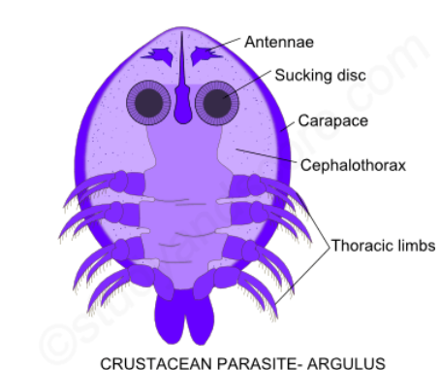

**PARASITISM IN SUBCLASS CIRRIPEDIA**

The following are the general characters of the animals belonging to this group,

* Barnacles are included in this group.
* The adults of this group are sessile, attached to a substratum or they are parasitic.
* The carapace forms two folds of mantel surrounding the body
* The carapace is externally covered by calcareous plates
* Six pairs of biramous and cirri form thoracic limbs are present
* For the purpose of attachment, antennae become cement glands
* Abdomen is rudimentary with caudal styles
* Nauplius larva passes through a cypris stage.

*Sacculina* is the most important parasitic form of this subclass which parasitizes crabs. It is the most unusual barnacle. Although the larvae resemble free-living species, the female will attach onto crabs and develop in the gonads of the host crab, much like a tumor.  The gonads of the host are destroyed in the process of the parasite developing, so that infection with Sacculina induces a phenomenon of parasitic castration.

Similar to other barnacles, Sacculina have a planktonic larval stage, the nauplius, and a settling stage, the cyprids. The adults are internal parasites (called the "interna"). They form cuticular tumors inside their crustacean hosts. These tumors can develop a system of branching roots that ramify throughout the host body and absorb their nutrients. The life cycle of Sacculina, therefore, comprises two stages: the endo- and ecto-parasitic stage.

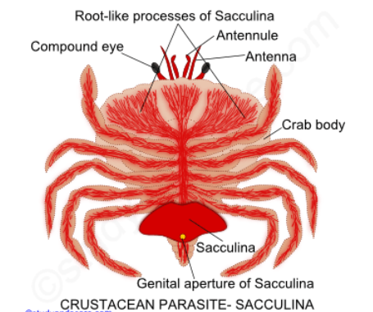

Sacculina larvae are dioecious. The male larvae are often smaller than those of the females. The life cycle begins with the female cyprid invading the crabs and then developing into a parasite with an internal root system (interna).

Once the interna matures, it will develop a reproductive body outside the crabs through the abdominal part called the virgin externa. Male cyprids will then enter the virgin externa, which give rise to a fertilized externa with the eggs brooding inside it. Larvae will then be released via the externa once the eggs became mature.

Other parasitic forms of this subclass are *Syngoga, Laura, Trypetesa, Proteolepas*.

**PARASITISM IN SUBCLASS ISOPODA**

The following are the general characters of the animals belonging to this group,

* They are also known as wood lice
* Their body is dorso-ventrally flattened
* Cephalothorax is formed by the head and 2 thoracic segments
* Carapace is absent
* Gills and heart are abdominal

**Aega:** They are also known as fish louse. They have heavily built and piercing mouthparts. They have hooked legs and broad uropods which form a tail fan.

**Gnathia:**Certain sages of this parasite are called pranzia larvae which are intermittent ectoparasites of marine fishes. They have piercing and sucking type of mouth parts.

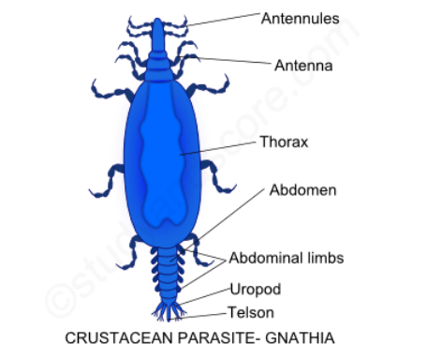

**Cymothoa:**Cymothoa have a short free-living planktonic phase. The juveniles and adults are exclusively parasitic living on the skin, buccal cavity and gill chamber of the fish. They have sucking type of mouth parts. They are hermaphrodite forms freely swimming and acting as males when young and become females after they settle down. The damage caused by them resembles that of other copepods but the most serious effect of isopod infection is destruction of host tissue resulting from the pressure of the parasites body

**Bopyrus:**Bopyrus lives as a parasite inside the gill chambers of prawns. It has suctorial and piercing type of mouthparts. It shows great degree of sexual dimorphism. Females are large with asymmetry and parasitic degeneration.

**PARASITISM IN SUBCLASS AMPHIPODA**

The following are the general characters of the animals belonging to this group,

* They are also known as sand-hoppers
* Their body is laterally compressed
* Carapace is absent
* Gills are thoracic
* Eyes are sessile and lateral

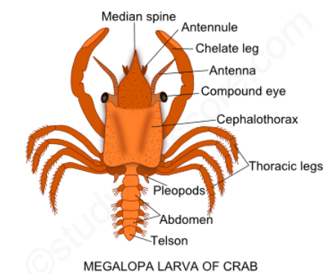

In amphipods, parasitism is not much seen but a few animals included in this group live as ectoparasites on the fishes. The most important of them is whale louse or cyamus which is an ectoparasite on whales. Its body is depressed and broad. Abdomen is much reduced. It has suctorial type of mouthparts. Its legs are clawed, to match its habit of clinging to the skin of the host.

**MODIFICATIONS OF MOUTHPARTS**

Mouthparts of insects are modified cephalic appendages. Different insects have adapted themselves to different modes of ingestion of food. The basic structure of mouthparts remains the same. These similar mouthparts are an example of homologous organs. Homometabolous insects have different types of mouthparts in their larvae and adult stages. Hemimetabolous insects have similar type of mouthparts in their larvae and adult stages.

**MOUTHPARTS OF BUTTERFLY**

The mouthparts of butterfly and moths are siphoning and sucking type. These mouthparts are best suited to draw nectar from the flowers. Siphoning-sucking mouthparts are mostly limited to adult butterflies and moths (Order Lepidoptera). Immature moths and butterflies have chewing mouthparts. The following are the features of the siphoning and sucking mouthparts,

* **Labium** is reduced to a triangular plate bearing labial palps.
* **Mandibles** and **hypopharynx** are absent
* **Maxillary palps** and **labial palps** are present in a reduced condition.
* The only well-developed structures are **galea of the first maxillae**. These are greatly elongated semi-tube like structures. When these two galeae are applied and locked together along the length they form a long tubular **proboscis**. The locking of galeae is done with the help of pegs and sockets. When not in use the proboscis is coiled like a watch spring.

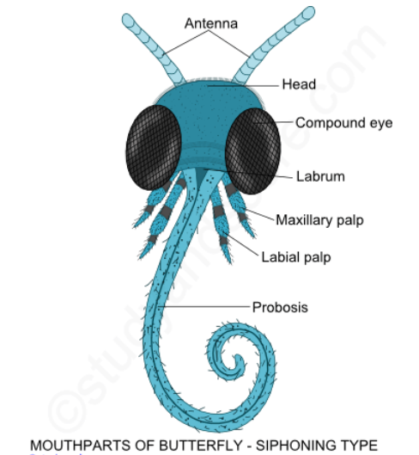

Insects with siphoning-sucking mouthparts do not chew their food, but have a siphon-like structure that allows them to suck or siphon liquid into their body. This feeding is analogous to inserting a straw into a drink to withdraw liquid. At the time of feeding, the proboscis which is coiled like a watch spring is straightened up due to high pressure of haemolymph. This pressure is generated in the stipes which is associated with each galea. Coiling results from the elasticity of the cuticle of galea together with the activity of the intrinsic muscles. The uncoiled-proboscis thrusts out into the nectaries of the flower. Due to the sucking action of cibarium muscles and pharyngeal muscles, the nectar is sucked up.

**MOUTHPARTS OF COCKROACH**

Mouthparts of insects are modified cephalic appendages. Different insects have adapted themselves to different modes of ingestion of food. The basic structure of mouthparts remains the same. These similar mouthparts are an example of homologous organs. Homometabolous insects have different types of mouthparts in their larvae and adults. Hemimetabolous insects have similar type of mouthparts in their larvae and adults.

The mouthparts of cockroach are biting and chewing type. This biting and chewing type of mouthparts are considered as the most primitive and unspecialized of all the mouthpart types. The other examples include grasshopper, dragonfly and beetle. Also the larvae of mosquito, housefly butterfly and honeybee also have biting and chewing mouthparts.

The mouthparts of cockroach are developed to suit its habit of feeding on solid food and as a result it has well developed mandibles. All the components of the mouthparts are present without any modification. These mouthparts help the cockroach to bite and chew on hard stuffs, consume soft stuffs and also lap upon liquids. The mouthparts also include Labrum, Mandibles, and a pair of first maxillae, labium, and hypopharynx. The following is the structure of each of the mouthpart,

**Labrum**: The mouth is covered by labrum. It is also known as upper lip. This labrum is attached to the clypeus. The labrum bears gustatory sensilla on its inner surface. Labrum helps in tasting and also handling the food.

**Mandibles:** These are a pair of triangular, hard, unjointed, stout, chitinised structures. The mandibles are located on either side of mouth behind labrum. They are dentate along their inner margins and are masticatory in function. These mandibles are provided with two pairs of muscles namely, adductor and abductor muscles to help the movement of mandibles only in horizontal plane against each other.

**First pair of maxillae:** A pair of first maxillae is located behind mandibles on either side of the mouth. The first maxilla has two basal segments called cardo and stipes. Cardo is attached to the head capsule and stipes is attached to the cardo. The stipes has five segmented maxillary palp on its outer side. This palp is situated on a small sclerite called palpifer. Inner to the palp two chitinous lobes namely lacinea and galea are found attached to stipes. Lacinea is pincer like with two terminal denticles whereas galea is the outer soft hood life structure bearing long chitinous bristles. The maxillary palps are used for cleaning the antennae and also the front pair of legs.

**Labium:** Labium is formed by the fusion of second pair of maxillae. It is also known as lower lip. The basal segment of labium is called post-mentum. Labium includes two segments namely broad rectangular sub-mentum and a triangular mentum. Also pre-mentum is present in front of the mentum. Pre-mentum is formed by the fusion of two stipes and it bears a small sclerite called palpiger. Each palpiger has a 3-segmented labial palp. At the distal end the pre-mentum bears a pair of paraglossae inner to labial palps. A pair of glossae is present between paraglossae. The paraglossae and glossae together constitute ligula.

**Hypopharynx:** It is chitinous, grooved and a rod-like structure found hanging into the preoral cavity. It is also known as ligula or tongue. Hypopharynx divides the proximal part of preoral cavity into a larger anterior cibarium and a posterior salivarium. The salivary duct opens into salivarium at the base of the hypopharynx.

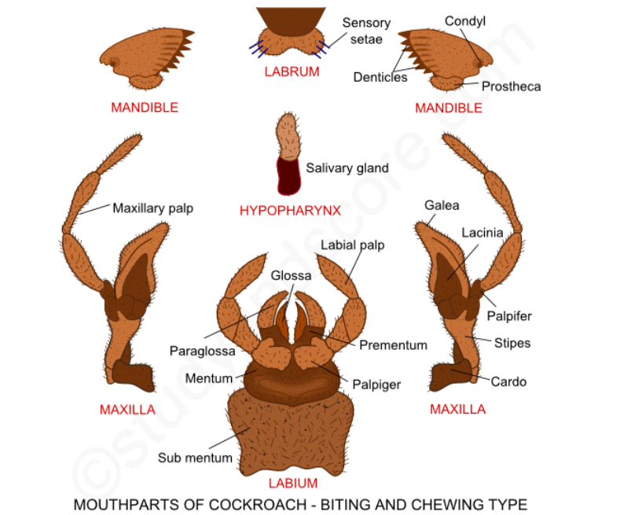

**MOUTHPARTS OF HOUSEFLY**

The mouthparts of housefly are of sponging type. Housefly feeds on any organic matter, exposed food or even an open wound and faecal matter. It takes liquid part of the material as food. Sugars containing solid foods are scrapped are liquefied with its saliva for sponging. The proboscis is divisible into rostrum, haustellum and labellum. Haustellum and labellum are modified labium. The following is the structure of each of the mouthpart,

**Rostrum:** It is the basal part of the proboscis and is proximally articulated with the head capsule. It is distally articulated with the haustellum by a hinge joint. The rostrum encloses pharynx and salivary duct. Pharynx communicated with the food canal. Mandibles are absent. First maxillae are represented by a pair of unjointed palps, which is present on the rostrum

**Haustellum:** It is the middle part of the proboscis and the proximal part of labium. It bears a median groove on its dorsal side. In this groove, the hypopharynx containing the salivary canal and labrum epipharynx are present. They are closely pressed against each other and form a food canal. Haustellum bears a theca underneath it.

**Labellum:**This is the terminal part of the proboscis which is formed of two lobes called labella. A preoral opening is present between the two labella. Prestomial teeth are present on the undersurface of the labella. Labellum has sense organs of taste and smell. The labella bear many grooves supported by semicircular chitinous rings. They appear as tracheae and so they are also known as pseudotracheae. All pseudotracheae of both labella converge into the preoral opening.

**Siphoning type mouthparts: Process of feeding**

When a housefly settles on the food, the haustellum and labella which are bent backwards underneath the rostrum are thrust out and labella are pressed against the food. Prestomial teeth break small food particles and some solid is dissolved in the saliva released on the food. This liquefied food enters pseudotracheae by the capillary action upto the mouth via food channel.

In the female horseflies which also possess sponging type of mouthparts, mandibles are present. The mandibles in these flies are useful in slicing the skin and then the blood which is exposed is sponged up.

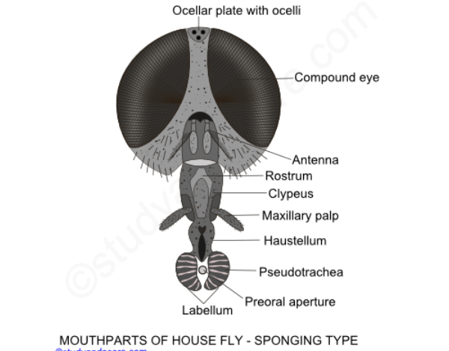

**MOUTHPARTS OF HONEYBEE**

The mouthparts of honeybee are chewing and lapping type. Also bumble-bees also have similar kind of mouth parts. Honey bees have a combined mouth parts than can both chew and suck. This is accomplished by having both mandibles and a proboscis.

Mandibles: The mandibles are a pair of jaws suspended from the head of the bee. The insect uses them to chew wood when redesigning the hive entrance, to chew pollen and to work wax for comb-building. They also permit any activity requiring a pair of grasping instruments. These paired "teeth" that can be opened and closed to get the work done.

**Proboscis:** The proboscis of the honeybee is not a permanent functional organ, but it is formed temporarily by assembling parts of the maxillae and the labium to produce a unique tube for drawing up liquids such as sweet juices, nectar, water and honey. The insect releases it when needed for use, then withdraws and folds it back beneath the head when it is not needed.

**Labellum:** The glossae are greatly elongated to form a hairy, flexible tongue. The glossa terminates into a small circular spoon shaped lobe called labellum, which is useful to lick the nectar. Labial palms are elongate and four segmented.

**Maxillolabial Structures:** Maxillolabial Structures are modified to form the lapping tongue. The tongue unit consists of the two galeae of maxillae, two labial Palps and an elongated flexible hairy glossa of labium.

**Chewing and Lapping mouthparts: Process of feeding**

The galeae fit tightly lengthwise, against the elongated labial palps and they in turn roof over the elongated glossae (tongue) to form a temporary food channel through which saliva is discharged. The tongue (glossae) is trusted into flower, which gets smeared with nectar. It is then retracted between labial palps & galeae. Nectar is then squeezed by galeae and is deposited in the cavity formed by the paraglossae. Accumulated nectar is then drawn into oesophagus by the pharyngeal pump.

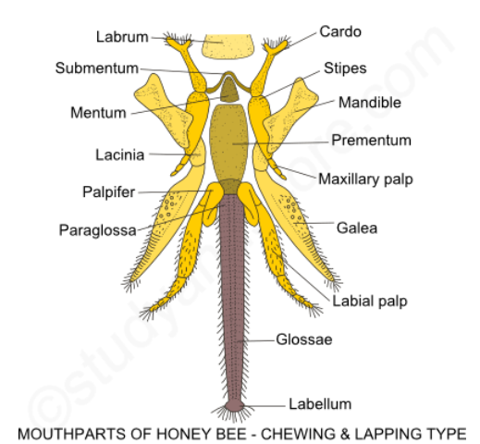

**MOUTHPARTS OF MOSQUITO**

Mouthparts of insects are modified cephalic appendages. Different insects have adapted themselves to different modes of ingestion of food. The basic structure of mouthparts remains the same. These similar mouthparts are an example of homologous organs. Homometabolous insects have different types of mouthparts in their larvae and adults. Hemimetabolous insects have similar type of mouthparts in their larvae and adults.

The mouthparts of female mosquito are piercing and sucking type. These types of mouth parts are present in almost all the bloodsucking insects like tse-tse fly, bed bug etc. Female mosquitoes feed on the blood of warm blood vertebrates. The mouthparts of mosquito are modified for piercing the skin of the vertebrates and then sucking their blood.

The mouthparts include labium, labrum-epipharynx, hypopharynx, mandibles and first maxillae. These mouthparts are characterized by stylets which are long and pointed. The number of stylets varies with different insects. Only maxillary stylets and mandibular stylets are present in bugs, whereas labrum-epipharynx and hypopharynx along with maxillary stylets and mandibular stylets are also present in mosquitoes. The following is the structure of each of the mouthpart,

**Labium:** It is a long, flesh, flexible and unpaired structure with groove called labial groove along its mid dorsal side. It is also called as proboscis. The labium bears a pair of lobes terminally called labella. The labella are interconnected by a membrane called as Dutton’s membrane. Labella represent the reduced labial palps. All the other mouthparts like mandibles, first pair of maxillae and hypopharynx are enclosed in the groove of the labium.

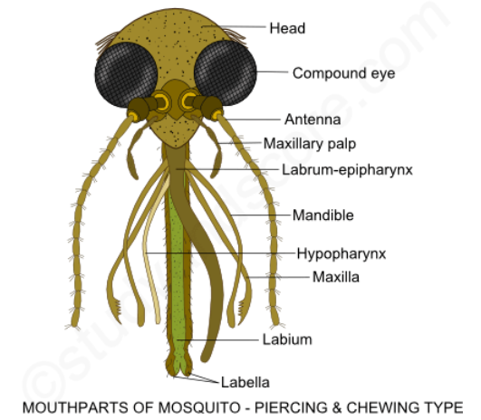

**Labrum-epipharynx:** This is a compound structure formed by the fusion of labrum and epipharynx. Labrum-epipharynx is a stylet that has a ventral groove, which forms the food canal with the hypopharynx.

**Hypopharynx:** It is a long flat stylet structure that forms the food canal with the labrum-epipharynx for sucking the blood. It also contains the salivary canal that injects saliva into the blood of the warm-blooded vertebrates.

**Mandibles:** Two mandibles are present each on either side. These are styles with blade like tips. They are useful to make a wound in the skin of the host. There are two first maxillae one on each side. These are the styles that bear serrated tips. Each maxilla bears a maxillary palp.

**Piercing and sucking mouthparts: Process of feeding**

When a female mosquito sits on the host, it presses the proboscis against the skin. The flexible proboscis bends and the mandibles along with maxillae make a wound on the skin of the host. The labrum-epipharynx and hypopharynx are inserted into the wound. The serrated tips of maxillae keep the wound open. The sucking action of muscles of cibarium and pharyngeal muscles help in sucking the blood through the food canal. The saliva is injected into the blood through hypopharynx. This saliva of mosquito contains haemolysin which prevents the coagulation of blood. This bite of mosquito causes itching and mild inflammation. And the mosquito thus feeds on the blood of vertebrates.

**METAMORPHOSIS IN INSECTS**

The word “**metamorphosis**” comes from the Greek which means to transform. Metamorphosis is the process of transformation of an immature larval individual into sexually mature reproducing adult. The transformed adult is completely different from larvae in form, structure and habit. It is the way insects grow and mature. Their lives are divided into separate stages for resting, growing and reproducing.

Humans grow gradually. You began life as a baby and grow a little at a time until you’re an adult. While you’re growing, the basic plan of your body doesn’t change. You have the same body your whole life. Insects grow in stages and the cycle of stages is metamorphosis. For many insects, the stages are so different from one another that you might not recognize them as the same animal.

There are four types of metamorphosis in insects namely,

* No-metamorphosis,
* Complete metamorphosis,
* Gradual metamorphosis,
* Incomplete metamorphosis.

Most insects begin life as an egg and hatch within a few days of being laid. But there are some insects that will live through an entire season as an egg before hatching. The insects that stay in the egg longer need more time to grow and become strong enough to live outside of the egg. When the temperature becomes warm and comfortable these tiny insects will break out of their eggs and, depending on the species, will go through any of the above said types of metamorphosis.

The following is the description of types of metamorphosis,

**NO METAMORPHOSIS**

This type of metamorphosis is also known as ametabolous development. In this type, the newly hatched creature looks like an adult except in size and differences in armature of spines and setae.

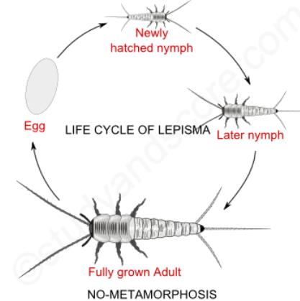

**Examples Orders**

Silverfish Collembola

Springtail Collembola

Chewing lice Mallophaga

Sucking lice Anoplura

**INCOMPLETE METAMORPHOSIS**

This type of metamorphosis is also known as hemimetabolous development. In this type, the immature stages are called as nymphs or naiads. These immature stages are aquatic and they respire with the help of tracheal gills. On the other hand the adults are terrestrial and respire with the help of tracheae.

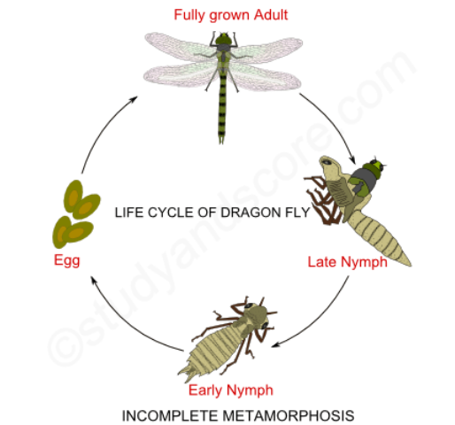

**Examples Orders**

Grasshoppers Orthoptera

Termites Isoptera

Booklice Corrodentia

Thrips Thysanoptera

**GRADUAL METAMORPHOSIS**

This type of metamorphosis is also known as paurometabolous development. In this type, the newly hatched young ones resemble the adult in general body form but lacks wings and external genital appendages. The young nymphs undergo several nymphal stages through successive moulting to transform into adult.

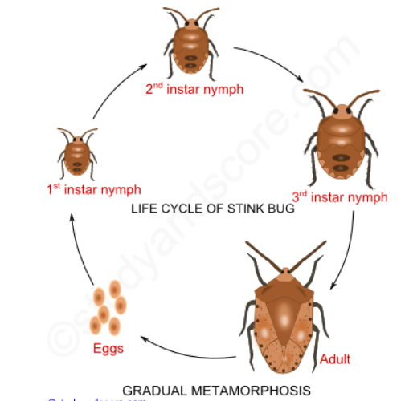

Examples Orders

Mayflies Ephemeroptera

Dragonflies Odonata

Stone-flies Plecoptera

**COMPLETE METAMORPHOSIS**

This type of metamorphosis is also known as holometabolous development. In this type, four metamorphic stages are included namely egg, larva, pupa and adult. After hatching larva moults several times to become fully grown one. It later becomes a pupa within a secreted case called as puparium. Inside the puparium, the pupa differentiates into adult and then breaks open the case to emerge out.

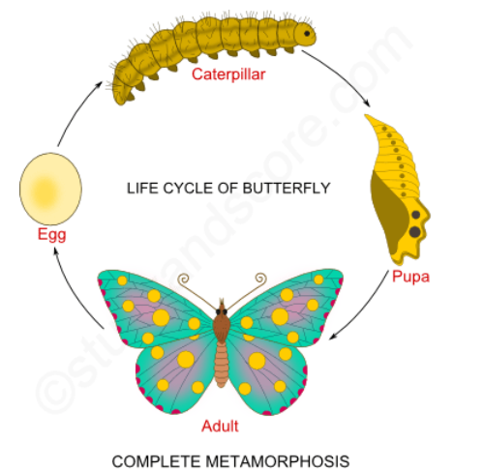

Examples Orders

Lacewings Neuroptera

Beetles Coleoptera

Scorpion-flies Mecoptera

Coddid-flies Trichoptera

Moths, Butterflies Lepidoptera

**HORMONAL CONTROL OF METAMORPHOSIS**

The role of hormones in the physiology of molting was first described by V. B. Wigglesworth in the 1930's. When an immature insect has grown sufficiently, it requires a larger exoskeleton then the sensory input from the body activates certain neurosecretory cells in the brain.   These neurons respond by secreting **brain hormone (BH)** which triggers the corpora cardiaca to release **prothoracicotropic hormone (PTTH)** into the circulatory system.   This sudden release of PTTH stimulates the prothoracic glands to secrete **molting hormone/Prothoracic gland hormone (PGH)**. These PGHs are ecdysteroids which trigger moulting process.

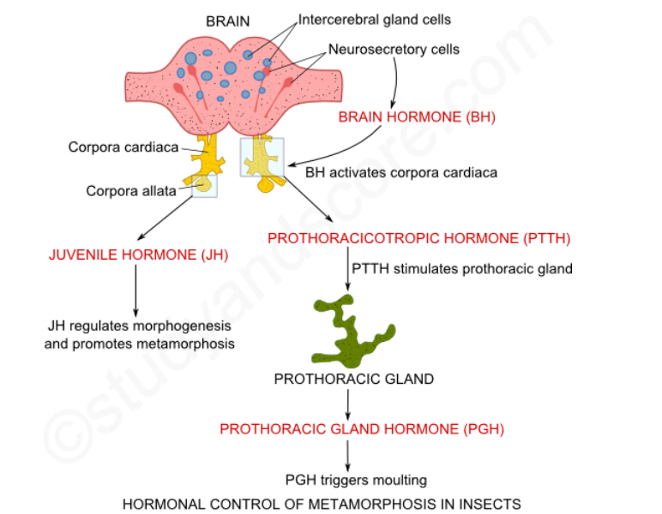

PGH affects many cells throughout the body, but its principle function is to stimulate a series of physiological events also known as apolysis. Apolysis leads to synthesis of a new exoskeleton.   During this process, the new exoskeleton forms as a soft, wrinkled layer underneath the hard parts of the old exoskeleton.   The duration of apolysis ranges from days to weeks, depending on the species and its characteristic growth rate.   Once new exoskeleton has formed, the insect is ready to shed off its old exoskeleton.   At this stage, the insect body is covered by two layers of exoskeleton and it is called as pharate.

Toward the end of apolysis, ecdysteroid concentration falls, and neurosecretory cells in the ventral ganglia begin secreting eclosion hormone. This hormone triggers ecdysis, the physical process of shedding the old exoskeleton. In addition, a rising concentration of eclosion hormone stimulates other neurosecretory cells in the ventral ganglia to secrete bursicon, a hormone that causes hardening and darkening of the integument due to the formation of quinone cross-linkages in the exocuticle (sclerotization).

In immature insects, juvenile hormone (JH) is secreted by the corpora allata prior to each molt.   This hormone inhibits the genes that promote development of adult characteristics causing the insect to remain in immature state.   Corpora allata becomes atrophied during the last larval stage and stops producing juvenile hormone. This releases inhibition on development of adult structures and causes the insect to molt into an adult

At the approach of sexual maturity in the adult stage, brain neurosecretory cells release a brain hormone that "reactivates" the corpora allata, stimulating renewed production of juvenile hormone.   In adult females, juvenile hormone stimulates production of yolk for the eggs.   In adult males, it stimulates the accessory glands to produce proteins needed for seminal fluid and the case of the spermatophore.   In the absence of normal juvenile hormone production, the adults remain sexually sterile.

The following table contains the details of the hormones involved in the process of metamorphosis,

|  |  |  |  |
| --- | --- | --- | --- |
| **Hormone** | **Secreted by** | **Chemical nature** | **Function** |
| Brain Hormone (BH) | Neurosensory cells | Lipids | Activates corpora cardiaca |
| Prothoracicotrophic hormone (PTTH) | Corpora cardiaca | Ecdysteroids | Stimulates prothoracic glands |
| Prothoracic gland hormone (PGH) | Prothoraacic glancs | Ecysone | triggers moulting |
| Juvenile hormone (JH) | Corpora allata | Lipids | Regulates morphogenesis and promotes metamorphosis |

**SOCIAL BEHAVIOR**

Few animals belonging to the order Isoptera and Hymenoptera of class Insecta, exhibit social behaviour. These animals live in complex societies and are referred to as eusocial.  Eusociality is an extreme form of social behavior found in just a few types of animals and is characterized by:

1. Occurrence of polymorphic forms each assigned with a different function
2. The presence of several generations in a single hive/nest at the same time
3. Worker members of the colony which provide food and care for the reproductives and the early developmental stages of the colony.
4. Division of labor with queens that reproduce a lot

**General characteristics of social insects**

The following are the characters commonly possessed by all the social insects:

* **Parental care:** Parental care is an instinct behavior whereby the young ones are provided with food, shelter and defense by the parents as a part of the family relationship. The social life in insects is linked with parental care. Parental care paves way for stronger association between the parents and the young ones. Parental care includes activities like providing the young ones with food, cleaning the nests, feeding the young and queen, removal of debris and bodies, arranging eggs in proper chambers, protecting the queen from all adversities, cooling the nest in summer season.
* **Rich nests:**The nests of all social insects are rich in structure which helps in protection, storage of food and maintenance of broods. The following table summarizes the nest richness of various social insects:

|  |  |  |  |
| --- | --- | --- | --- |
| **Habits** | **Honey bee** | **Ants** | **Termites** |
| Position of nest | Trees | Leaves, wood | Wood, ground |
| Material of nest | Wax | Leaves, wood, soil | Wood, soil |
| Shape of nest | Hexagonal cells | Chambers & galleries | Chambers & galleries |
| Nest built by | Females & workers | Females/males & workers | Female/male & workers |
| Population of nest | 35-50 thousand | 600 thousand | Several millions |
| Brood nature | Perennial | Perennial | Perennial |
| Brood food | Pollen & Nectar | Vegetables, wood, insects | Wood & insects |
| Feeding type | Progressive | Progressive | Progresive |
| Swarming | Yes | In some species | Yes |

* **Polymorphism:** Polymorphism is the occurrence of several forms within the same species. It refers to specialization of individuals within a species. In the animals exhibiting polymorphism, individuals at the center of the colony develop gonads and reproduce sexually. Individuals at the periphery expose themselves to danger of combat, and do not reproduce sexually. This is also an example of altruistic behavior. The polymorphic individuals are sometimes called super-organisms, as in polymorphic individuals the unit for natural selection is not a single individual but the whole colony. The social insects are the most prominent examples of super-organisms. They are found in two orders of class Insecta namely Isoptera and Hymenoptera.
* Termites included in the order Isoptera have typical sexual reproduction, and ants, bees and wasps included in order Hymenoptera have haplo-diploid sex determination. The general structure of these super-organisms is that there are only one or very few reproductive females, small numbers of reproductive males, and large numbers of non-reproductives that provide food and care for the reproductives and the early developmental stages of the colony. In termites, non-reproductives include are both male and female where as in Hymenoptera the non-reproductives include only females. In most of these super-organisms, reproductives and non-reproductives are genetically identical, and environmental factors control the development, by suppressing the developmental capabilities of reproductives.
* **Large population:** Al the individuals of the social insects species live in an integrated manner and hence the term colony is commonly used to describe their complex society. These colonies are matriarch or in other words, all the members of the colony are the offspring of a single female and so all of them have similar genotype. Also these colonies do not accept the members form other colonies of same species.
* **Extra populations:**Some aphids, beetles, mites etc. are attracted into the nests of ants and termites by the high temperature and surplus food. These extra populations are protected and fed by the ants and termites. In return the ant and termite populations feed on a fluid secreted by them. Sometimes intruders and thieves rob the social insects of their food. Some beetles live in the nest of the ant and feed on the ant larvae. All these form the extra populations of the social insects.
* **Cohesiveness of the colony:** Cohesiveness is a measure of the attraction of the group to its members and the resistance to leave it. The sense of team spirit and the willingness of its members to coordinate their efforts are very important for the group to perform best as a biological unit. All the members of the insect society live in a coordinated manner. As a result of this various castes which differ in structure and function are formed. And these castes cannot live independently. All the members of the colony work in cooperation and they reap mutual benefit of the work done. The success of these insects is measured in terms of the colony and not individually. The members of the castes are bound by chemical and physiological mechanisms.
* **Liberal food facility:** After laying the eggs, stingless bees and some other insects provide sufficient mass of food for development of the larvae which hatch out of the eggs. This phenomenon is known as mass provisioning of the food. At the same time, other social insects daily feed their young ones continuously and extensively. The young ones are fed until they metamorphose into adults. For example, in the ant colony army ants hunt insects or flesh; pastoral ants feed on the honey dew produced by aphids. Also the pastoral ants carry the aphids into the overwintering locations to protect them from predators. Harvesting ants gather and store seeds in summer to tide them throughout the winter.
* Finally the leaf cutter ants or fungus growing ants grow their own crop of fungi. These ants cut and carry the leaves underground to serve as a substrate for growing fungi. These ants feed on the fungi. Protection of the colony and self: Protection of the individual self is done with the help of protective devices like stings and jaws. Stings are present in most of the bees and also in few ant species. Also well-developed jaws are present in stingless bees, soldier ants and termites. Sometimes for the protection of the colony or nest, few guards are posted at certain locations. These guards protect the nest and attack the intruders. Finally the nests are made in such protective locations which have the possibility of rapid exit during danger. Insects also take care that their nests have numerous side exits.
* **Trophallaxis:**Exchange or sharing of food between the insects of different species is called as trophallaxis. For example, termites and ants feed each other from mouth to mouth. Similarly young ones exchange food with the adults. Also beetles, aphids and coccids are fed by ants and then in return ants drink a fluid secreted by them. This is a form of mutual feeding. Trophallaxis is an important phenomenon in determination and regulation of castes in termite colony. During trophallaxis, ectohormones with certain inhibitory substances are passed on to the young nymphs and this prevents them from developing into individuals of same sex or caste. Consequently the number of individuals in a particular caste is maintained.
* **Communication:**Communication is an interesting feature found both in social and nonsocial insects. Insects use chemical, visual, tactile and auditory signals as a means of communication with each other. Chemical communication occurs with the help of body secretions called pheromones. Pheromones pass out of the body and help in regulating and coordinating the colony activities. For example, ants deposit substances on their way which act as trail markers and help them return to their homes after foraging trip.  Similarly visual, tactile, and auditory signals help in various activities of the colony.
* **Swarming:**The behaviour of the insects to come out of the nest in large numbers to relieve the overcrowding is called as swarming. It takes place during spring or early summer seasons. Swarming occurs for feeding and migration. It is also a means of the colony reproduction or in other words founding of new colonies. The queen and the males mate during swarming flight and this is also known as nuptial or marriage flight.

**SOCIAL ORGANIZATION OF TERMITES**

The termite life cycle has the three castes, the reproductives, the soldiers and the workers. Due to the fact that termites are hemimetabolous insects, even the nymphs take part in the social life and have their specific tasks to accomplish. In case of termites, once the caste of an individual is determined, development into other castes is still possible. Soldiers also called as inter-castes, may turn into workers or even into reproductives, if there is a shortage of individuals of other castes. This process of development in to other castes is controlled by pheromones. In the case of the queen, there is a specific ‘queen’ pheromone, preventing other individuals from turning into queens. Only if the queen is removed or dies, does the lack of the specific pheromone promote the development of a new queen.

**Reproductives-**Reproductives have compound eyes and are more or less brown due to their sclerotized cuticle. Developing reproductives have wing buds, wings or wing stumps. Reproductives can be further divided into:

**Alates:** They are young winged reproductives of both sexes. From time to time about 100 to 1000 alates leave the colony for a mating and colonizing flight. After mating a pair settles down at a suitable site like a rotting scar on a tree to establish a new colony.

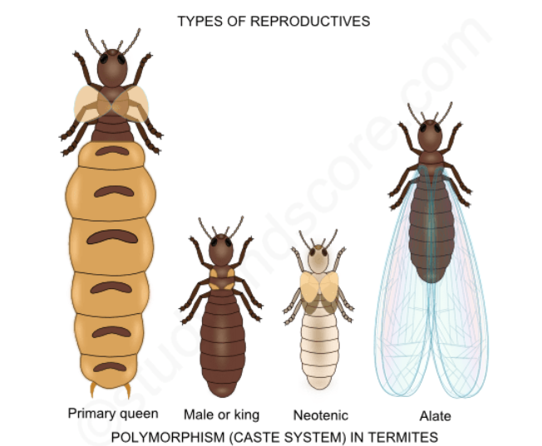

**De-alates:** These are the alates that cast their wings after the colonizing flight and successively turn into queens and kings. Initially only a few eggs are laid and brought up by a female de-alate. As the number of individuals in the colony grows, more workers are available to help the young queen to care for the brood. After three to five years the number of individuals is already so large, that the colony of this pest species can turn into the damaging stage.

**Queen and king:** They are the main reproductive individuals in a colony. Once there are many workers to help the queen, her only job is to produce tremendous number of offsprings. A large queen may lay more than 1000 eggs per day. The life span of a queen can be as much as 50 years.

**Neotenics:**They assist the queen in laying eggs, once her productivity decreases. When the queen has died or deteriorated, one of the neotenics takes her place and so they are also known as Secondary queens. Hence, the removal of a queen from her colony does not necessarily mean the end of the colony

**Workers:**They are sterile, wingless and blind males and females. Their cuticle is unpigmented and not hardened; therefore the animals are confined to a dark and moist environment. Workers build the nest and galleries, they fetch food, care for the brood and feed reproductives and soldiers. The life span of a worker is about one to two years.

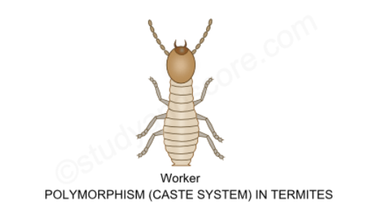

**Soldiers:**Just like workers, they are also sterile, wingless and blind males and females with an unpigmented, unsclerotized cuticle. Soldiers defend their colony from intruders by the use of powerful jaws or by ejecting a white sticky repellent from an opening on their head. Soldiers can’t feed themselves; they have to be fed by workers. Usually the number of soldiers is much smaller than the number of workers. Soldiers can be mandibulate or nasute depending on the species. Therefore soldiers can be used for the identification of termite species. The life span of the soldiers is about one to two years.

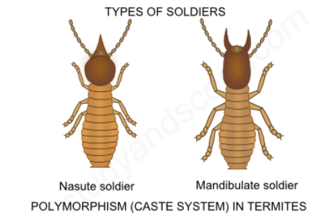

**SOCIAL ORGANIZATION OF APIS**

Honey bee is a social insect. The nest of the honey bee is known as the bee-hive. The population of an average sized colony consists of 30 to 50 thousand individuals.

A colony is termed ‘weak’ or ‘strong’ according to the number of worker bees it possesses. There are three types of individuals in a colony, namely the Queen, worker and drone. Due to the existence of several morphological forms, bees are said to be a polymorphic species. All these three castes depend on each other for their existence. Drones and queen are concerned only with reproductive function and so the workers have to perform all the other duties of the colony.

The following is the description of each type of member of the bee colony,

**Queen:** It is a diploid, fertile female. The presence of queen in a colony is a must. The size of the body of queen is much larger than other castes of bees of the colony. Her legs are strong as she always has to walk about on the comb. The queen has a sting curved like a scimitar at the tip of the abdomen, which is a modification of the egg-laying organ known as ovipositor. The sting serves as an organ of defense. She never uses it against anybody except her own caste. The queen is responsible for laying eggs for a colony. She lays about 1000 to 1500 eggs every day and lives for about two to three years. She lays both fertilized eggs (from which females develop) and unfertilized eggs (from which males develop).

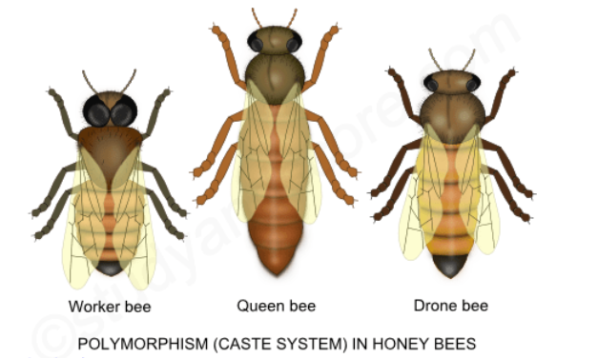

**Worker:**It is a diploid, sterile female. The size of a worker is the smallest among all the other castes but they constitute majority population of the bees in a colony. The following are the functions of worker bees,

* Collection of honey,
* Producing royal jelly for feeding the community,
* Raising larvae and  young ones,
* Cleaning the comb,
* Making wax,
* Constructing the beehive,
* Defending and protecting the hive,
* Clearing the debris and dead bees,
* Maintaining the temperature of the hive

Numerous adaptations have occurred in the worker bees for performing various functions. The body is covered with branched hairs so that when a bee visits a flower, pollen grains adhere to the hairs and other parts of the body. The worker cleans off pollen grains with special structures, the antenna cleaners on each foreleg, pollen brushes on all legs and pollen combs on hind legs. All pollen is stored in the pollen basket present on the outer surface of tibiae on hind legs.

Water and nectar are gathered by means of sucking mouthparts which are modifications of the maxillae and labium. Workers are provided by a sting at the tip of the abdomen which is a modified ovipositor. The sting is used to protect the colony from the enemies. A large poison storage sac is connected with the base of the sting. Two acidic and one alkaline gland mix their secretion to form poison which is injected by the operation of muscles to other animals. During the withdrawal from the prey’s body, the stings along with other poison apparatus are torn off, resulting in the death of that particular bee. Workers are female but are incapable of producing eggs. The life span of a worker bee is about 4 to 5 months.

**Types of worker bees**

Worker bees are again of different types depending on the type of work they do,

**Laying worker:** These worker bees lay unfertilized eggs in the absence of the queen bee. Drones develop from these unfertilized eggs.

**Nurse workers:**These worker bees are 1-10 days old. They serve the queen with troyal jelly which contains more mandibular secretion. These nurse workers also serve the larvae and drones with honey and beebread which is the combination of pollen and honey. Nurse workers also help in cleaning the beehive.

**House workers:** These workers are 10-20 days old. These workers perform house cleaning, comb building, accepting nectar and pollen for foragers and finally guard the hive. The special wax glands are present on the abdominal segments of these worker bees. The wax glands secrete bee wax. Bee wax is used in making walls and caps of the comb. These workers also transfer the eggs with larva to make new queen.

**Field workers:** These workers are 20 days plus older. These workers travel to distant places to collect the nectar, pollen grains and resin from the flowers. They convert the nectar into honey with the help of the enzymes present in their crop. The honey and pollen grains are deposed by these workers into the storage chambers. The field workers also make propolis from the resin collected from the flowers and tree saps. Propolis which is special bee glue is used to seal the cracks in the comb.

The field workers perform two types of dances namely round dance and waggle dance. Through these dances, bees communicate about the source of food and the distance & direction of food source from the hive.

**Drone:** It is haploid, fertile male. The drones are born out of unfertilized eggs in the brood chamber. The males are larger than workers and are quite noisy. They have large wings, robust body and reduced mouthparts. They are unable to gather food, but they voraciously eat the food fed to them by the worker bees. They are stingless and their sole function is to fertilize the queen during the nuptial flight after which they are starved to death. They are designated only for mating. The number of drones in a colony varies from 200-300. The drone develops parthenogenetically from unfertilized eggs. Drones live only for a short period of time.

 Arthropods possess simple as well as compound eyes; the latter evolved in Arthropods and are found in no other group of animals. Insects that possess both types of eyes are considered to be the most successful animals on earth.

**VISION IN CRUSTACEA (Prawn) – The Compound Eye**

Crustacea includes prawns, crabs, lobsters, shrimps, barnacles, water fleas etc., which possess a pair of compound eyes for vision.

Prawn possesses a pair of large stalked hemispherical eyes on the anterior side of cephalothorax below the rostrum. Each eye is composed of a large number of independent visual units called **ommatidia** which are connected to the optic nerve. An ommatidium is divisible into the outer **dioptrical region** for receiving and focusing light rays and the inner **sensory region** for perceiving light and sending the nerve impulse to the brain, which analyses the impulses as image of the object.

The cuticle on the surface is modified as cornea over the ommatidia and gives the eye necessary protection and also allows the light rays to enter the eye. Below the cornea, a pair of **corneagen cells** secretes fresh cornea in case of wear and tear. A lens-like **crystalline cone** is located beneath the corneagen cells and serves to focus light rays inwards. The crystalline cone is surrounded by four **cone cells**or**Vitrellae** that serve to provide nourishment to the cone.

Next layer is of sensory cells called **Rhabdomes** which are elongated and transversely striated and are sensory in function. Seven **retinalcells** that surround the rhabdome and encircle it provide it nutrition and protection. **Chromatophores** are pigment cells which are responsible for separating one ommatidium from the other so that they remain as independent units. They are located around the cone cells and retinal cells and can shrink or expand to increase or decrease the intensity of light entering the eye.

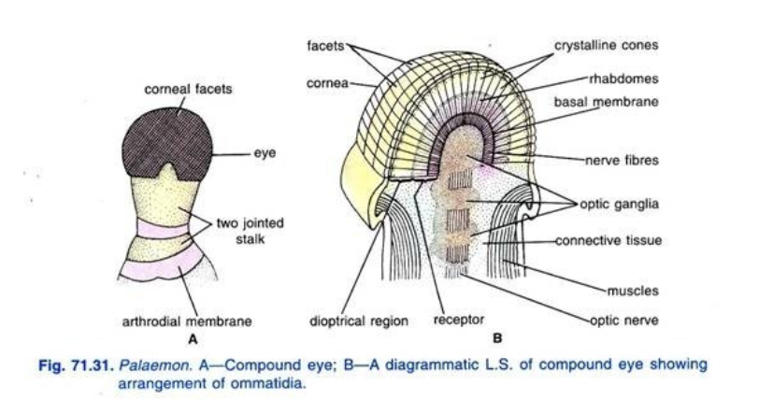

**THE MOSAIC VISION**

 The compound eye is incapable of giving distant vision and sharp vision but is efficient in picking up motion and in providing 360° view, as it is large globular and mounted on a movable stalk. Each ommatidium is capable of producing an independent image of a small part of the object seen and not the entire object. All these small images are combined in the brain to form a complete image of the object that is made of small dots or mosaic of dots and hence it is called mosaic vision. The range of the compound eye is not more than a foot and hence no single ommatidium can perceive the entire object. Movement of the objects can be detected much more efficiently by the compound eye because as the object passes in front of the eye, the ommatidia switch on and off according to their location in relation to the object . This characteristic of the compound eye helps the animal in detecting the movement of the predators and escape before the latter can strike.

Another characteristic feature of the compound eye is its high **flicker fusion rate,** which means it can perceive action as successive independent frames of images and not as a continuous motion. The flicker fusion rate of the compound eye is about 50 frames per second as compared to 12-15 frames per second of human eye. By perceiving motion the compound eye helps arthropods to escape from predators.

**The Apposition Image**

This is perceived in bright light, when pigment cells in the dioptrical and sensory regions spread and completely separate the ommatidia from each other, so that the angle of vision of an ommatidium is only 1 degree and light rays coming directly from the front can only enter the ommatidium, whereas the light rays coming at an angle are absorbed by the pigment before they can reach rhabdomes. The image formed in brain is a mosaic of several dots, each one of which is formed by an ommatidium. Each ommatidium uses only a tiny portion of the total field of vision and then in brain these tiny images are grouped together to form a single image of the object. Since each dot is clearly separated from the other, it is called mosaic or apposition image. The sharpness of the image depends on the number of ommatidia and their isolation from one another.

**The Superposition Image**

This type of vision occurs in dim light in nocturnal arthropods. The pigment cells shrink to allow more light into the eye, so that the ommatidia no longer remain optically isolated from one another, enabling even oblique light rays to strike one or more ommatidia. This results in overlapping of the adjacent blotches of images formed by different ommatidia. This is called superposition image because overlapping images are formed in the brain. This image is not sharp but hazy because of overlapping images.

**VISION IN ARACHNIDA (Scorpion) – The simple eye**

Scorpion belongs to the class Arachnida and possesses only simple eyes. It has a pair of large median indirect eyes and three pairs of lateral direct eyes which function in different ways in different situations.

**The Median Indirect eyes:**  The median eyes are large convex and covered with the thick cuticle that forms cornea or lens. The hypodermis forms a thick vitreous body that nourishes the lens. The sensory rhabdomes point backwards towards the reflecting layer called **tapetum**. The rhabdomes are surrounded by many sensory retinal cells which transmit nerve impulses to the optic nerve and then to the brain. Median eyes of scorpion are used for vision in the night or in dark places because the dim light entering the eye is reflected by the tapetum to strike the rhabdomes again to form vision.

**The Lateral direct eyes:** Lateral eyes are small in size, 3 pairs and located on the lateral sides of prosoma. This eye is covered externally by a biconvex lens formed from the transparent cuticle. The epidermis forms a thinner vitreous body under the lens. Inside the eye cup are several rhabdomes which point directly towards the source of light as the tapetum is absent in these eyes. Each rhabdome is connected on the posterior end to a sensory retinal cell that is connected to the nerve. The lateral eyes are used to provide vision in day time or in bright light.

**VISION IN INSECTA (Cockroach) – Simple as well as Compound Eyes**

Insects possess one pair of compound eyes and 1-3 simple eyes or ocelli on top of the head. In cockroach the ocelli are rudimentary.

**The Insect Compound Eyes:** The compound eyes are sessile in the form of convex brownish-black, kidney-shaped structures on the lateral sides of head. Each eye contains about 2,000 ommatidia, similar in structure to those already described earlier.

The pigments separating ommatidia are not retractable in the eyes of cockroach since the animal is nocturnal and spends daytime in dark places. But the eye produces mosaic vision similar to the crustaceans. Compound eyes are specially adapted to perceive movements of objects. The insect compound eye is advanced structure because the number of ommatidia in insect eyes increases giving the eye sharpness of vision. Also the distance of vision increases in predatory insects and fast flying insects.

**The Insect Ocelli.** Ocelli are simple eyes, more or less similar to the simple eyes of arachnids and provide the eye with distant vision. Ocelli also give nocturnal vision to night flying insects, which find their way by aligning them at an angle with the moon or stars. By possessing both types of eyes, insects enjoy both types of visions, namely detection of movement with compound eyes and distant vision with simple eyes or ocelli.

**RESPIRATION**

Arthropods constitute three-fourth of the animal kingdom and inhabit a variety of habitats. They breathe air as well as water and some are accomplished amphibians. Their respiratory organs vary according to their way of living as described below.

**RESPIRATORY ORGANS OF CRUSTACEANS (e.g. Prawn)**

In smaller crustaceans, such as Copepods and Ostracods oxygen simply diffuses through the body surface since small animals have larger surface area as compared to the body mass. In majority of crustaceans gills are the chief respiratory organs. In prawn gills are enclosed in a gill chamber on each side of the cephalothorax and are covered by a carapace, inner side of which is called branchiostegite and has vascularised respiratory epithelium.

**Epipodites** are highly vascularised leaf-like membranous structures attached on the coxa of the three maxillipedes. They carry out respiratory function.

The gills are regarded as primary respiratory organs and they are three types in prawn, namely podobranchs, arthrobranchs and pleurobranchs.

**Podobranchs** are one pair of small gills that are attached on the coxa of the second maxillipedes.

**Arthrobranchs** are two pairs, one smaller and the other larger, attached to the arthrodial membrane of the third maxillipedes.

**Pleurobranchs** are 5 pairs of arched gills attached in the gill chamber on the outer margin of cephalothorax, just dorsal to the walking legs. The gill lamellae are flat, plate-like arranged parallel to each other like the pages of a book.

Water current flows through the gill chamber by the action of **scaphognathite** which is a fan-like appendage of maxilla and lies near the entrance of the gill-chamber. It is also called baler as it forces water over the gill chamber. Fresh water enters the gill chamber from behind in the form of a current. The highly vascularised gill-plates are covered with permeable membrane for the passage of gases.

**RESPIRATORY ORGANS OF ARACHNIDS (e.g. Scorpion)**

Scorpion breathes air through four pairs of book lungs or pulmonary sacs that open to the outside through four pairs of stigmata on the ventral side of mesosoma.

**Book lungs** are sac like structures, within which there are delicate folds that are arranged like the leaves of a book. These folds are richly supplied with blood. The four pairs of book lungs are located in the third, fourth, fifth and sixth mesosomal segments. Each book lung consists of an air cavity or **atrial chamber** on the ventral side which opens to the outer side by a slit-like spiracle or **stigmata** that opens on the ventro-lateral side of the sternum. Dorsal part of book lung consists of nearly 150 vertical folds or **lamellae**arranged like leaves of a book. Each lamella is a hollow structure, made of two thin layers of respiratory epithelium.

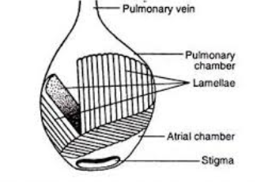

The air breathing in the book-lungs is effected by the action of the **dorso-ventral** and **atrial** muscles. Contraction of the dorso-ventral muscles compresses the pulmonary chamber so that the air from the chamber is forced out through the stigmata. When the atrial muscles contract the book-lungs expand creating vacuum and sucking fresh air in through the stigmata.

**RESPIRATORY ORGANS OF INSECTS (COCKROACH)**

Great majority of insects breathe air by means of an elaborate and most efficient gas exchange system made of branching elastic air tubes or tracheae called the **tracheal system**. In majority of insects tracheal system serves for transport of oxygen and carbon dioxide. Each trachea is an air tube lined with epithelial cells and spiral ridges called the **taenidia**. Tracheae open externally by small openings called **spiracles**through which the air enters the system. The tracheae are branched into finer branches called **tracheoles**which are air capillaries without inner taenidial ridges. Breathing is affected by the paired **tergo-sternal muscles** which connect dorsal side of body with the ventral side and hence their contraction compresses the abdominal cavity forcing air to move out. Relaxation of these muscles brings the abdominal cavity into its original shape, sucking the air into the tracheal tubes.

 In many aquatic insects such as mayfly and dragon fly larvae there are tracheal gills for respiration in water. Tracheal gills are leaf-like extensions on the terminal abdominal segments that carry respiratory epithelium.

 Inside the body of cockroach there are three pairs of parallel longitudinal **tracheal trunks**, one dorsal, one ventral and one pair lateral in position, which are connected together by transverse commissures. The cuticular lining of these tracheae is spirally thickened to form **taenidia** which prevent the tracheal tubes from collapsing. **Tracheoles** profusely branch and anastomose and penetrate in all parts of body and connect to the muscle and tissue cells. Tracheoles have a diameter of only 1 micron only and their cavities are intracellular and walls are very thin and devoid of cuticular thickenings. Instead they are lined by a protein called **trachein** and are usually filled with a fluid in which oxygen dissolves and diffuses to the tissues. The tracheal system carries oxygen directly to the body cells and does not require blood to transport it. Generally there are 10 pairs of spiracles in insects, two pairs are thoracic and eight pairs are abdominal.

